Proposal for the preparation of the implementation of the EUDET generic DAQ system for Particle Flow Calorimeters

People and Funds:

The User Group consists of members of the Laboratoire Leprince Ringuet (LLR - École polytechnique, CNRS/IN2P3, 91120 Palaiseau, France) represented by Dr. Vincent Boudry (Nationality: French) as the local project leader.

From the LLR group Dr. David Decotigny (Nationality: French) will be travelling.

Initially, the TA is expected to last three days.

Estimated Travel Costs:
up to 200 GBP Eurostar
up to 200 GBP Hotel
~50 GBP per diem

Timeframe & Location:

July 20th-22nd 2009, University College London

Introduction:

The CALICE collaboration is pursuing calorimeter R&D for particle flow calorimeters to be operated at the International Linear Collider (ILC). Three types of calorimeters are under study: a Silicon Tungsten Electromagnetic calorimeter (SiW Ecal), a Scintillating Tile Hcal (AHCAL) and a hadronic calorimeter based on glass RPC with digital readout (DHCAL).

EUDET has developed a Data Acquisition System (DAQ), called EUDET DAQ hereafter, that interfaces e.g. to the DHCAL and is conceived to be a generic DAQ to interface to all three calorimeter types.
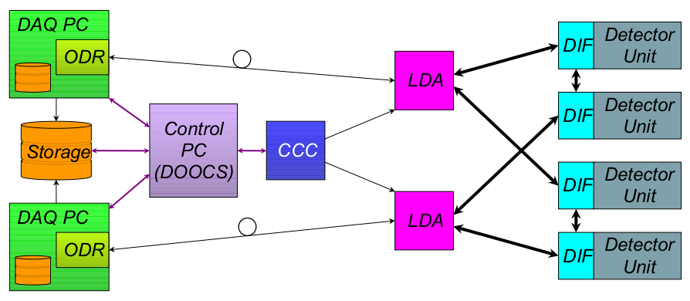
Figure 1 - Schematic Overview of the CALICE DAQ system which connected to detector units via a DIF.

Motivation:

The Detector Interface Card (DIF) is, as the name suggests, the hardware link between the EUDET DAQ and the on-detector readout electronics, which in turn is specific to each sub detector. The study will enable the User Group to test the DCHAL DIF in terms of transfer speed, data integrity and general data communication issues. The tests will be performed using entirely the soft and hardware as provided by the EUDET DAQ.

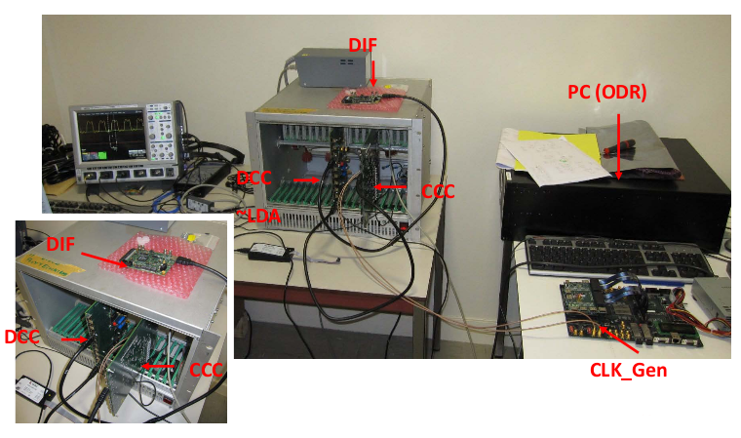

Figure 2 - Prototype of a DAQ setup for the CALICE DHCAL

More generally, the CALICE collaboration will acquire expertise in the application of the generic DAQ for different Very Front End (VFE) electronics for the three different types of CALICE calorimeters. Namely the know-how will afterwards be transferred to groups working on the VFE for the SiW ECAL and AHCAL to setup a similar DAQ system. The individual working groups within CALICE will have, however, the need for further studies dedicated to their individual systems.

Conclusions:

The Transnational Access will allow for a detailed study of the DHCAL DIF and later on the ECAL and AHCAL DIF under the same conditions using the EUDET DAQ. The initial visit in July is a very first test of this DAQ system in combination with hardware conceived for the DHCAL and henceforth for the CALICE Calorimeters. This is test is vital in view of large-scale test beams envisaged for the year 2010.

Citation:

EUDET report 2008-06: Status of the data acquisition system for the EUDET calorimeters, V. Bartsch, M. Wing, T. Wu

