7/31/2026

1

Proposal for measurements with a Japanese GEM system using the large prototype TPC at the DESY test beam in September 2010

GROUP LEADER: Leif Jönsson
HOME INSTITUTE: Phys. Dept., Lund Univ

OTHER PARTICIPANTS:
Björn Lundberg 10.9 – 17.9
Ulf Mjörnmark 10.9 – 24.9
Martin Ljunggren 10.9 – 24.9
Hirotoshi Kuroiwa 10.9 – 24.9

SCIENTIFIC BACKGROUND AND PROGRAM

In September 2010 measurements will be preformed, using the large prototype TPC with 3-4 GEM modules, built in Japan, taking advantage of an infrastructure system provided by the EUDET collaboration at the DESY test beam. The goals of the measurements are to (1) measure position resolutions in the full volume of the TPC i.e. to determine the effects of diffusion of the electrons in the gas, (2) study the effects of the boundaries between modules on the track reconstruction and (3) perform momentum measurements for different inclination angles of the incoming beam particles over the full TPC volume.

Due to the installation in 2010 of an automated 3D movable table, on which a superconducting solenoid (PCMAG) is resting, the impact position of the beam can be varied, with the TPC still resting in the region of the most homogeneous magnetic field. This means that for the first time the full drift length can be used without suffering from big distortions from drastic field variations. Accordingly, it will be possible to test more accurately against data if the simulation of how the electron clusters are drifting through the TPC and the pad response function are correctly described.

The reconstruction of tracks over the full (radial) distance of the TPC will be possible for the first time and enable us to test with real data that the Kalman filter, implemented into the Marlin TPC program, is working satisfactorily, and that the corrections for inhomogeneities in the magnetic field are done properly. Further with help of the 3D movable table and rotating the TPC inside the PCMAG, we have the opportunity to investigate tracks that are crossing the different boundaries of the modules and what influence this has on the reconstruction.

Since 2008 the EUDET infrastructure is available to a broader community for testing various gas amplification systems, like the GEM-system as built by the Asian groups. The infrastructure system consists of a thin coil 1T superconducting solenoid (PCMAG) into which a thin field cage TPC has been installed. The end plate of the TPC can take up to 7 GEM modules which are connected to the readout electronics, based on the ALTRO chip, which has been developed by the Lund group in collaboration with CERN.

The GEM detector modules have two layers of thick GEM (100 micron thick) for gas amplification and the installation at a later stage of one layer of very thin GEM (14 micron thick used for gating) is prepared in order to prevent the ion feed back into the drift space of the TPC. A 'field cage' will be introduced in order to prevent the mechanical support structure of the GEM layers to distort the electric field at the boundaries of the layers as long as the gating grid is not mounted. The GEM modules will be read out by around 8000 channels of the ALTRO electronics.

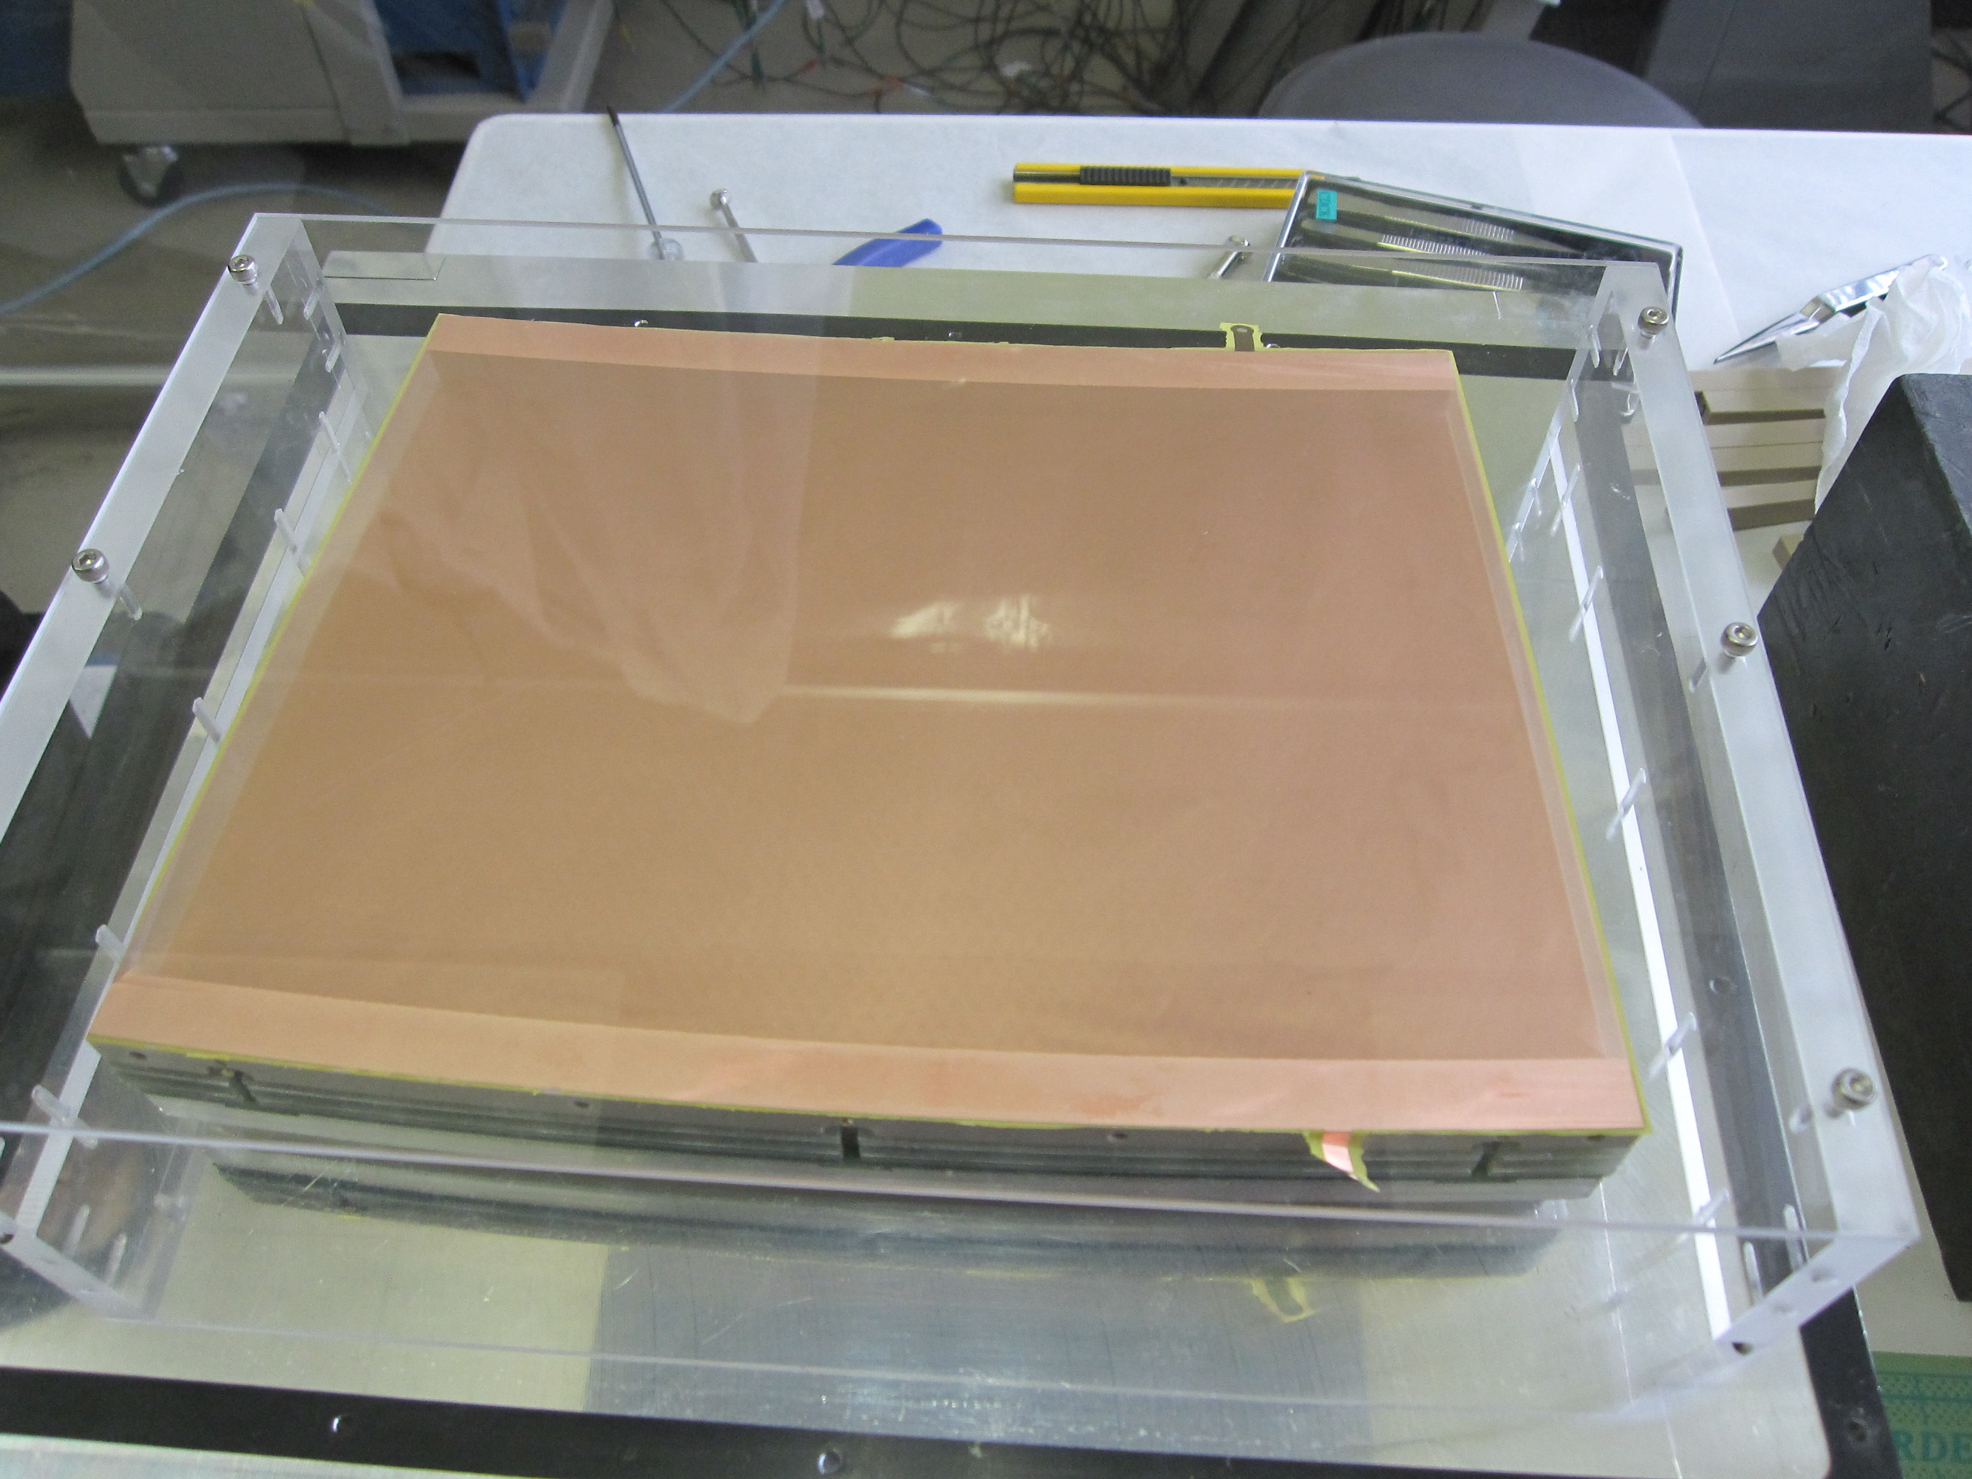
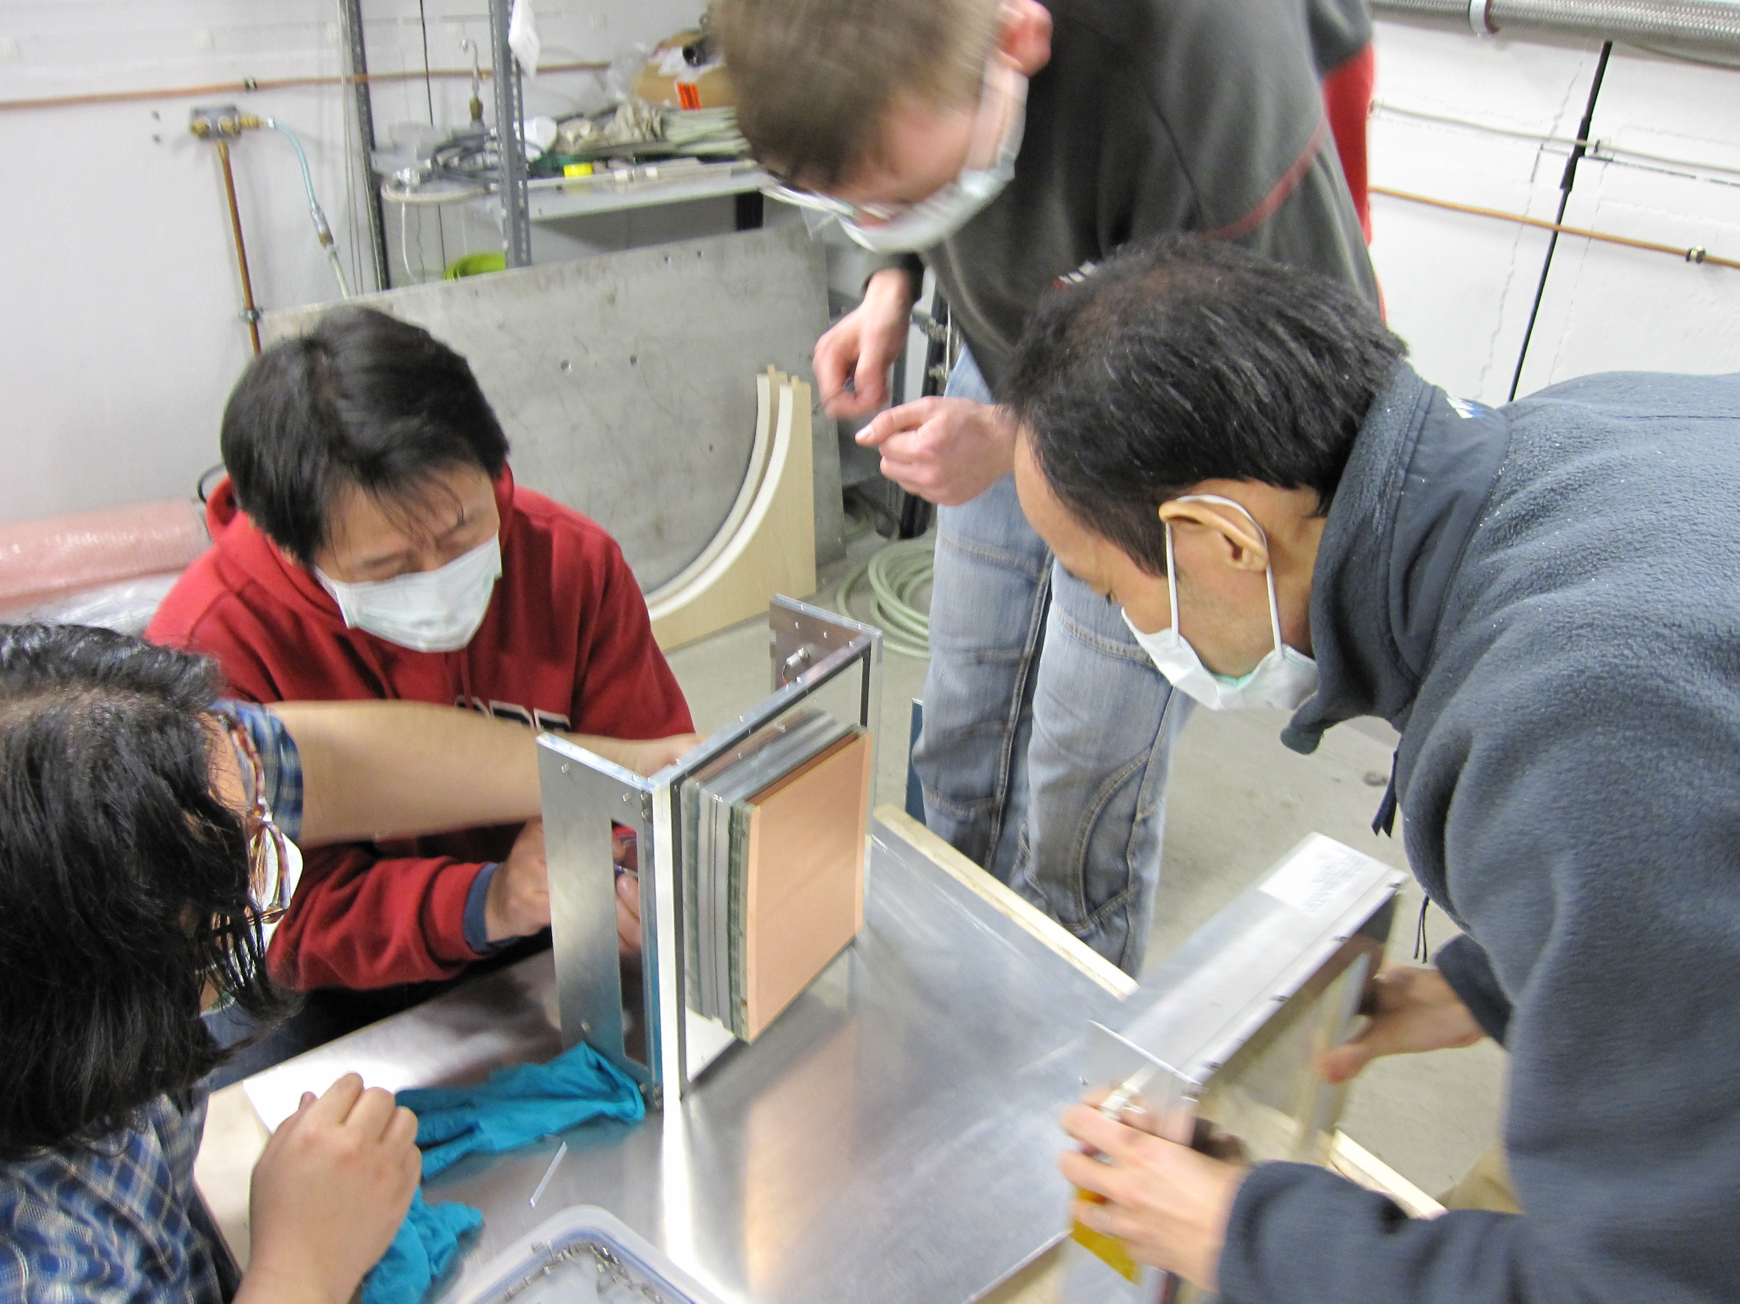
Presently the readout electronics is in Lund for maintenance and for implementation of some improvements. These will be ready and tests of the electronics together with the data acquisition system will be performed before the system is moved to DESY. Lund will be responsible for setting up the readout system at DESY and test it in the preparation phase , and for the operation during the measurement phase . The people who will be involved in the measurement from Lund are Leif Jönsson (project leader), Anders Oskarsson, Ulf Mjörnmark, Björn Lundberg, Lennart Österman and Martin Ljunggren. To ensure effective operation of the GEM modules during the measurement phase we would like to involve also the experts from the Asian group. Their participation is considered as crucial for the success of the test beam campaign.

We apply for financial support to Leif Jönsson for the time period 10.9- 24.9, to Björn Lundberg 10.9 – 17.9, to Ulf Mjörnmark 10.9 – 24.9 and to Martin Ljunggren 10.9 – 24.9 from Lund, and to Hirotoshi Kuroiwa 10.9 – 24.9 from Japan.

Björn Lundberg is an electronics engineer who has been responsible for the design and construction of the readout board for the EUDET project.

Ulf Mjörnmark has developed the data acquisition system based on the one used in the ALICE experiment.

Martin Ljunggren is about to finish his master degree. Since the beginning of 2010 he has worked within this project to prepare the analysis of the test-beam data for his master thesis.

Hirotoshi Kuroiwa, a post doctoral research associate at Gaga Univ., Japan, is a core member of the Asian TPC group for the hard ware development of the GEM modules.

Best regards,
Leif Jönsson
Prof.

