Jacek Ciborowski
Institute of Experimental Physics 23 February, 2009
Faculty of Physics
Warsaw University
Hoża 69
00681 Warsaw
Poland

PROPOSAL

for measurements using the DESY test beam 22
16-29 March 2009

entitled:

“ Study of the Mimosa-18 pixel matrix“

Project leader: Jacek Ciborowski,
Institute of Experimental Physics,
Warsaw University, Warsaw, Poland
cib@fuw.edu.pl

Project member (applying for TA): Marek Adamus
Institute of Nuclear Studies,
Warsaw, Poland

Since over 3 years the Warsaw/Łódź Group is studying properties of pixel matrices as possible candidates for a pixel vertex detector at the ILC. At the considered future e+e- collider ILC, the beams will collide with energies up to 1 TeV. There exist several concepts of detectors which will be placed at the interaction point however each of them is planned to be equipped with a vertex detector built of pixel matrices. Such detector will record tracks of numerous particles emerging from the interaction of beam particles. The pixel matrix is needed to allow for flavour identification in the final state. Hadrons containing heavy quarks decay within μm distances from the production point. Thus separation of secondary vertices arising from decays of unstable particles is needed. This will be done with the vertex detector which will be built of several layers of pixel matrices, each matrix having a 10-20 μm pixel spacing. Such detector will allow to spatially reconstruct tracks with a μm precision and determine possible secondary verteces by means of e.g. impact parameter analysis. MAPS - Monolithic Active Pixel Sensors - are candidates for being used in building such a detector. Charged particles traversing a pixel matrix deposit charge in many pixels which taken together form a cluster. Tracks close to being perpendicular to the matrix leave round clusters, which is mostly the case with the physics tracks. However an important source of background in e+e- collisions is beamstrahlung - an electromagnetic process in which a e+e- pair is produced as a result of the beams interactions. Our simulations have shown that beamstrahlung electron and positron tracks impact the vertex detector matrices at different (larger) angles than the tracks of particles originating from the e+e- interaction. Beamstrahlung tracks often leave elongated, not round, clusters and the degree of elongation is related to the angle of incidence.

Our activities are presently focused at investigations regarding cluster shapes corresponding to particles traversing the matrix at various angles. In October 2008 we studied cluster shapes using the Mimosa-5 matrix at the test beam at DESY (1-6 GeV) and partially using the Mimosa-18 matrix. Both were produced by the IReS, Strasbourg, the former had 17 μm pixel spacing while the latter had 10 μm pixel spacing. In December 2008 we studied cluster shapes using the Mimosa-18 matrix at a test beam in the Frascati Laboratory (300 and 750 MeV). The reason for the low energy scan was to obtain results for energy values falling into the actual energy range of the beamstrahlung pairs. The measured dependence of the cluster elongation for the Mimosa-18 matrix, as function of the incidence angle is shown in the Fig.1 (preliminary results):
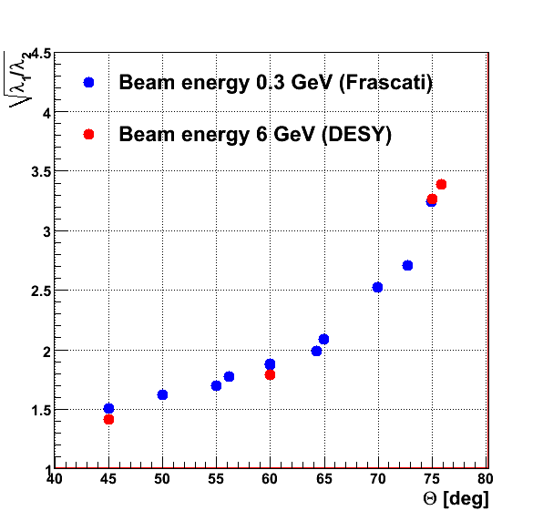

Fig.1. Measured relative cluster elongation vs. the angle of incidence for Mimosa-18 pixel matrix (preliminary results).

At Frascati we measured the Mimosa-18 matrix without the trigger and without the tracking telescope.

During the presently proposed data taking period, 16-29 March 2009, we intend to do the following:

- perform measurements of the Mimosa-18 matrix with the trigger and tracking telescope using the setup shown in Fig.2.
- complete the measurements of the Mimosa-18 for a range of incident beam energies (mainly 1 GeV) and orientation angles
- study of the effect of temperature on reconstruction of clusters (magnitude of the background and its influence on the reconstructed parameters – in particular accuracy of the angle reconstruction)
- study of the influence of the clock frequency on the readout quality

The experimental setup consists of the studied matrix and the beam microstrip telescope. The latter allows to determine the beam track parameters as well as correlate the interpolated hit position at the matrix with the recorded cluster position. For the purpose of variable orientation of the pixel matrix w.r.t. the test beam, we are using a dedicated mechanical support which we have built. It allows to set two angles to approximately desired values while the precise determination of the orientation is done if the trigger telescope information is used. Fig. 2 shows the experimental setup which we are using.

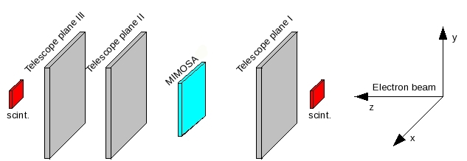

Fig.2. Experimental setup.

The reasons for choosing the DESY test beam 22 are the following: (i) appropriate beam energies and intensities (ii) the beam telescope is in place; (iii) existing and known infrastructure for data taking (incl. cooling device as well as mechanical support); (iv) software for data acquisition and backup disks are in place; (v) we are familiar and experienced with the general DESY infrastructure.

We are asking for two weeks of the Beam 22 at DESY, 16-29 March 2009.

The members of the Warsaw/Łódź Group are: M. Adamus, J. Ciborowski, G. Grzelak, P. Łużniak, Ł. Mączewski, P. Nieżurawski and A.F. Żarnecki.

The tests will be performed by: M. Adamus, Ł. Mączewski and J. Ciborowski.

We apply for the TA financing of the visit of 2 persons:

- M. Adamus in the period 15-30 March, 2009 - 16 days.
- J. Ciborowski in the period 19-25 March , 2009 – 7 days.

