Jacek Ciborowski DESY, 11 Sept. 2008
Department of Physics
Warsaw University
Hoza 69
00681 Warsaw

PROPOSAL

for measurements using the DESY test beam 22
1-14 October 2008

Since over 3 years the Warsaw/Lodz Group is studying properties of pixel matrices as possible candidates for a pixel vertex detector at the ILC. At the considered future e+e- collider ILC, the beams will collide with energies up to 1 TeV. There exist several concepts of detectors which will be placed at the interaction point however each of them is planned to be equipped with a vertex detector built of pixel matrices. Such detector will record tracks of numerous particles emerging from the interaction of beam particles. The pixel matrix is needed to allow for flavour identification in the final state. Hadrons containing heavy quarks decay within μm distances from the production point. Thus separation of secondary vertices arising from decays of unstable particles is needed. This will be done with the vertex detector which will be built of several layers of pixel matrices (4-5), each matrix having a 10-20 μm pixel spacing. Such detector will allow to spatially reconstruct tracks with a μm precision and determine possible secondary verteces by means of e.g. impact parameter analysis. MAPS - Monolithic Active Pixel Sensors - are candidates for being used in building such a detector. Charged particles traversing a pixel matrix deposit charge in many pixels which taken together form a cluster. Tracks close to being perpendicular to the matrix leave round clusters, which is mostly the case with the physics tracks. However an important source of background in e+e- collisions is beamstrahlung - an electromagnetic process in which a e+e- pair is produced as a result of the beams interactions. Our simulations have shown that beamstrahlung electron and positron tracks impact the vertex detector matrices at different (larger) angles than the tracks of particles originating from the e+e- interaction. Beamstrahlung tracks often leave elongated, not round, clusters and the degree of elongation is related to the angle of incidence. Our activities are presently focused at investigations regarding cluster shapes corresponding to particles traversing the matrix at various angles in view of feasibility to reject beamstrahlung tracks at the stage of data taking. First such measurements were done by us in October 2007 and the preliminary results were presented at the ALCPG Conference in Fermilab in 2007. In short, the bigger the angle of incidence, the larger is the cluster elongation. The matrix studied was the Mimosa-5, delivered by the IReS, Strasbourg (17 μm pixel spacing). The measured dependence of the cluster elongation as function of the incidence angle is shown in the Fig.1.

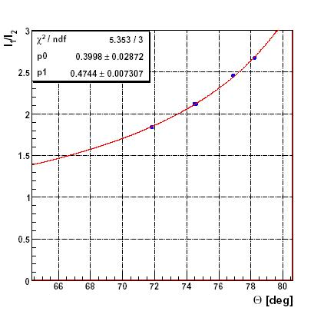
Fig.1. Measured relative cluster elongation vs. the angle of incidence - round points.

The experimental setup consists of the studied matrix and the beam microstrip telescope. The latter allows to determine the beam track parameters as well as correlate the interpolated hit position at the matrix with the recorded cluster position. For the purpose of variable orientation of the pixel matrix w.r.t. the test beam, we have built a dedicated mechanical support. It allows to set two angles to approximately desired values while the precise determination of the orientation is done offline using telescope information. Fig. 2 shows the experimental setup which we are using.

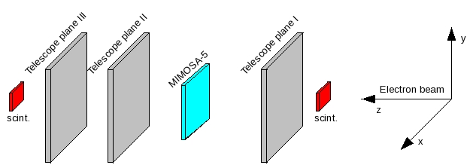

Fig.2. Experimental setup.

During the presently proposed data taking period, 1-14 October 2008, we intend to do the following:

(i) complete the measurements of the Mimosa-5 (17 μm pixel spacing) for a range of incident angles at E=6 GeV, in particular study the transition region from round to elongated clusters
(ii) check selected measurements at E<6 GeV to assess the influence of the multiple Coulomb scattering
(iii) perform similar measurements using the Mimosa-18 matrix with 10 μm pixel spacing

The reasons for choosing the DESY test beam 22 are the following: (i) appropriate beam energies and intensities (ii) the beam telescope (ZEUS MVD telescope) is in place; (iii) existing and known infrastructure for data taking (incl. cooling and mechanical support); (iv) software for data acquisition and backup disks are in place; (v) we are familiar and experienced with the general DESY infrastructure.

We are asking for two weeks of the Beam 22 at DESY, 1-14 October 2008 (with extension for the third week if needed and if possible).

The members of the Warsaw/Lodz Group are: M. Adamus, J. Ciborowski, G. Grzelak, P. Luzniak, L. Maczewski, P. Niezurawski and A.F. Zarnecki.

The tests will be performed by: M. Adamus and L. Maczewski.

We apply for the TA financing of the visit of 1 person, M. Adamus in the period 1 - 22 October, 2008, i.e. 14 days of data taking and 7 days of preliminary data analysis.

