Micromegas resistive anode test at 1T magnetic field

D. Attié^{,a}, I. Giomatarisª, M. Riallotª
M. Chefdeville^{b}, J. Timmermans^{b}
ª (CEA/Irfu, Saclay, France)
^{b} (NIKHEF, Amsterdam, Nederland)
Project Leader: D. Attie

December 01, 2008

Abstract

Micromegas technology could be one of the possible choices for the next Linear Collider. To achieve the 100 μm spatial resolution we proposed to test and characterize a Micromegas at the 6GeV electron DESY test beam.

.

- Introduction
The recently developed Micro-Pattern Gas Detectors (MPGD), such as the Micromegas [1] and the GEM [2], have many advantages for the TPC readout (less mass, naturally ion backflow suppression, negligible ExB and track angle effects). A way to achieve a spatial resolution better than 100 microns, as required for the ILC-TPC, is to use a resistive layer above the standard pad in order to spread the charge over several pads. We need to associate this resistive anode with a Micromegas amplification system and a magnetic field to reduce the transversal diffusion.
- Resistive anode
  - Technique and history
The new MPGD readout technique of charge dispersion enables us to use wide pads again and to still achieve good resolution. The principle of charge dispersion and its application to the MPGD-TPC readout has been described in [3].
The charge dispersion Micromegas-TPC readout concept has been previously demonstrated in cosmic ray tests with 5T magnetic field at DESY [4] using a detector of 126 pads of 2 mm x 6 mm each. The readout structure comprised a 1 MΩ/□ surface resistivity Cermet (Al–Si alloy) coated 25 μm Mylar film laminated to the readout plane with a 50 μm thick insulating adhesive. The maximum TPC drift length was 15.7 cm.
  - Description
We built a 23x17 cm² panel which consist in a 24 x 72 matrix of 1726 pads (about 3.2x7 mm² each) shown in Figure 1. This panel uses the T2K electronics [] and fits to the Large Prototype TPC.

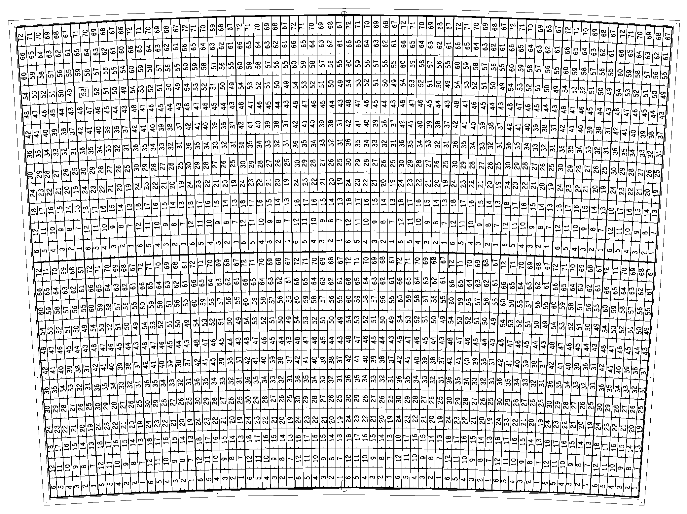 | 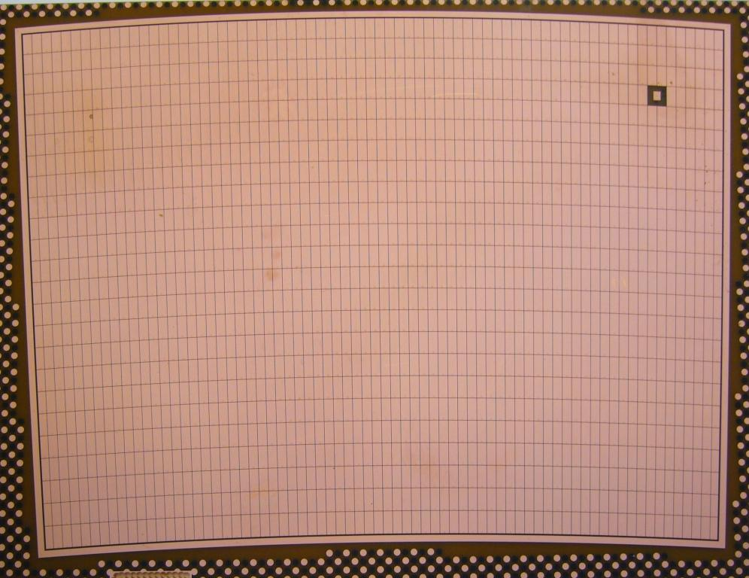
Fig. 1 – Panel Micromegas
- Request
We request a week of beam (09.12.2008- 14.12.2008) data taking for several shaping time (100 ns, 200 ns, 500 ns, 1 μs and 2 μs), for several drift distance (up to 50 cm) and at several frequency (from 25 to 100 MHz). We would like to use the DESY test beam as the MIP equivalent signals from the 6GeV electron beam is the perfect tool for these measurements. No financial support is requested.

References

[1] Y. Giomataris, Ph. Rebourgeard, J.P. Robert and G. Charpak, Nucl. Instr. Meth. A376(1996)29-35.

[2] F. Sauli, Nucl. Instr. and Meth. A 386(1997)531.

[3] M.S. Dixit and A. Rankin, Nucl. Instr. Meth. A566(2006)281.

[4] M.S. Dixit et al, Nucl. Instr. Meth. A581(2007)254.

david.attie@cea.fr

