Date: January 2006
Author: Tobias Haas

EUDET Pixel Telescope
Requirements Document,

General:
This device is planned and built within the EU Integrated Infrastructure Initiative EUDET. It is planned as a general user facility and as such should be flexible and easy to use. It will initially be used at the DESY 6 GeV electron beam line. But it should be movable so that it can be used at higher energy hadron beam lines.

Layout:
Figure 1 gives the overall layout of the different ingredients inside the DESY 6 GeV electron beam line.
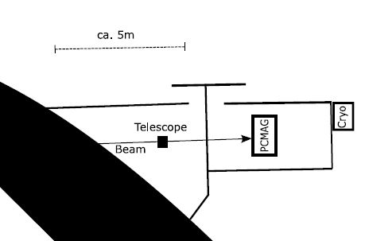
Figure 1: Overall arrangement of the EUDET components in the DESY 6 GeV electron beam line

The two major infrastructure components, the pixel telescope and the superconducting 1.2 T magnet (PCMAG), are installed in separately interlockable experimental areas. The cryo infrastructure of the magnet is installed outside the experimental areas and accessible at any time.

A very compact configuration of the telescope is foreseen initially. This means 6 telescope planes plus one plane for a “device under test” (DUT). The overall length of the entire device will be smaller than 400 mm. (Waiting for the figure to be done by Adam Zuber)

Coordinate System:
The coordinate system is right handed and defined as follows: The Z axis points along the electron beam, the X axis is in the horizontal plane and the Y axis points up.

Sensors:
The telescope planes will be equipped with MAPS sensors to be supplied by CNRS/IRES Strasbourg. It is foreseen to use a successor of MIMOSA 9, the MIMOSTAR3 chip. This chip has the following characteristics:
- 15 x 7.5 mm² area,
- 512 x 256 pixels,
- 30 x 30 µm² pixel pitch,
- Thinned to 110 µm.
- Good performance at room temperature.
In addition, the DUT plane may contain a wide variety of different sensor types.

Sensor Mounting:
The telescope sensors will be mounted on 50 x 70 mm² PCBs, the sensor boards, with a precision of better than 100µm.

Mechanical Mounting and Precision:
The sensor boards need to be mounted on support structures with a precision better than 100 µm along the X and Y axes. The individual telescope planes should be movable along the Z axis the positioning being done by hand. The actual Z position should be measurable with a micrometer screw. The DUT plane should provide remote actuated transverse positioning both along the X and the Y axis with a travel of ±50 mm and a precision better than 2 µm.

Environment Requirements:
The entire telescope volume should be dark and temperature controlled. The volume should also be constantly flushing with a gentle flow of dry nitrogen gas. The temperature should adjustable and held constant with ΔT ≤ 0.5 º within an a range of -20º ≤ T ≤ 20º. The only parts of the electronics that need to be housed inside the controlled volume are the sensor boards. The entire telescope should also be fully operational inside the PCMAG solenoid.

Electrical Considerations:
The electrical load inside the controlled volume is smaller than 4 W per plane, or 28 W for 6 telescope and 1 DUT plane. In addition to the sensor boards there are also 50 x 50 mm² auxiliary boards, one per plane. They are connected to the sensor boards with flat cables. The auxiliary board need not be housed inside the controlled volume, but the length of the flat cable connection should not be more than 40 cm. From the auxiliary boards there are flat cable connections to the readout crate which should be no longer than 40 m.

