Summary of Meetings with Yasuhiro Makida at DESY, 24 March 2006

Present:
Ingrid Gregor
Tobias Haas
Katsumasa Ikematsu
Ute Krell
Yasuhiro Makida
Norbert Meyners
Carsten Muhl

Ordering of Components to be used at KEK:
The number of components to order that are used at KEK is reduced from the previous estimate. The remaining ones are
- Breaker and bus cabling inside the power source rack
- Signal wires and wiring terminals
- 1 equipment controller (A standard laptop can be used)
It was decided that for items 1 and 2 Yasuhiro sends a copy of his order to DESY and DESY will the issue the order with delivery address KEK. For the equipment controller T. Haas will order a standard DESY laptop (DELL Latitude D610, US keyboard, Win XP, Visual Basic, Office) and ship it to KEK. This will be brought back to DESY with the magnet. The remaining items for magnet operation will be ordered by DESY and delivered to DESY. These are
- LHe transfer line + Cold valve + normal valve
- Power cables between power rack and magnet
- Vacuum pump unit (200l/min, with gate valve)
- Field sensor 0 – 2 T
Yasuhiro offered a spare transfer line from NASA which could be shipped to DESY with the magnet. It has diameters of 12 mm at the magnet side and of 1/2" at the dewar side. If an adapter can be built this will save acquisition of a new transfer line.

Operation of Magnet:
The magnet can be operated while completely disconnected from the CRYO line. Refilling is required every ca. 9 days. Refilling and ramping of the magnet are expert tasks. These experts need to be trained at DESY. The existing instructions from KEK will be translated from Japanese into English by Katsumasa
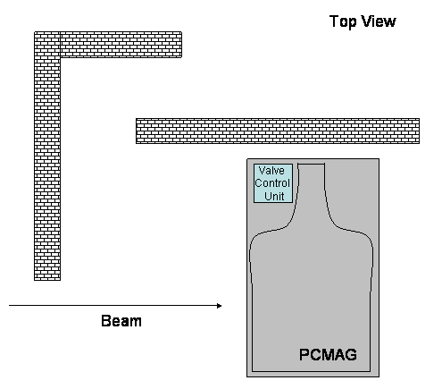
Placement of Components:
The control units for the magnet will be split over two locations:
- Valve unit to be mounted on the magnet frame as indicated in the sketch
- Power rack to be installed in the measurement hut.

