

Magnetic field tests of the QRLED driver

J. Cvach, J. Hladký¹, M. Janata¹, J. Kvasnička1,, D. Lednický1, I. Polák1, J. Zálešák1

July 28, 2026

Abstract

The QRLED driver produces short ~ 5 ns long electrical pulses for LEDs. It is foreseen as a source of the tuneable LED light for calibration of SiPMs in the EUDET analogue calorimeter module. The short electrical pulses are created in the toroidal inductance made directly on the PCB. This design results from the requirement on the minimal height of the electronic circuitry in the compact EUDET module. We measured the behaviour of the signal shape of the QRLED on variation of the magnetic field up to 4 T. The strength of the magnetic field is close to the field foreseen in the ILD detector.

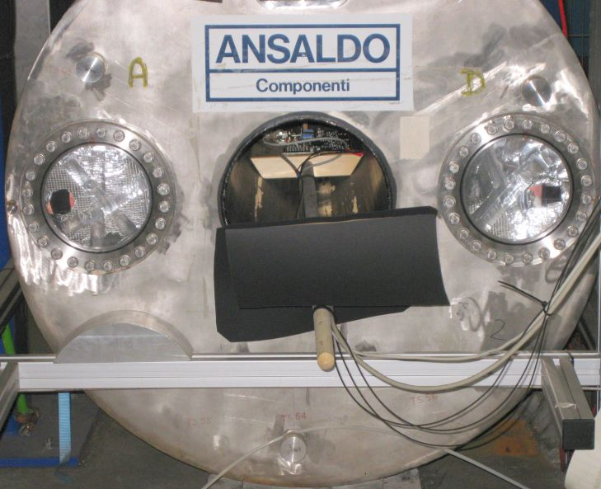

- Introduction
The concept and performance of the new 6 channel prototype of the LED driver for the SiPM calibration is described in [1]. We call it quasi-resonant (QRLED) as the pulse shape is formed by the discharge of a small toroidal inductor made by conductive loops in the PCB volume (see Fig. 1).

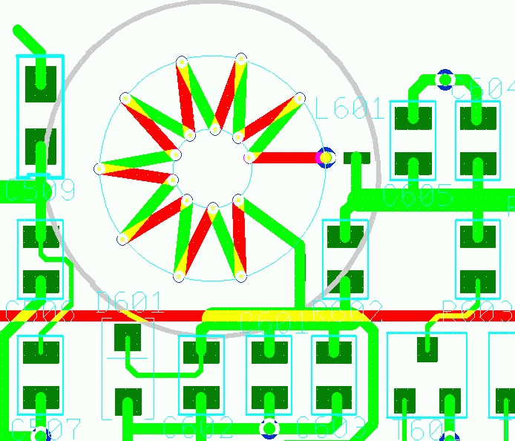

Figure 1 Detail of the inductor design on the PCB. The green (red) colour is used for conductors on the top (bottom) PCB surface.

In the ILD detector the hadron calorimeter and the calibration electronics will be placed in strong magnetic field of 4 Tesla. We decided to check the behaviour of the QRLED driver in conditions close to the real experimental situation. The FLC group at DESY has an experimental area equipped by the 5 T magnet, originally used as a compensating magnet for the ZEUS experiment having the bore diameter of 30 cm [2].
The measurement of the calibration signal behaviour in the varying magnetic field between zero and four Tesla was done at the beginning of February 2009 at DESY. In this memo we first describe the experimental setup, then the measurements done and finally arrive at the dependence of the pulse amplitude on magnetic field. Using the assumption about possible variation of the magnetic field in the real detector we estimate the change of the calibration signal in calibration runs.

- Setup for magnetic field measurements
We want to measure the stability of optical signals generated by a UV-LED (400 nm) from the QRLED driver [1] in magnetic field. The magnetic field is created in the superconductive solenoid of a barrel structure in the distance of about 4 meters from the control room. The solenoid can produce magnetic field of the strength 0 to 5 Tesla. The ramping time of the magnetic field is about 7 minutes per 1 Tesla.
We installed the QMB6 (the Quasi-resonant Main Board consists of 6 QRLED driver circuits) on a wooden paddle to have possibility to slide it in and out of the magnetic barrel (solenoid) (see Fig. 2). In the control room, there was the readout electronics with photodetectors, DAQ and power supplies. The principal scheme of the setup can be seen in Fig. 3. As we ran three LEDs of six at once, we routed three opto-fibre cables and two copper cables from the QMB6 to the control room (see Fig. 3). One of the copper cables from the QMB6 was CANbus cable (shielded 4 twisted pair) and the second one was UTP (Unshielded Twisted 4-Pair).

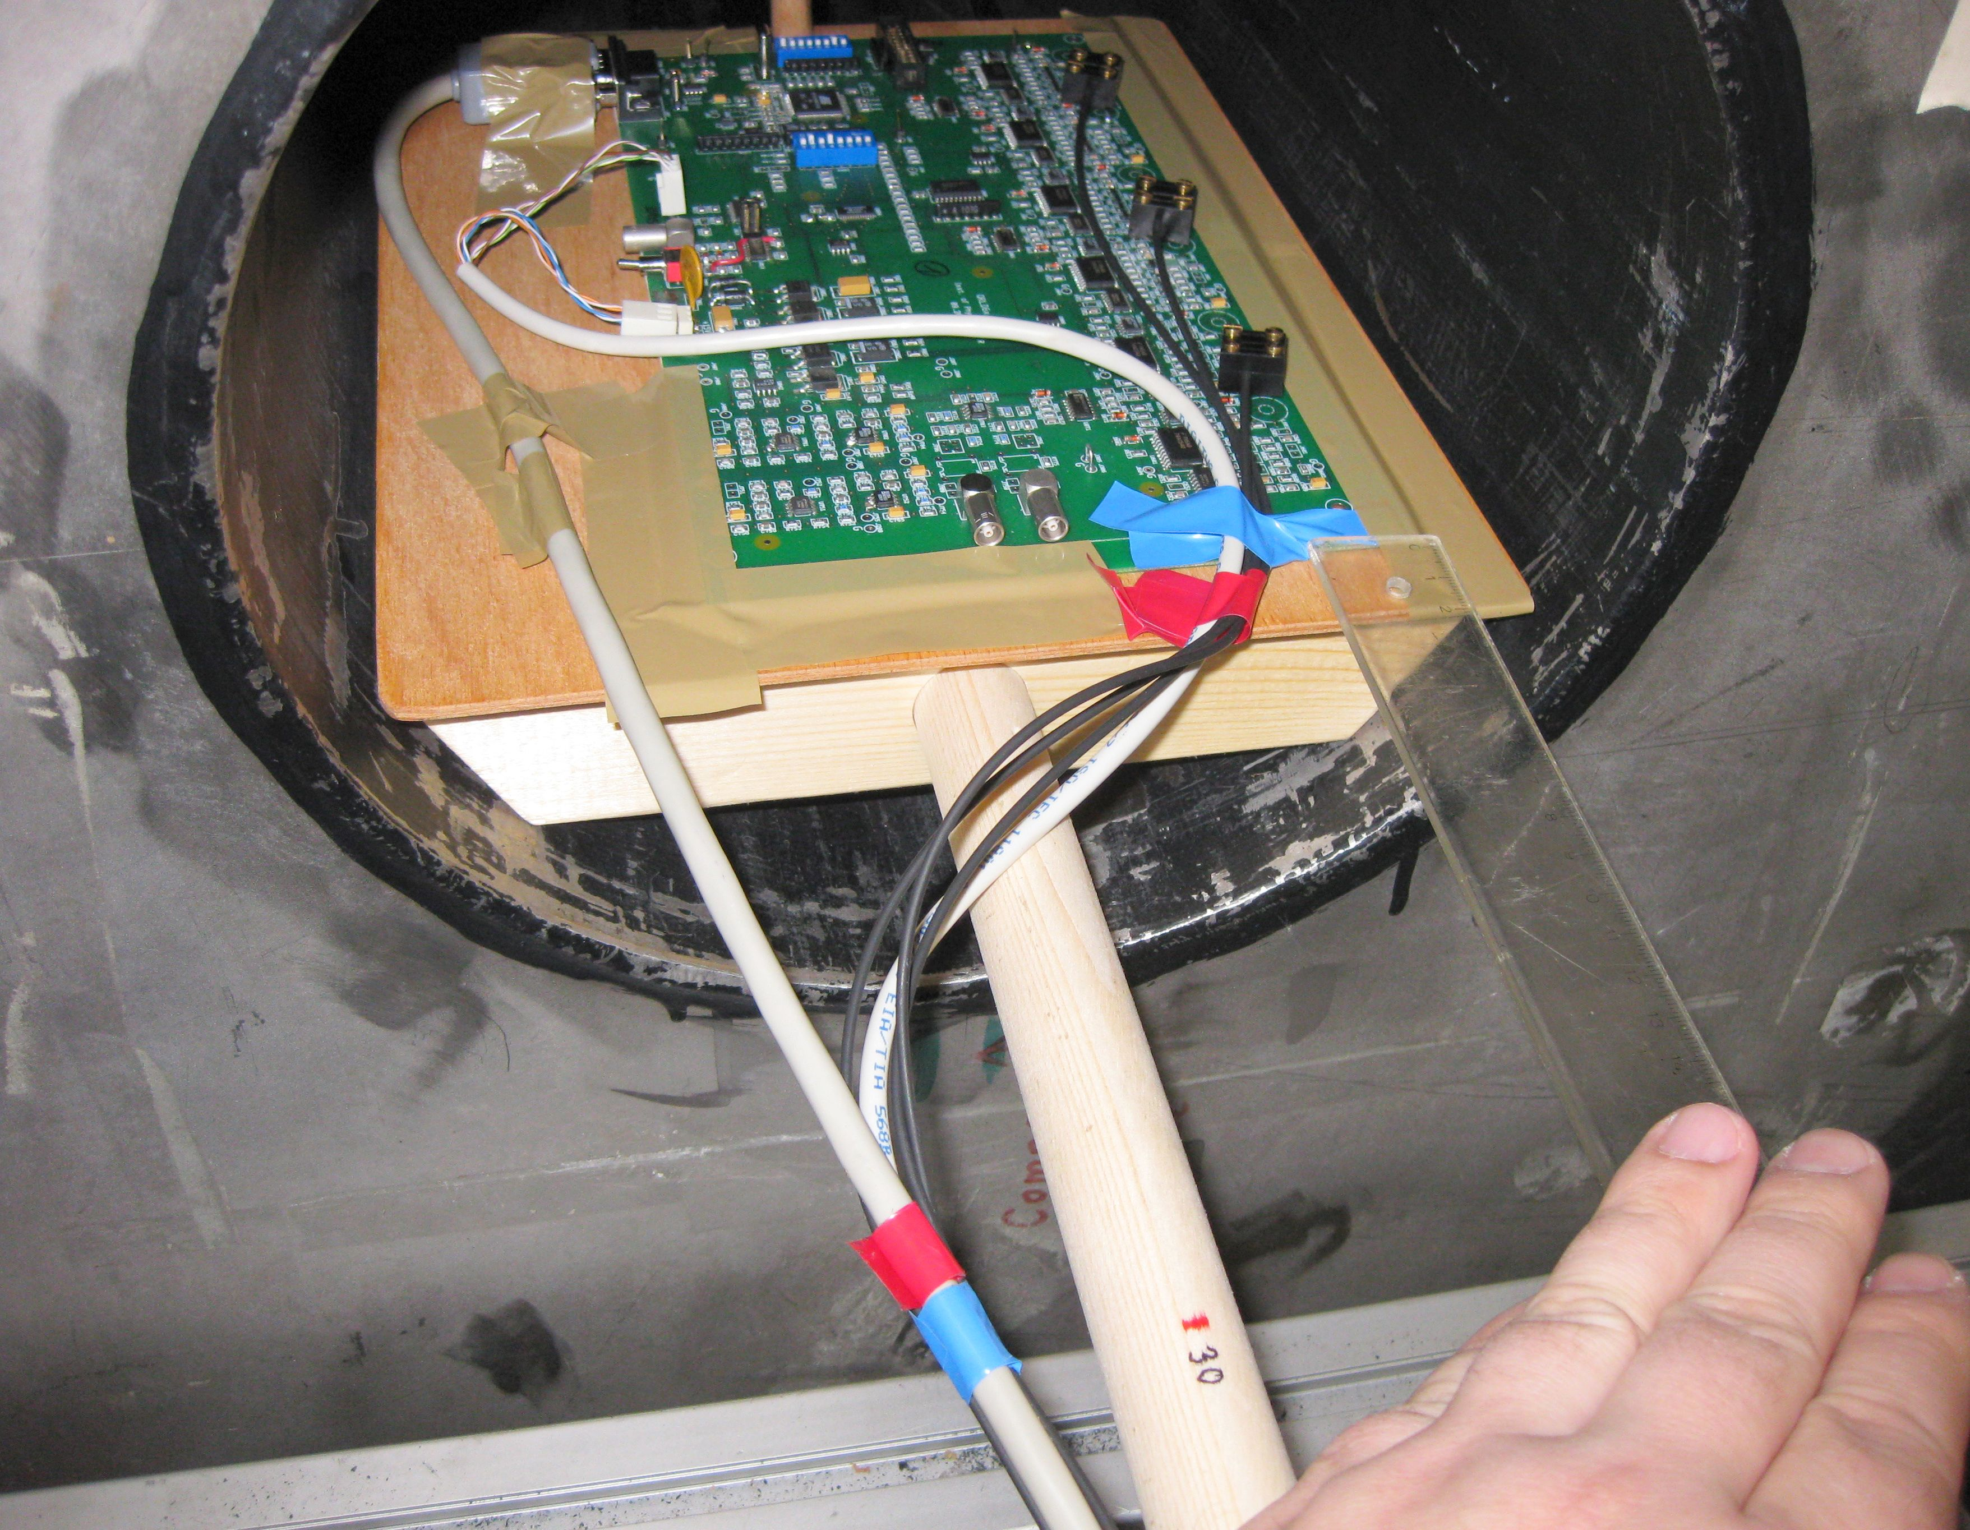

Figure 2 QMB6 on the wooden paddle in the magnet bore.
The cables were 7 meters long. The QMB6 was remotely controlled by the CANbus and it needed one power line of +15 V line (draws 0.15 A) and trigger T-calib signal at LVDS level. At both ends of the barrel a shielding made of black carton sheets was installed. This protection against an ambient light did not have significant effect on the readout signals.

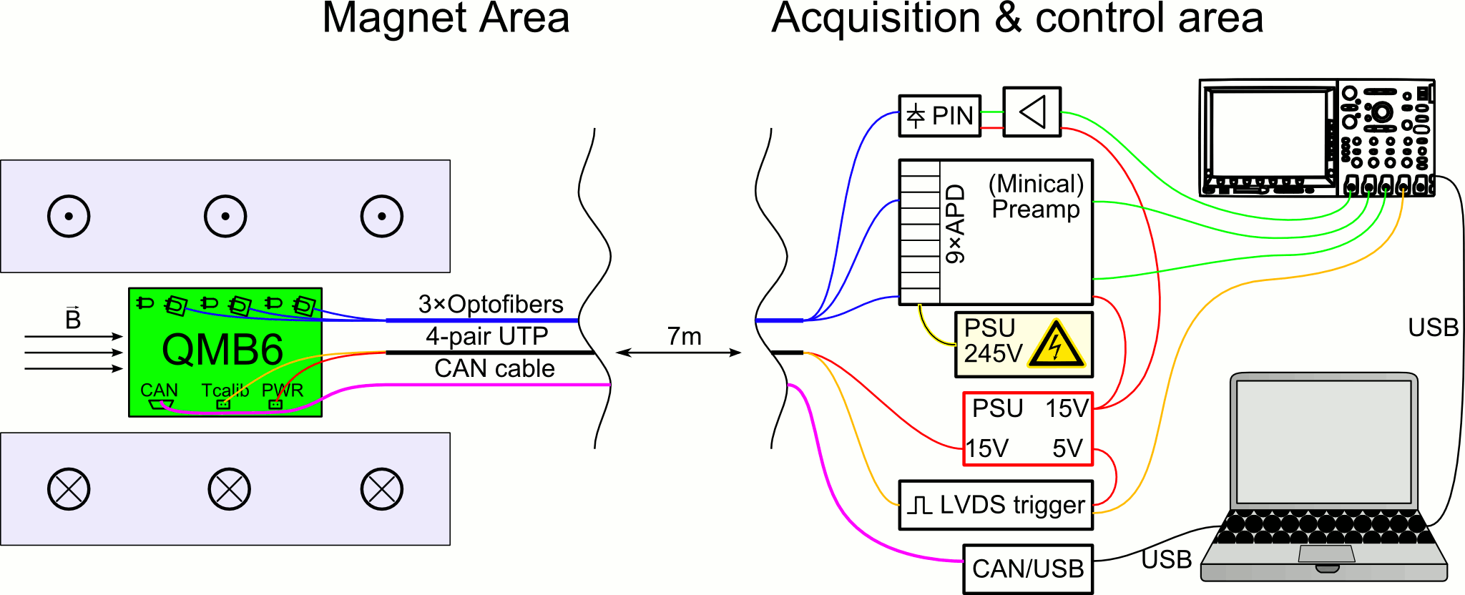

Figure 3 Principal scheme of the setup. The QMB6 with LED is marked green.
The ends of the optical fibres were connected to one PIN photodiode and two APDs (Fig. 4). The PIN photo-diode (SFH250 by Infineon) sitting at front-end of the wide-band preamplifier (made in our institute) and the APDs (S8664-55 Hamamatsu) [4], were integrated in the MiniCal preamplifier 9-channel compact piggy back unit [3]. We used also 2 temperature sensors AD590 (Analog Devices) placed close to the APDs. We ran the APDs at low gain mode (g ~ 5 at V_{bias} = 245 V) to minimize the gain temperature dependence. The PIN photo-diode served as a reference, due to its low temperature coefficient (see datasheet SFH250).

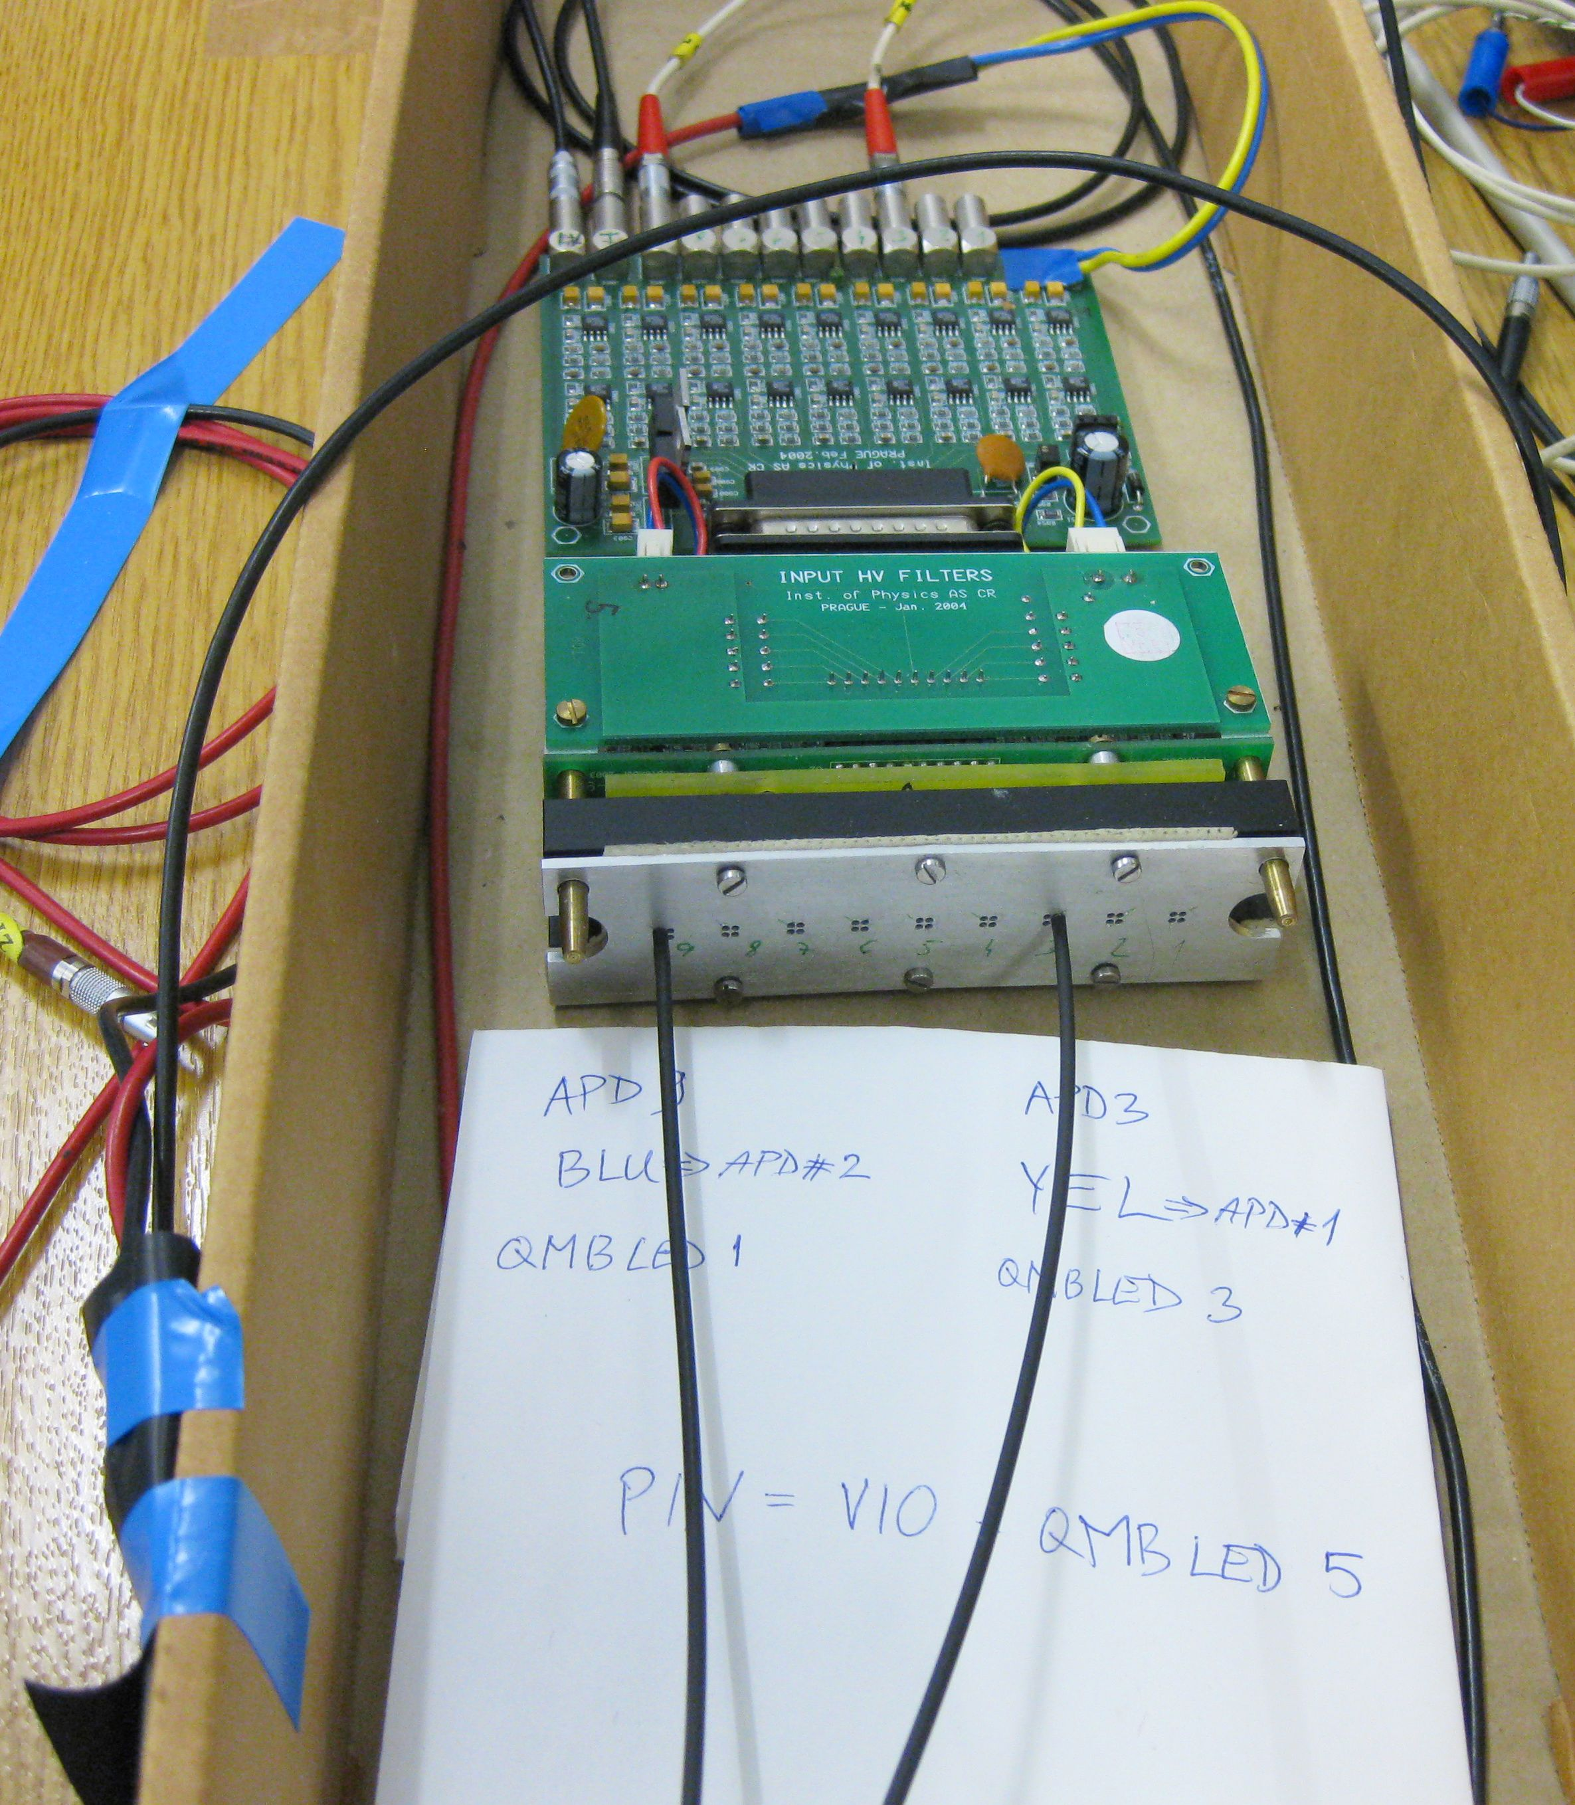

Figure 4 Two fibres connected to 9-channel APD preamplifier. The third fibre coming to the PIN photo-diode and its preamplifier is fixed by a blue tape to the carton box on the left side.
Fig. 5 shows the whole setup in the control room. One spare QMB6 can be seen on the table. The readout of our signals has been processed with a 1 GHz digital oscilloscope DPO4104. We had a possibility to check the shape of the waveform of each signal from LEDs. We found, there is no distortion of the signal with a change of magnetic field. The complete system was controlled by LabView 8.2 on a computer running Windows 2000. We employed CAN/USB convertor (Kvaser USBcan Rugged).
The T-calib signal was generated by a small board called “dummy DAQ” and consisted of the LVDS output of 400 Hz trigger pulses. This synchronisation signal was fed to the QMB6 to flash LEDs. The oscilloscope was synchronized with a sample of the T-calib signal.

- Measurements
The main task of our measurements was investigation of the stability of the QRLED driver in constant and changing magnetic fields. To achieve this goal we measured the pulse height from the photodetectors (APDs and PIN diode) as a response to the incoming light flashes induced by the QRLED driver.

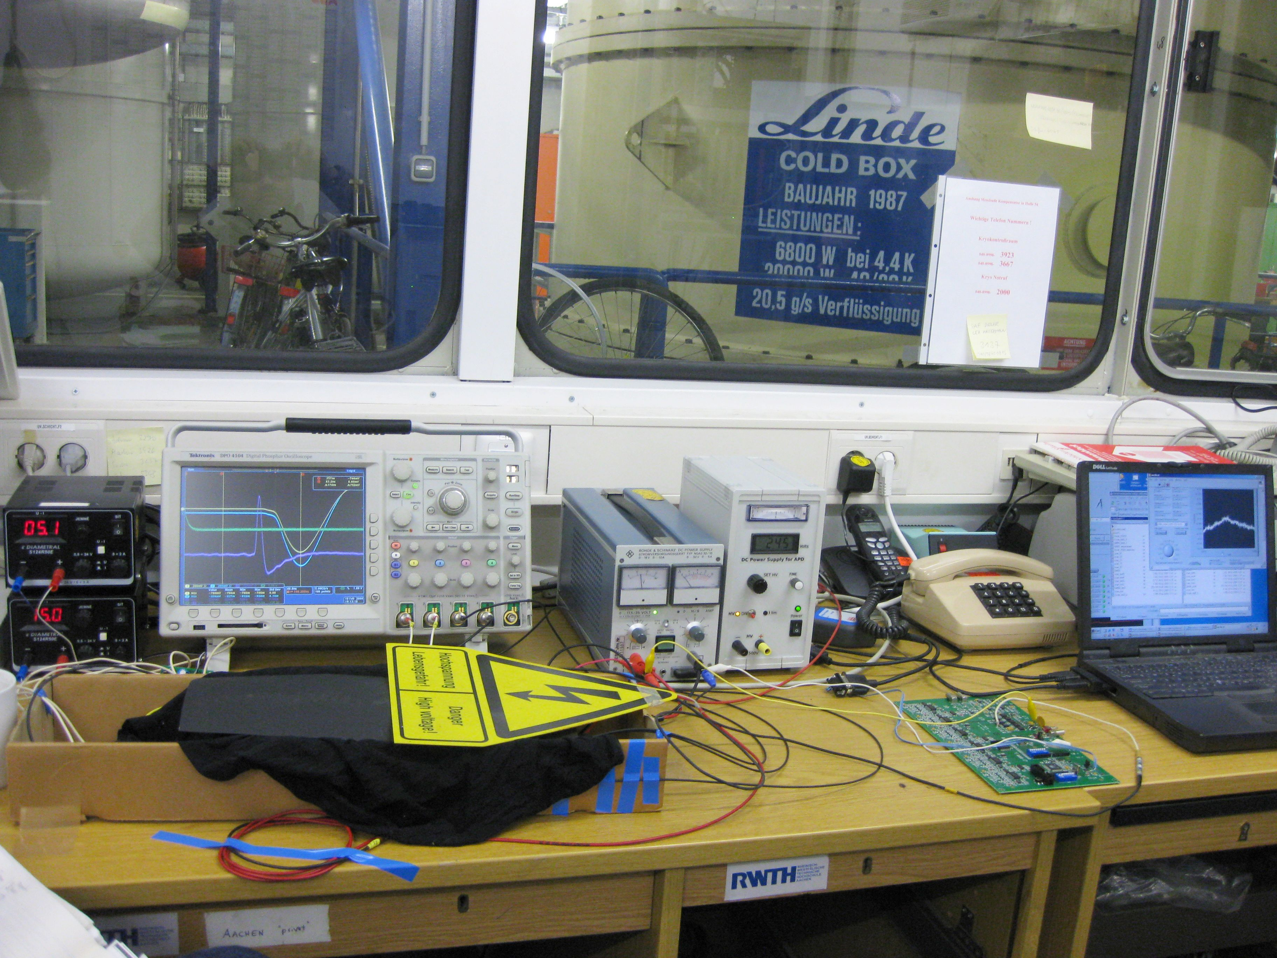

Figure 5 View to the complete acquisition containing the oscilloscope, four power supplies, a laptop, one spare QMB6 and a carton box with APDs, PIN photo-diode and preamplifiers.

  - Procedure
To generate uniform light intensities from the QRLED driver we set the control voltage V₁ of the LED amplitude to a constant value. The maximal LED light output was chosen to increase the signal to noise ratio. We did several measurements; firstly, we investigated a long-term stability of the QRLED behaviour at the maximal magnetic field of 4 T over several hours. Then we placed the QMB6 in two different positions with respect to the magnetic field lines (see Fig. 6).

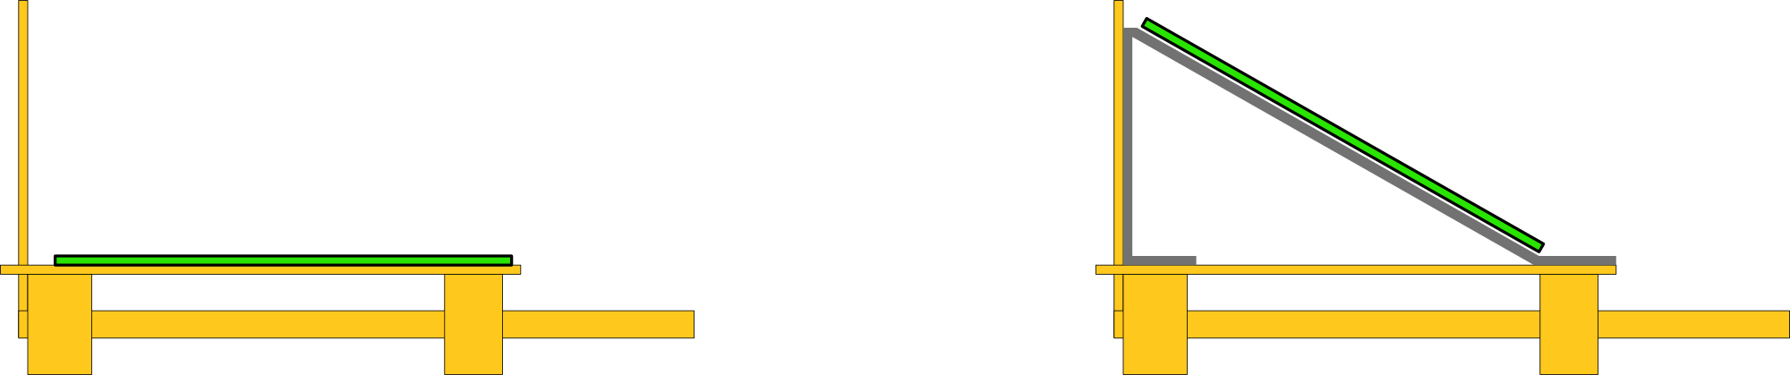

Figure 6 A side view of two test positions of the QMB6 in magnet. The wooden structure is represented by the yellow colour while the green colour is dedicated to QMB6.
We changed linearly the intensity of the magnetic field in steps by 1 T which took about 6-7 minutes. Between the steps, the data at constant magnetic field were also taken for 7 minutes to have data in both the stable and changing conditions. We were changing the field intensity from 0 T to the maximal value of 4 T and back to 0 T. One round of our measurements took almost two hours.
For final results the response of the photodetectors (mainly APDs) must be corrected for temperature changes. We heated up the photodetectors by a 60 W light bulb lamp and measured the amplitude response with increasing and decreasing temperature to determine the temperature dependence (see the subsection 3.2.2).
  - Results
The response of the photodetectors was measured by the oscilloscope as the amplitude of the voltage waveform in the automatic readout of three channels - two for the APDs and one for the PIN diode. Each measured point was taken as a statistical mean and its error over 1000 samples. The rate of the LED flashes was 400Hz.
    - Long-term stability
At first, we measured the long-term response of APDs and of the PIN diode during stable conditions overnight at the maximal value of the magnetic field 4 T. The result is shown in Fig. 7 as a dependence of the relative normalized amplitudes on time.

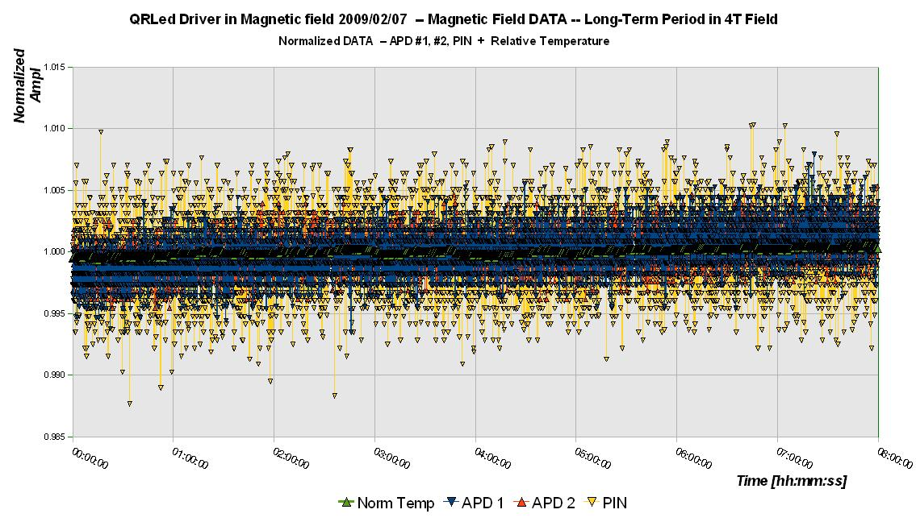Figure 7 Long-term behaviour of APDs and PIN diode in the constant magnetic field of 4 T.
The response from both APDs and PIN diode is stable over 8 hours within the statistical fluctuations. A few per-mile drift in amplitudes correspond to the temperature variation at the level of 0.1%.
    - Temperature dependence
At the beginning of our measurements when the temperature was recorded by hand, we observed rather high fluctuation of the temperature up to several degrees. To obtain more accurate data for corrections we then implemented an automatic measurement and readout of temperature from sensors.
We did a special measurement and heated up the photodetectors to have data for temperature corrections. The temperature dependence of the response amplitudes is shown in Fig. 8. From linear fit to the data we extracted the slope for each photodetector. We observed a negligible dependence of the PIN diode response on temperature as expected. On the other hand the temperature dependence of the APDs is quantified by slopes 0.5%/K and 1.0%/K for APD1 and APD2 respectively. We assume that the difference between two APDs is caused by the different distances of APDs to temperature sensors and not by APDs themselves (according to the data sheet the temperature dependence of an APD gain may vary by a factor ~1.5).

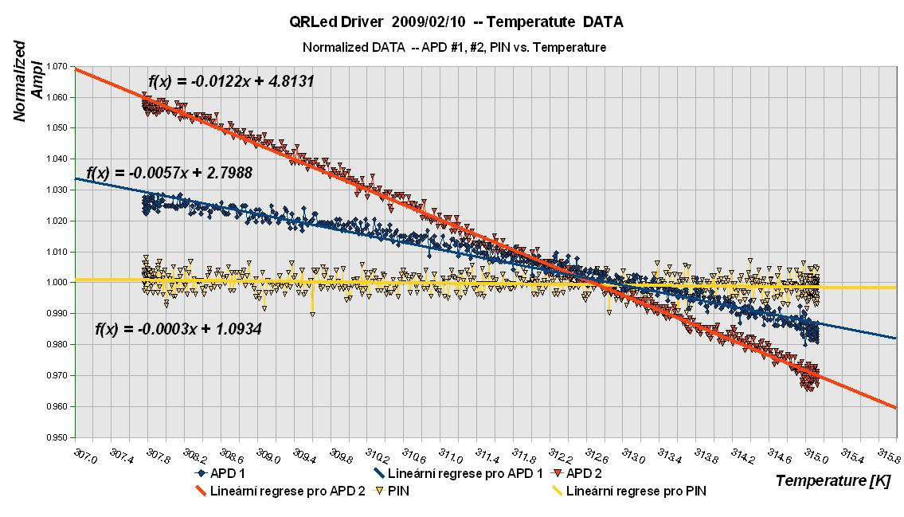

Figure 8 Temperature dependence of photo-sensors. The dependence of the normalized amplitudes on the temperature is fitted by a simple line. The lines and parameter values of the fits are displayed.

The extracted slopes from the linear fits were used to correct measured data. The effect of these corrections can be seen comparing Fig. 9 and 10.
    - Magnetic Field Scan
As it was mentioned above, we tested the QRLED driver in two different orientations between the QMB6 and magnetic field lines (see Fig. 6) to quantify the effect of the direction of the magnetic field on the response amplitude. The basic, parallel position, was also used for other measurements. In both positions we did a scan with a slow ramp up and down of the magnetic field.

Parallel position
Results from the scan with parallel oriented QRLED PCB are shown in Fig. 9 and 10. The magnetic field was ramped up or down in steps of 1 T and it was kept stable between the steps (shown as the purple polyline). The measured responses of APD1 (blue points), APD2 (red points) and PIN diode (yellow points) are displayed as averaged normalized amplitudes recorded by oscilloscope.
We can see in the Fig. 9 some discrepancy between responses of both APDs and the PIN diode. It is caused by their different temperature dependence. The temperature shown by green polyline was decreasing throughout this scan. Applying the temperature correction (see subsection 3.2.2) we get reasonable agreement in response of the APDs and PIN diode, as can be seen in Fig. 10.
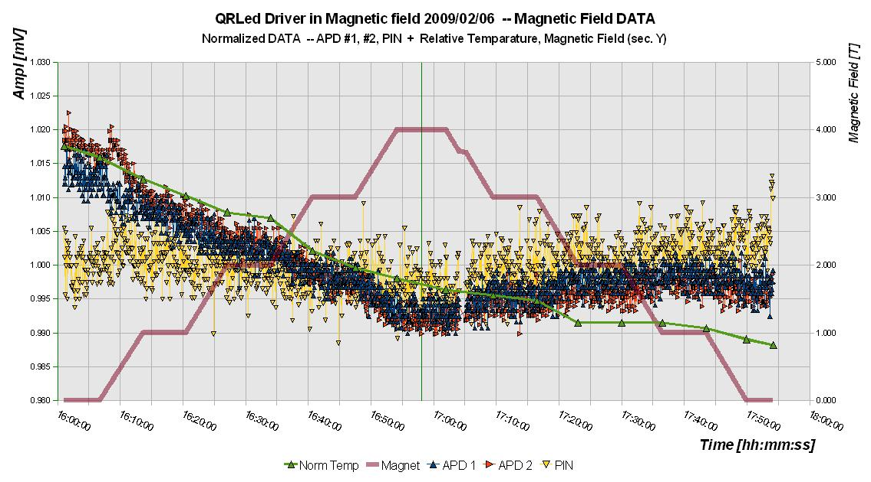

Figure 9 The magnetic field scan in the parallel orientation of the QMB6. The results are not corrected for the temperature changes.

We can conclude that the fluctuations in the measured amplitudes are about ±0.5% and are at the level of statistical fluctuations during the whole scan. A possible small decrease in the response for the highest value of the magnetic field is discussed in the next paragraph.

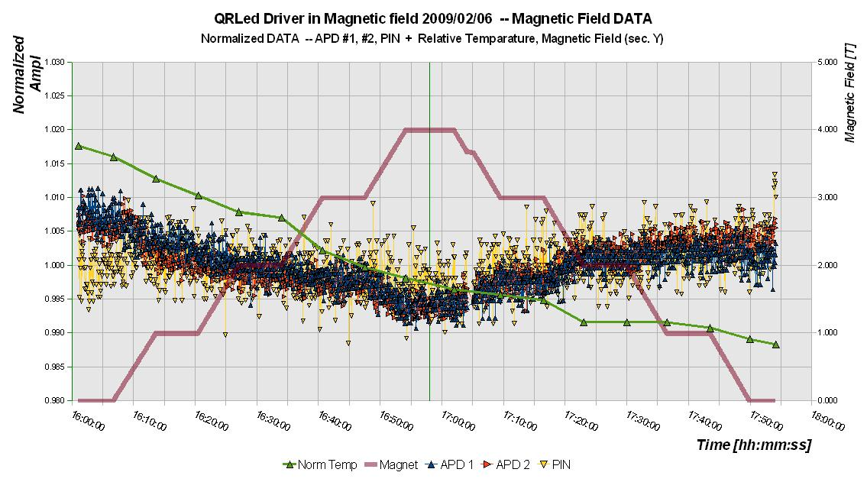
Figure 10 Magnetic field scan in the parallel orientation of the QMB6. The temperature corrections are applied to the displayed results.

Slantways position
The results for the slantways position of the QMB6 are shown in Fig. 11. The angle between the PCB plane and direction of the magnet’s force lines was about 25 degrees (it could not be set to a larger angle due to the big size of the QMB6 and a small bore of the solenoid). Similarly to the parallel case, the variations in the response (after the temperature corrections) of all photodetectors are very low, at the level of 0.6% (there is a small jump at the beginning of data taking probably due to technical problems with the magnet).
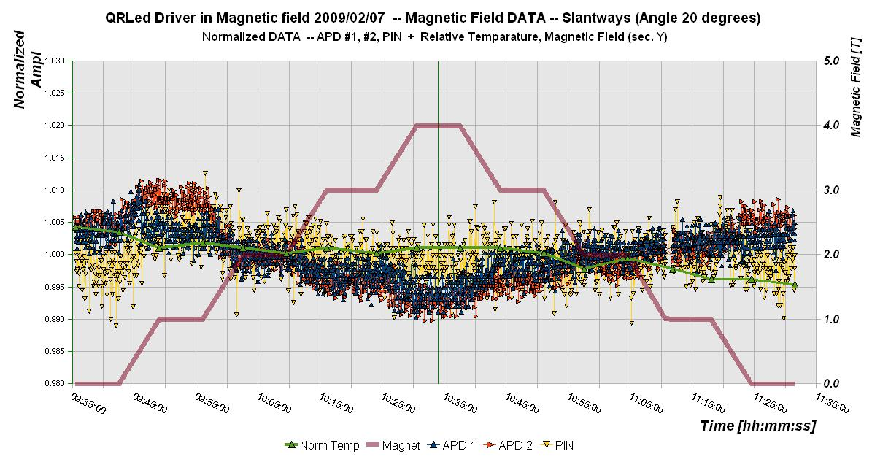
Figure 11 Magnetic field scan in the slantways position of the QMB6.

Slopes
We performed a study to quantify small changes in the responses measured during the magnetic scans being visible mainly at the highest value of the magnetic field (see Fig. 10). We omitted the periods when the field was constant and plot the response amplitudes in Fig. 12 (left), both for the field ramp up and down periods together. After applying temperature corrections the measured responses are consistent (we show amplitudes in volts for the APD2). Interpreting the graph like a uniform scan from 0 to 4 T and back we observed a linear decrease of the amplitude with the increase of magnetic field.
We made linear fits to each one Tesla range and to the dependence in the whole range from zero to four Tesla as shown in Fig. 12 (left). The slopes of linear fits are displayed in Fig. 12 (right). The values of slopes are shown in different colours for cases when the magnetic field went up and down. At the position of 4 T, the slope for the overall fit is displayed. We see that the mean slope of -2.5 mV/T is consistent within errors to all fitted slope values. It corresponds to the relative decrease of gain by 2.5 per mile for a 1 Tesla change of the magnetic field
If we make a similar fitting procedure for the second APD (not displayed in this memo) we get same relative factor 2.5 per mile per 1 Tesla. Also results from the slantways scan lead to the consistent results (values in range 2 – 3 per mile per 1 T field change).
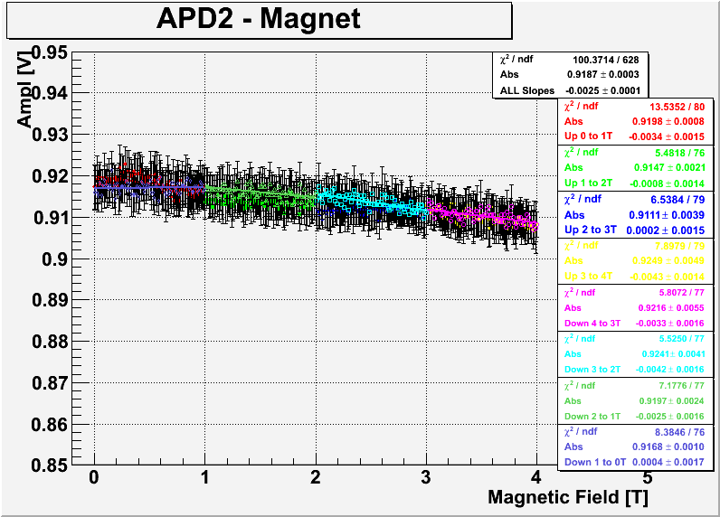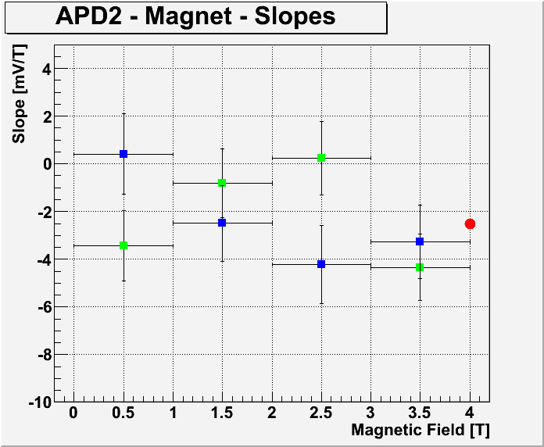

Figure 12 left: Linear fits to the magnetic scan periods.
Figure 12 right: Graph of the fitted slopes for magnetic fields periods. Green (blue) points are for periods with increasing (decreasing) magnetic field, red dot indicate the slope value of the overall fit.

- Conclusions
We performed measurements of the amplitude dependence of the QRLED driver on the intensity of the magnetic field in the range 0 – 4 T. We conclude that the relative change of the amplitude of the QRLED driver does not exceed level of -3 per mile for the 1 Tesla field change. If we assume that the relative time stability of the magnetic field of the ILD solenoid will be at the level of 5x10⁻⁴ [5] then the amplitude time stability of the calibration light is better than 2x10⁻⁶. If we take the maximal inhomogeneity of the field inside the CMS solenoid 0.3 T for the 4 T average magnetic field (7.5%), we conclude that the maximal relative change of the calibration light amplitude inside the CMS solenoid from the QRLED driver will be smaller than 3x10⁻⁴. These numbers can be compared e.g. to the relative spread of the calibration light amplitudes resulting from the optical couplings LED – optical fibre or the optical fibre – scintillator tile which at the level of 10⁻¹.

Acknowledgement
This work is supported by the Commission of the European Communities under the 6th Framework Programme “Structuring the European Research Area”, contract number RII3-026126 and by the Ministry of Education of the Czech Republic under the projects LC527 and INGO-LA09042. We would like to thank to R. Diener from DESY FLC for the technical support during the measurements.

References
[1] J. Cvach et al., EUDET Report-2008-07
[2] www-flc.desy.de/tpc/projects/magnet5/magnet5field.html
[3] V.Andreev et al., NIM A 564 (2006) 144-154.
[4] http.//jp.hamamatsu.com/resources/products/ssd/s8664_series_kapd1012e04.pdf.
[5] V. Maroussov, Fit to an Analytic Form of the Measured Central CMS Magnetic Field, PhD Thesis, Purdue University 2008.

Institute of Physics of the ASCR, v.v.i., Prague, Czech Republic
Czech Technical University, Prague, Czech Republic

