

LumiCal new mechanical structure

J. Błocki, W. Daniluk, E. Kielar, J. Kotuła, A. Moszczyński, K. Oliwa,
B. Pawlik, W. Wierba, L. Zawiejski and J. Aguilar

Institute of Nuclear Physics Polish Academy of Sciences, Cracow, Poland

on behalf of the FCAL Collaboration

December 07, 2009

Abstract

Two LumiCal calorimeters will be located in very forward region of the future ILD detector at the planned International Linear Collider (ILC) on both sides of the interaction point (IP). Both LumiCal’s will be used for precisely luminosity measurement and consist of thirty tungsten plates intersected with segmented silicon sensors planes. The actual position of each silicon detector plane relative to each other has to be stable within ~10 µm and the position of the calorimeter relative to the beam line and the interaction point should be known with accuracy of a few hundred micrometers. To achieve this goal the structure of the calorimeter has to be very stiff. The aim of this paper is to describe the last changes made in mechanical structure of the LumiCal to fulfill the integration with ILD detector.
- Introduction

In the future detector for the International Linear Collider (ILC, with colliding beams of electrons and positrons e⁺e⁻) [1], the very forward region is a particularly challenging area for instrumentation. The LumiCal detector [2] is expected to give a required precision luminosity measurement and to extend calorimetric coverage of small angles of electron emission from 27.5 to 83.1 mrad. The luminosity measurement will be based on detection of Bhabha event rate and a relative precision of the integrated luminosity of 10⁻⁴ will be enable. A precise measurement of the scattering polar angles requires an ultimate precision in detector mechanical construction and metrology.

- Design overview
On both sides of the interaction point there will be one LumiCal detector. Each calorimeter is in a form of a barrel which is divided into two parts along the vertical plane .The proposed LumiCal detector will consists of 30 layers of tungsten of 1 radiation length thickness and 320 μm silicon sensors layers. The sensitive region extends from 80 mm to 195.2 mm in radius. The outer radius of calorimeter is foreseen to be 260 mm to cover the space for front end electronics, readout cables, cooling and precision positioning sensors. The mechanical inner radius is 76 mm.
The proposed design overview is presented in Fig. 1.

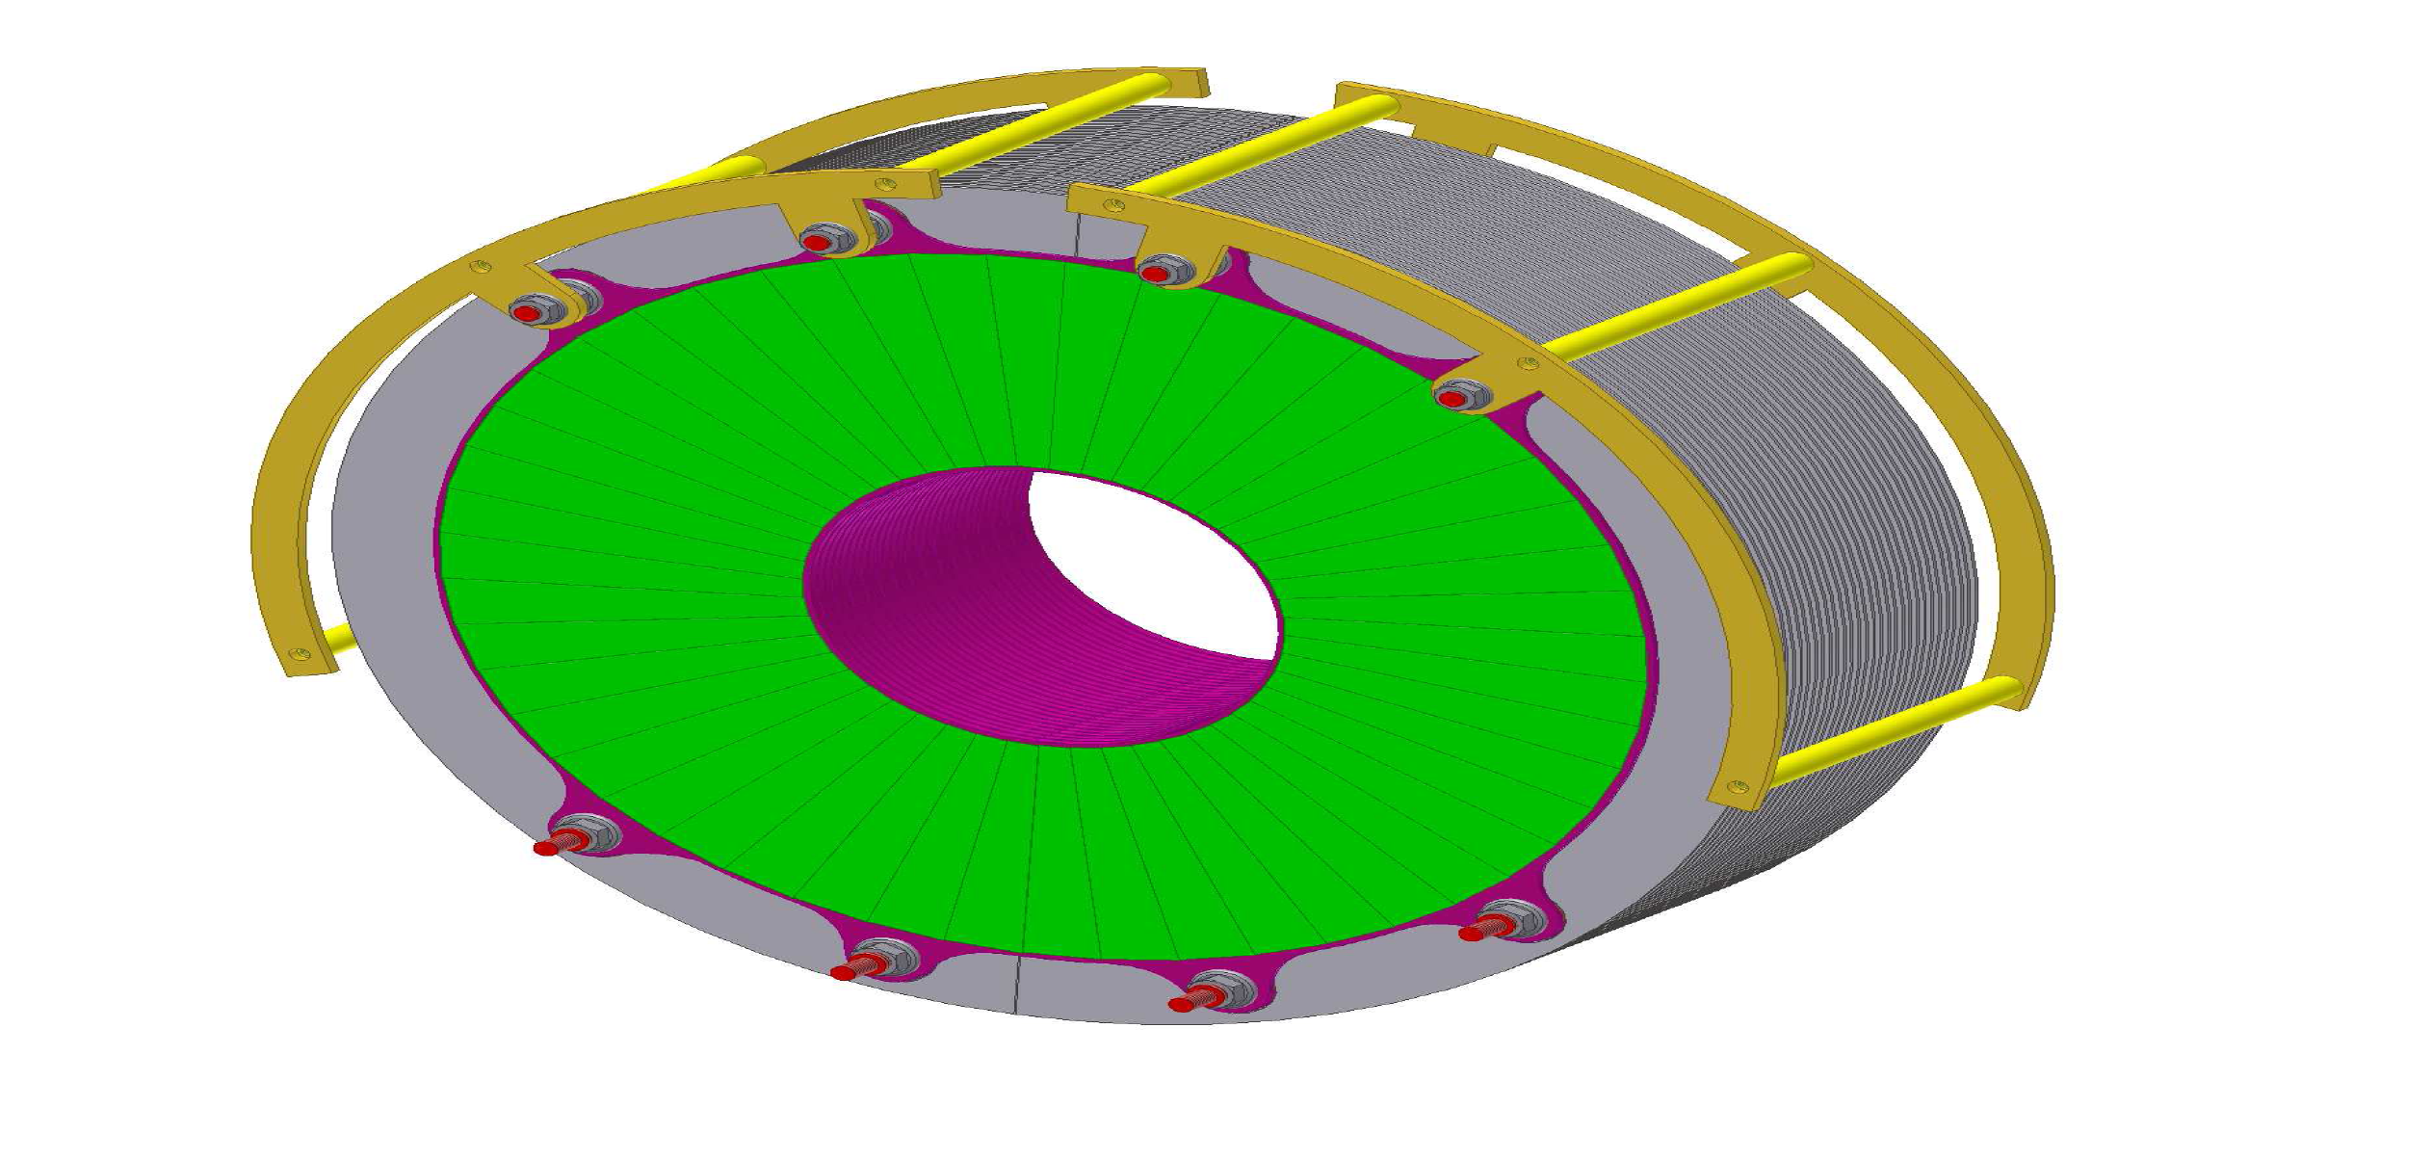

Fig. 1. LumiCal isometric view

In comparision to the mechanical structure of LumiCal described in [3] we have lowered the diameter of tungsten plates from 231,5 mm to 200 mm. This reduces the amount of heavy material in the space which is not equipped with silicon sensors.
- Tungsten plates
The tungsten plate thickness will be 3.5 mm (1 radiation length) and the shape is shown in Fig. 2.

Fig. 2. One tungsten plane with new dimensions.

The tungsten plate with silicon sensors glued on one side is presented in Fig.3.
In Fig. 4 the assembled LumiCal is shown.

Fig. 3. Tungsten plate with silicon sensors.

Fig. 4. LumiCal with some details of assembly.

The main advantage of the design is its simplicity. The structure is composed of very limited number of elements.
- Space for electronics
One LumiCal will have 92160 electronic readout channels. On one half plane it should be a place for 1536 electronic channels. We foresee a space as shown in Fig. 5.

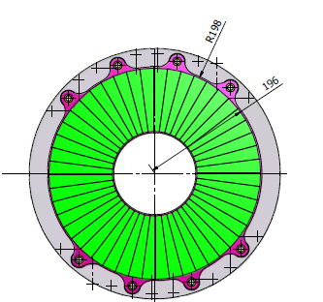
Space for front end electronics

Fig. 5. Space for front end electronics on one half plane.

The electronics will be placed on thin 2 mm aluminium plates working also as heat exchanger.
The cross section of a spaced for electronics is presented in Fig. 6.

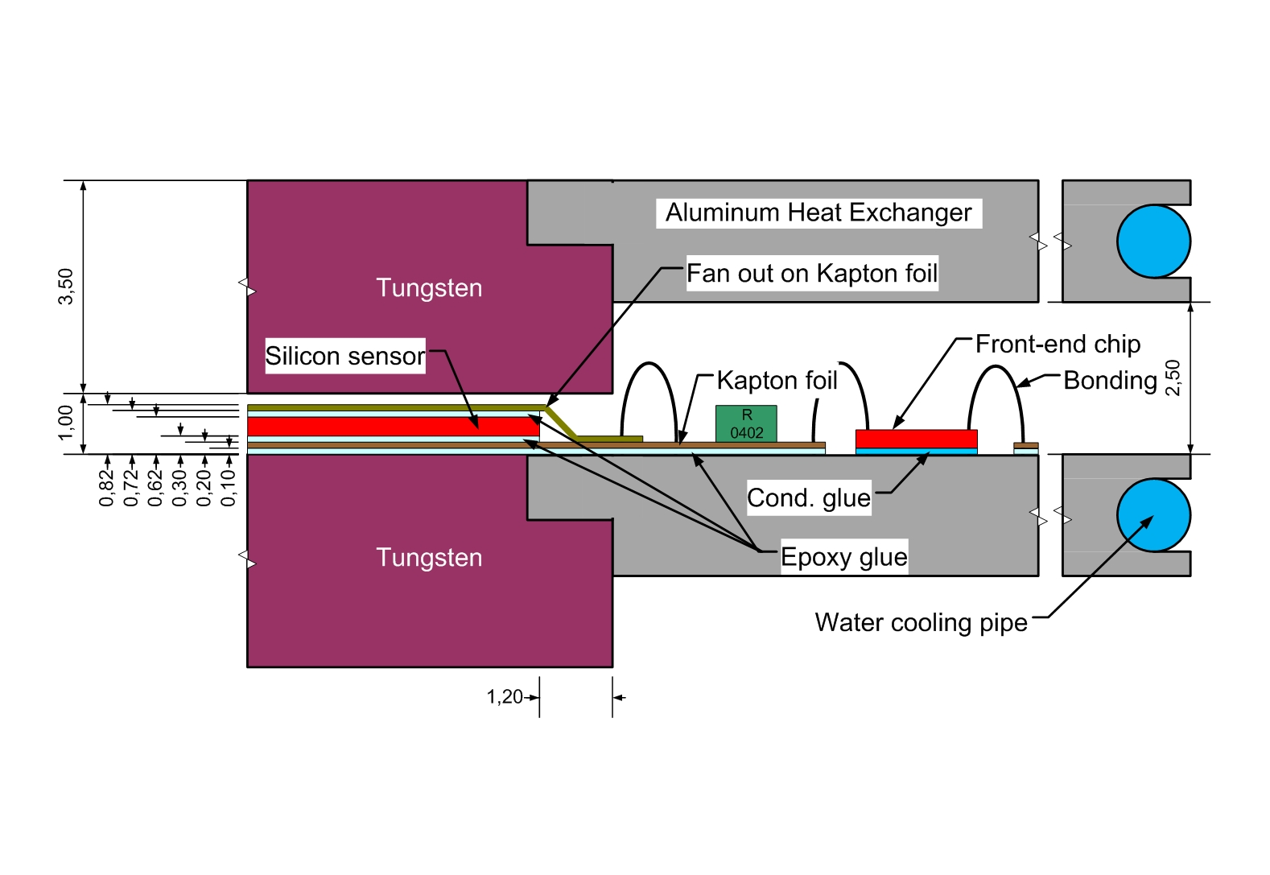

Fig. 6. Cross section showing fan out connections to the front end electronics chips.

- Conclusions
The design is quite simply, the structure is composed of very limited number of precisely manufactured elements. Reduction of ‘dead’ material in space not equipped with particle sensors will significantly increase the accuracy of ILD detector.

Acknowledgement
This work was partly supported by:
The Commission of the European Communities under the 6th Framework Programme “Structuring the European Research Area”, EUDET program: Detector R&D towards the International Linear Collider, contract number RII3-026126
and
The Polish Ministry of Science and Higher Education
under Agreement No. 141/6.PR UE/2007/7.

References
- International Linear Collider: http://wwwlinearcollider.org/cms
- TESLA Technical Design Report, DESY 2001-011, ECFA 2001-209, March 2001; H. Abramowicz et al., IEEE Transactions of Nuclear Science, 51 (2004) 2983; R&D for ILC – Detector, Instrumentation of the Very Forward Region, The Forward Calorimetry (FCAL) Group, DESY PRC R&D Report 02/01, April, 2006; Large Detector Concept, LDC outline document: http://www.ilcldc.org/documents .
- J. Błocki et al., “LumiCal mechanical design proposal and integration with ILD”,
EUDET-Memo-2008-13.

Institute of Nuclear Physics PAN, Cracow, Poland
AGH University Science and Technology and Institute of Nuclear Physics PAN, Cracow, Poland
list of members can be found: http://www-zeuthen.desy.de/ILC/fcal/

