

Test Results of the Zero Suppressed Digital Chip sensor for EUDET-JRA1 beam telescope
M. Gélin², J. Baudot¹, G. Bertolone¹, A. Brogna¹, G. Claus¹, C. Colledani¹, Y. Degerli², A. Dorokhov¹, G. Doziere¹, W. Dulinski¹, M. Goffe¹, A. Himmi¹, C. Hu¹, K. Jaaskelainen¹, F. Morel¹, F. Orsini², M. Specht¹, I. Valin¹, M. Winter¹
July 28, 2026

Abstract

The Telescope Chip (TC, alias MIMOSA-26) equips already the final version of the EUDET beam telescope. This sensor is back from foundry since February 2009 and has been characterized extensively in laboratory. Beam tests have occurred in September 2009 at CERN-SPS to qualify this chip. Here are presented the lab test results and the very preliminary test beam results.

- TC description
TC is built in AMS 0.35µm Opto process, with a pitch of 18.4µm, like IDC (alias MIMOSA-22) [1, 2]. This chip is composed of 1152 x 576 pixels which correspond to an active area of ~ 21.2x10.6 mm². Figure 1 shows a photograph of the sensor and the layout of the block-diagram. The readout of the chip is made in rolling shutter mode [3]. When a row is selected, via a sequencer, the signal induced by the charges collected is amplified in each pixel by a preamplification stage and decoupled from the column driver by a double sampling circuit based on a clamping capacitor. The 1152 pixel signals of the selected row are transmitted to the bottom of the pixel array where 1152 column-level, offset compensated discriminators ensure the analogue-to-digital conversion.

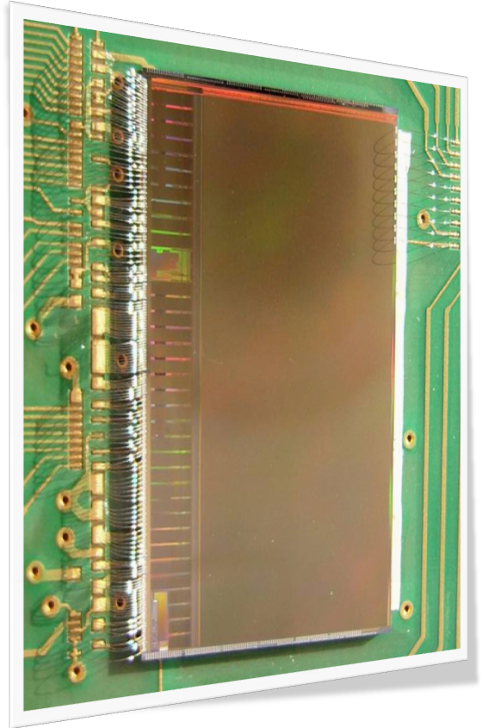

Figure 1 : On the left, a photograph of TC sensor mounted on an interface board. On the right, block-diagram of TC.

Outputs are then connected to a zero-suppression circuitry [4], organized in a pipeline mode, which scans the sparse data of the current row. This is achieved in two consecutive steps. The one closest to the discriminator outputs is split into 18 blocks of 64 columns. Inside each block, the circuitry scans the 64 columns, skipping non-hit pixels and identifying contiguous pixels having their signals above the threshold. It considers up to 6 strings per block, each string being composed of up to 4 hit pixels. In the second stage, the outputs of the 18 blocks are combined in up to 9 strings, strings overlapping two neighboring blocks being merged in a single one.
- In-lab characterization of TC
In year 2009, 34 chips have been tested. These chips come from one unthinned wafer and one from a 120µm thinned wafer. The sensors were tested extensively in the laboratory. The tests were first performed with the analog part in order to check the pixel response over the complete sensitive area. Then the digital outputs were tested, in 4 different configurations:
- the 1152 discriminators alone (insulated from the pixel array),
- all discriminators connected to the pixel array,
- the zero-suppression circuitry alone,
- the full chain including the pixel array, the discriminators and the zero-suppression logic.
Some of the main results are summarized in this section.
  - Tests of the analogue part of the sensor
The analogue response has been studied on 8 different chips to evaluate the pixel noise, the calibration constants and the uniformity of the response over the active area. All sensors exhibited similar performances. Figure 2 shows the temporal noise of a whole chip. No dead pixel is observed. The mean noise value is ≤ 14 e⁻ at a readout frequency of 80 MHz, it decrease to ≤ 12 e⁻ at 20MHz.

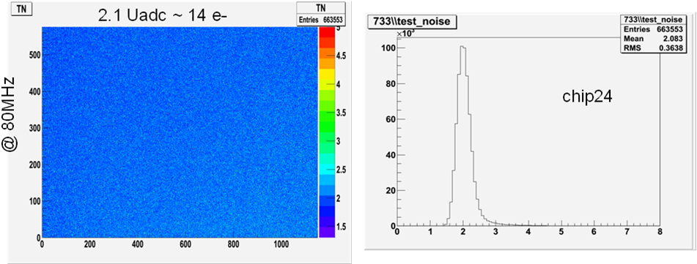Figure 2 : Distribution of temporal noise on whole the active area at nominal frequency (80MHz).

For the characterization of the charge collection a ⁵⁵Fe source is used. The Charge Collection Efficiency (CCE) is extracted from the reconstruction of clusters generated by the 5.9 and 6.49 keV X-Rays of the source. The measured values are presented on table 1, where TC CCE values are compared to the IDC ones. The values are roughly similar, as expected.

Cluster size | Seed (1x1) | 2x2 | 3x3 | 5x5
TC | 22 % | 55 % | 73 % | 83 %
IDC | 22 % | 58 % | 75 % | 86 %
Table 1 : CCE Measurements of TC and IDC.

  - Tests of the digital part
The digital readout of the sensor was studied by characterizing the performances of the 1152 column-end discriminators with and without the pixel array connected to their inputs. The control of the discriminator thresholds is organized with 4 groups, each addressing 288 continuous columns. In both cases, transfer curves are obtained by scanning the threshold via JTAG. Systematic offset, Temporal Noise and Fixed Pattern Noise (FPN) are extracted by applying an error function to the transfer curves.
For discriminators alone, the Temporal Noise is ~0.4 mV while the FPN is found ~ 0.2mV.
For discriminators + pixels (figure 3), the Temporal Noise amounts to ~0.6-0.7mV and the FPN ~0.3-0.4 mV, which are the values expected, compared to IDC results.
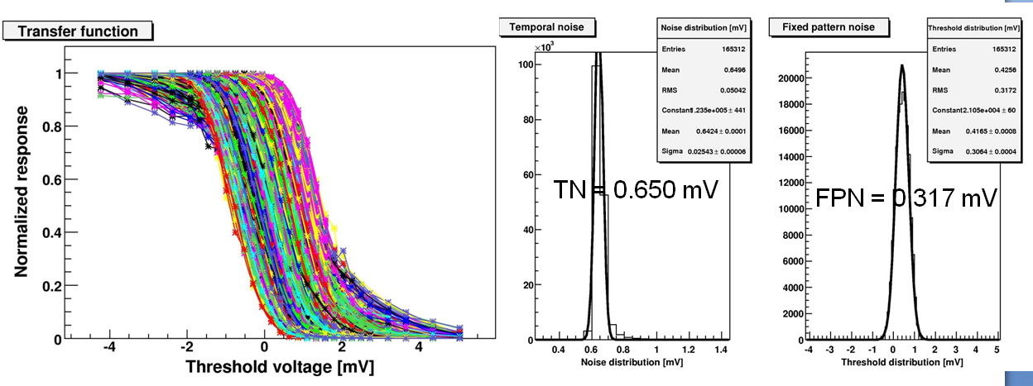
Figure 3 : Response of a group of 288 discriminators + pixels; the threshold scan is shown on left, while extraction of Temporal Noise and Fixed Pattern Noise are shown on right side.

The zero-suppression logic was investigated, disconnected from the rest of the chip. Various patterns were emulated with a pattern generator, and ran through the logic millions of times without any error up to frequencies of 115 MHz. All critical configurations were checked repeatedly to be treated properly. Finally, the signal processing of the complete chain, ranging from the pixel array to the output of the zero-suppression logic, was characterized on several different sensors.
- Beam test preliminary results
TC performances were characterized with a 120 GeV pion beam at SPS-CERN in September 2009. This section presents the preliminary results of this test beam. The set-up consisted of a telescope made of 5 planes of TC and in middle a TC as DUT (Device Under Tests). 4 Chips have been characterized included two 120 µm thinned chips.

A discriminator scan has been performed to characterize the noise. Temporal Noise is evaluated ~ 0.6-0.7 mV which is similar to the laboratory test values.
Detection efficiency, fake hit rate and spatial resolution have been evaluated for different thresholds and chips.
To determine efficiency, 5 planes are considered as telescope. Hits are looked for in the last plane associated with a telescope track if the distance between hit and extrapolated track is less than 50 microns. At low thresholds (4-5 times the noise value), the efficiency is above 99.5% which is compatible with the IDC results. Beyond this threshold value, the detection efficiency starts to decrease significantly as expected (Figure 4 left).
Fake hit rate is considered as the probability for one pixel and for one event to pass accidentally the discriminator threshold, while there is no MIPs crossing the pixel in the event. Practically, to estimate the fake rate, one uses test beam data without beam. Above a threshold corresponding to 6 times the noise value threshold, the fake hit rate is less than 10⁻⁴ which is expected and usable for the EUDET telescope.
Spatial resolution is obtained by using the residual distribution between the telescope track extrapolation and the associated hit position. The current result is still preliminary and appears to deviate by +0.5 µm with respect to the 3.5 μm measured resolution of IDC.
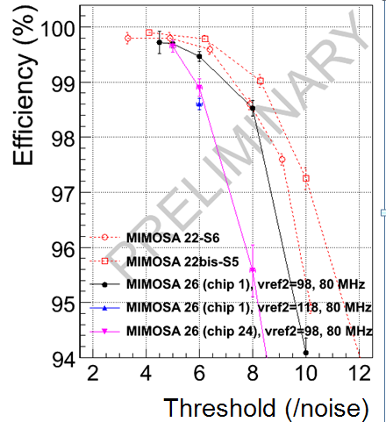 | 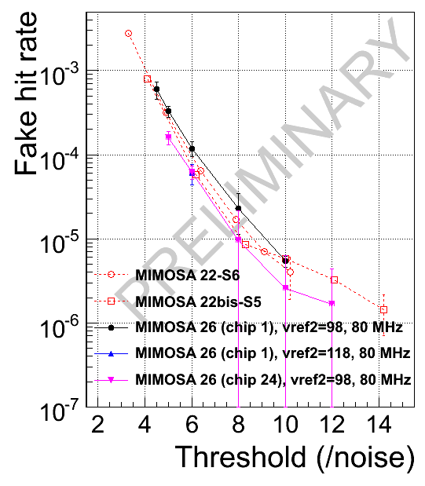
Figure 4 : In-beam performances of TC (MIMOSA-26) compared to IDC (MIMOSA-22) one (chip1 is unthinned, whereas chip24 is 120µm-thinned). On left detection efficiency vs. discriminator threshold, on right fake hit rate vs. discriminator.

- Conclusion
TC is the first reticule size, fast readout digital MAPS with on-chip data sparsification for EUDET beam telescope. The assessment is practically fully completed but this chip provides expected tracking performances needed for the telescope.

Acknowledgement
This work is supported by the Commission of the European Communities under the 6th Framework Programme “Structuring the European Research Area”, contract number RII3-026126.

References
[1] G. Claus et al., JRA-1 Beam Telescope Towards the Final Pixel Sensor, EUDET-Memo-2008-51.
[2] M. Gélin et al., Intermediate Digital Monolithic Pixel Sensor for EUDET High Resolution Beam Telescope, IEEE Trans. Nucl. Sci. vol. 56, n°3, June 2009, pp 1677 –1684.
[3] Y. Degerli et al., Development of Binary Readout CMOS Monolithic Sensors for MIP Tracking, IEEE Trans. Nucl. Sci. vol. 56, n°1, February 2009, pp 354 - 363.
[4] A. Himmi et al., A Zero Suppression Micro-Circuit for Binary Readout CMOS Monolithic Sensors, Proceedings of TWEPP2009, Paris, September 2009.

IPHC, IN2P3/CNRS - Université de Strasbourg, Strasbourg, France
SEDI/DSM, IRFU - CEA Saclay, Gif Sur Yvette, France

