

Silicon Strip Sensors
with integrated pitch adapters

Thomas Bergauer⁾, G. Auzinger, M Dragicevic, C. Irmler, S. Haensel, W. Kiesenhofer, M. Valentan
(HEPHY Vienna, Austria)

P. Grabiec, M. Grodner, K. Kucharski, J. Marczewski
(ITE Warsaw, Poland)

Abstract
Material reduction is a crucial point for inner tracking systems of all high energy physics experiments, especially for those based on silicon micro strip sensors. Our goal is to build a silicon module with as little material as possible. As a first step, we have designed silicon strip sensors which are equipped with integrated routing lines. These routing lines allow a readout chip to be directly connected to the sensor using wire bonds, omitting a pitch adapter. A beam test has been performed at CERN with these sensors to test their performance, especially when they are being hit in the routing region. Results from this test are shown in this report.

- Introduction

The SiLC collaboration is pursuing research towards a new generation of silicon tracking devices for possible use in future projects like the International Linear Collider (ILC). The core activities include new developments in silicon sensors, readout chips, mechanics and system integration, complemented by simulation.
For any ILC experiment, material budget is a crucial point for its inner detectors. Therefore, different approaches to minimize the material budget are under investigation by the SiLC collaboration. One possibility is the material reduction of each detector module itself. To archive this, the different discrete components like pitch adapter and front end hybrid should be integrated directly into the silicon sensor.
A conventional module consists of a carrier structure supporting the silicon sensor, a pitch adapter and the front end hybrid. As an intermediate step, we developed silicon sensors with an integrated fan-out, making an independent pitch adapter obsolete. Different layouts and concepts were designed and have been fabricated by the silicon foundry at ITE Warsaw (Poland).
- Sensor Design and Production

The different layouts of these new silicon sensors are compiled such that all of them fit onto a single 4” wafer, which reduces the mask and setup costs to a minimum. A drawing of the full wafer is shown in figure 1. The wafer consists of five large sensors, surrounded by three sets of test structures. Four of the sensors have identical outer dimensions. Each of these sensors is equipped with 128 strips.

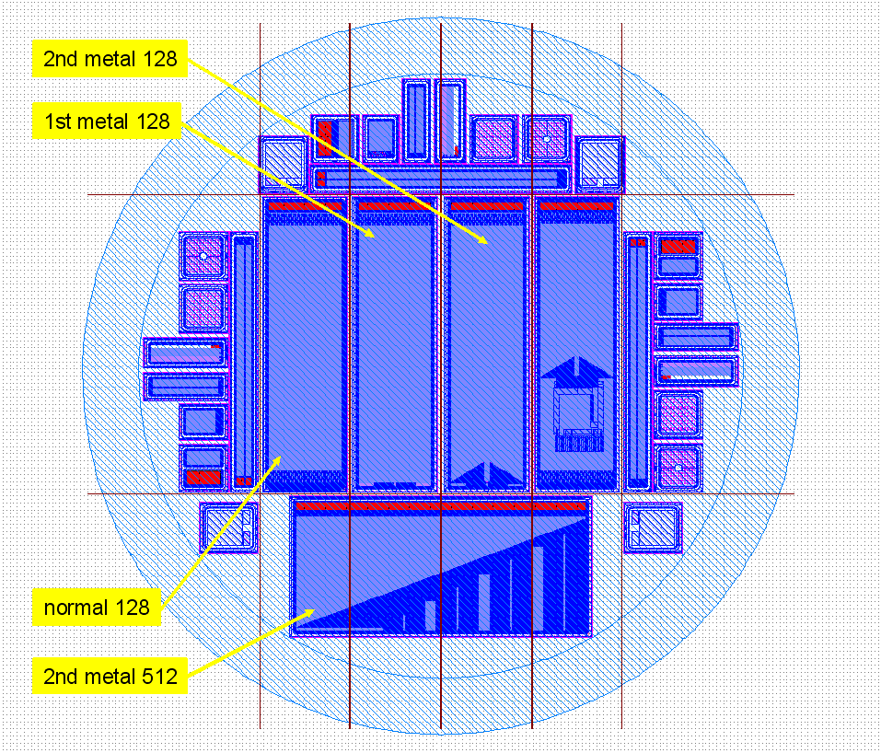
Figure 1: Layout of the full silicon wafer, as it was
processed at ITE Warsaw. Red lines show the dicing (cut) lines.

Standard Sensor (STD)
The leftmost sensor on the wafer is a standard sensor without any routing or Pitch Adapter (PA). It is used for comparison reasons.

Sensor with integrated PA on single metal layer (PAS)
The sensor next to STD is using the strip metallization on one end as a fan-out to connect the strips to the bonding pads. Since this sensor is having an integrated Pitch Adapter on Single metal, it is called PAS. A drawing of its routing region is shown in figure 2.

Sensor with integrated PA on double metal layers (PAD)
The third sensor from the left has the Pitch Adapter implemented with double metal layers for both readout and routing metallisation. Therefore it is abbreviated as PAD. The connection from the strips (first metal) to the routing layer is done via via’s through an insulating oxide layer, separating both metallizations. A close-up of the routing region is shown in figure 3.

  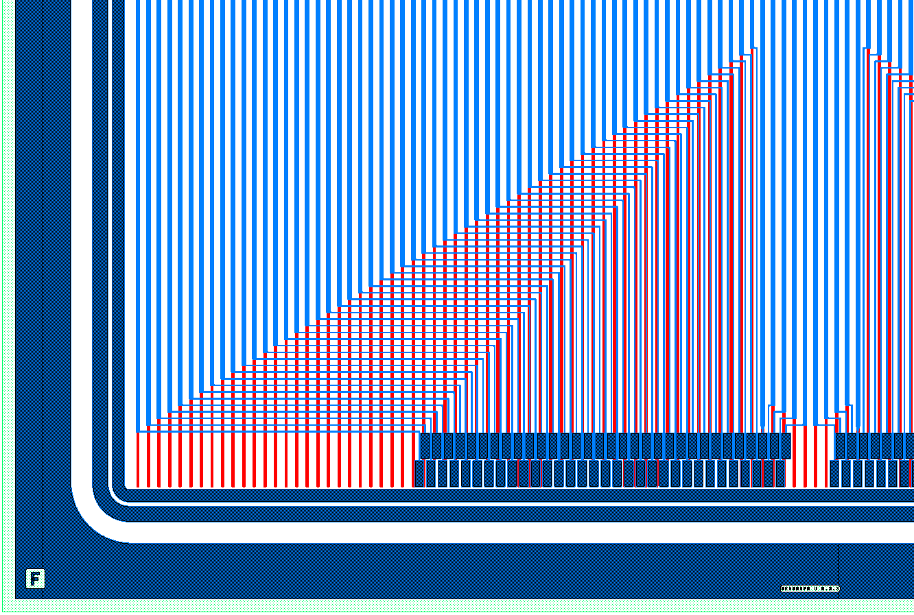  p+ implant  metal 1  metal 2 | 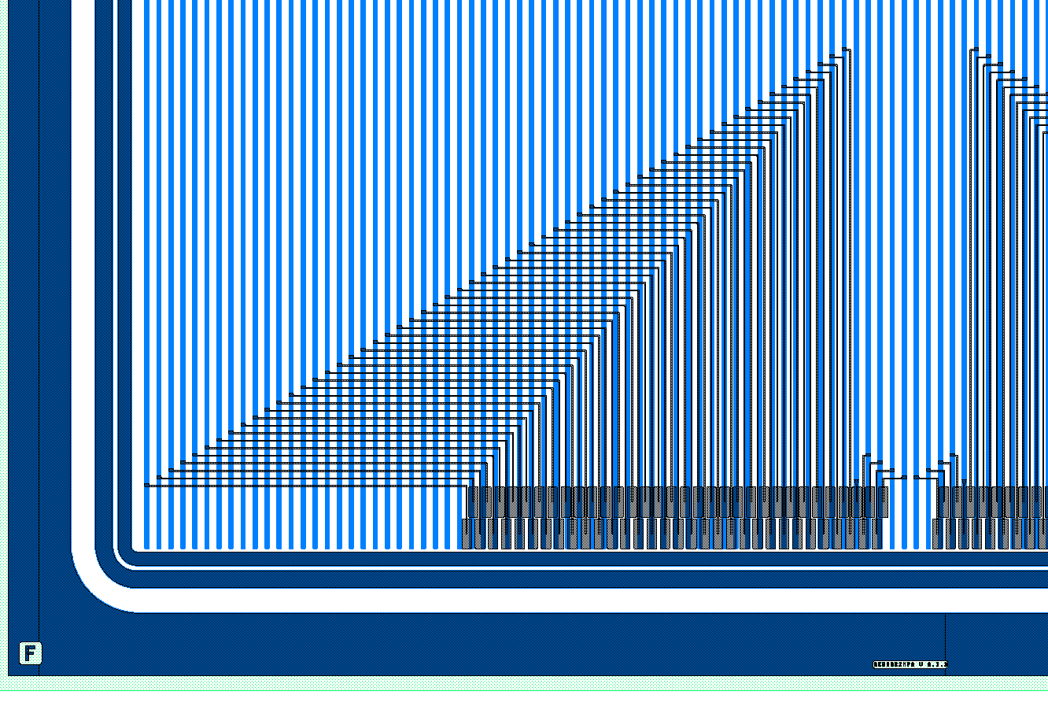  p+ implant  metal 1  metal 2
Figure 2: Closeup of routing region in PAS sensor. The routing is implemented in the same metal layer as the metallization of the readout strips. | Figure 3: Closeup of routing region in PAD sensor, in which the routing is implemented in the second metal layer

Sensor with direct-bonding region
The fourth sensor from the left is again of the same shape than the ones before, but here we implemented a region (shown in figure 4) where an APV25 readout chip can be bonded directly onto the sensor. The signals from the readout strips to the bonding pads are also routed using a second aluminium metallisation. The necessary auxiliary connections of the APV chip (digital I/O, I2C, power) are implemented on this layer as well and can be wire bonded to Kapton cable connecting the chip to the back-end electronics.
Hence, if the chip is directly bonded onto this region, a discrete hybrid PCB can be avoided as well, reducing the overall material budget even further.
In this sensor, we will determine the influence of the APV digital data lines, which are separated from the readout strips only by a very thin insulating oxide. Furthermore, we will test the thermal influence of such setup to the sensor behaviour with and without cooling of the readout chip and the efficiency of the sensor areas. This sensor has not been used for the testbeam because of time constraints. It is foreseen that this concept will be tested in an upcoming beam test.

Sensor with 512 Strips
The bottom sensor on of the wafer (shown in figure 4) is equipped with 512 readout strips which are shorter than the strips on the other sensors. It exists in two versions: The first version is a standard sensor with a single metallization. The second version implements the signal routing from the strip metallisation to the four readout chips using again a 2nd metal layer. The routing lines are optimized to directly wire-bond them to the 4-chip APV25 front end hybrid available in Vienna. To get two versions of this sensor, ITE Warsaw simply stopped processing after the first metallization was applied to several wafers, while the remaining ones were fully processed with the second metal layer.

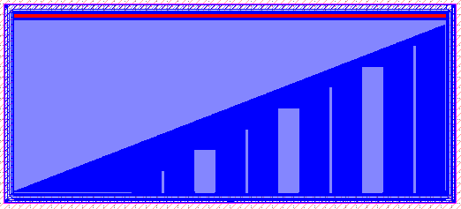
Figure 4: Sensor with 512 strips and routing on 2nd metal routing.

Using both versions of this sensor allows us to test the difference in terms of signal to noise ratio caused by the second metal routing layer explicitly. This layout has an advantage to the PAD sensor, since its routing lines are approximately of the same length than the corresponding strips itself. This should show us a much more distinct effect than for the other sensors.

Wafer processing
Ten wafers in total have been produced at ITE Warsaw. Since two wafers were broken during processing, eight wafers arrived in Vienna in June 2009.
On four wafers, processing was stopped after the first metallization (Wafers 1,2,3,4), while the others were fully processed with double metal layers (Wafers 5, 6, 7, 8).

The following table lists some essential values, as specified for the processing:
Thick oxide: | 0.9 micron thickness
Readout oxide: | 177 nm thickness
Poly-silicon | 473 nm thickness
Insulation between PolySi and 1st metal: | thermal oxide on PolySi 43nm, CVD SiO2 100nm, BPSG 700nm, PSG 200nm
Thickness oxide between 1st metal and 2nd metal: | 700nm (PE CVD SiO2)
Metal 1: | Alu-Si 0.7 micron thickness
Metal 2: | Alu-Si 1.2 micron thickness
Passivation: | PSG 450nm, AP CVD SiO2 300nm
Backside Al: | 20nm (very thin, to allow laser tests)
Backside getter: | 1 micron Poly-Si
Backside n⁺⁺ implantation: | 6-8 micron thickness

Figure 5 shows the IV curves of all wafers measured at ITE Warsaw directly after processing. Afterwards, the wafers have been diced into several pieces each, according to the dicing lines shown in figure 1.

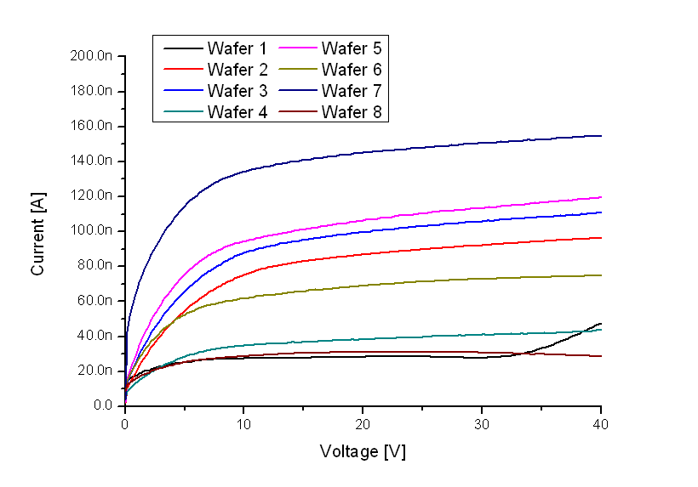
Figure 5: IV curves of all wafers, as measured at ITE Warsaw.

After the diced sensors arrived in Vienna, they have been electrically characterized using the probe stations available in the institute’s clean room. This was performed quickly since we had to proceed to module assembly. Figure 6 shows an example of a IV curve up to 200V with a very stable behaviour. We have also checked the resistivity of the wafer bulk material by measuring the CV curve on some wafers. This measurement can be seen in figure 7. As the kink in the 1/C² curve results in a full depletion voltage of 25V, the resistivity has been calculated as 12.5 kΩcm.

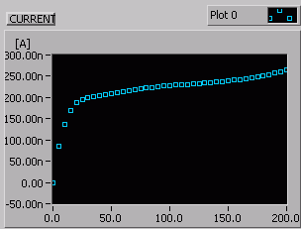 | 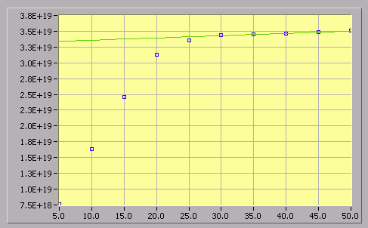
Figure 6: IV curve of PAD sensor of Wafer 5. | Figure 7: 1/C2 vs. bias voltage curve of STD sensor of Wafer 2. The full depletion voltage is shown as kink of the curve at approx. 25 Volts.

- Module Assembly

Mechanical frames have been designed and manufactured using fibre-reinforced epoxy (Isoval R11), onto which the FE hybrid and the different DUT sensors have been glued. In total, eight modules have been built, two each with STD, PAS, PAD and 512-stip sensors.
Examples of those modules are shown in figure 8 and 9.

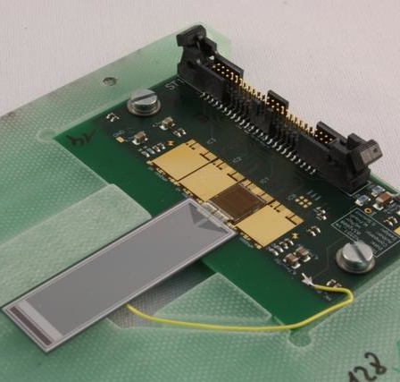 | 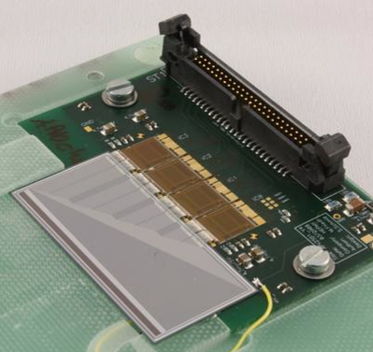
Figure 8: PAS sensor connected to front-end hybrid equipped with a single APV25 readout chip | Figure 9: 512-strip-sensor connected to front-end hybrid equipped with four APV25 readout chips

- Data Acquisition System and Beam Test

The DAQ and readout system, as sketched in figure 10 and shown in figure 11, is called APVDAQ, since it has been built to read out APV25 readout chips. It contains a 9U VME crate with a single controller (NECO) and a fan-out unit (SVD3_Buffer) as well as several FADC modules with built-in processing capabilities. The readout is done via the VME crate to a PC connected via NI VME controller.
On the front-end side, which can be located up to 30m away, there are repeater boxes (DOCK) which connect to the front-end hybrids housing the APV readout chips. The system has been adapted to be compatible with the EUDET pixel telescope, which means that the trigger information (including time-stamps) from the TLU is directly included into our VME hardware.

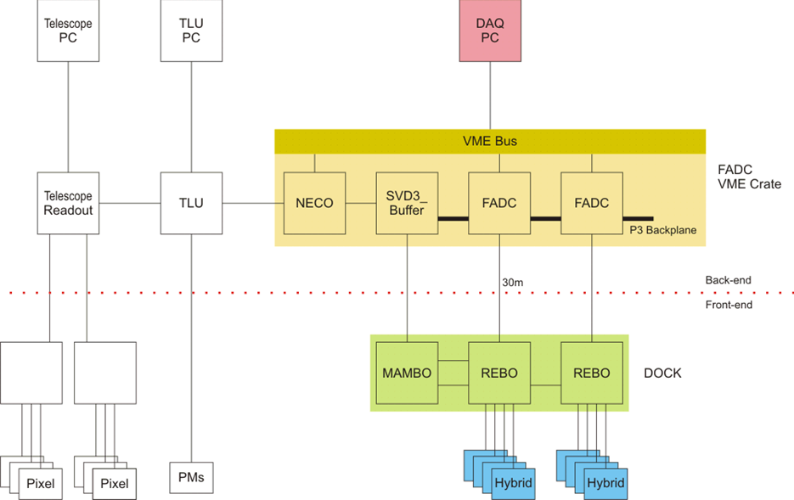
Figure 10: Schematics of the DAQ system.

The online DAQ software is implemented in Labwindows/CVI. The software has already been used for various testbeams before and is therefore very stable. The graph shown in figure 12 corresponds to a scope picture (raw data) of six consecutive readout frames of a single APV chip with 128 strip values multiplexed in each frame, where frames are spaced by 25ns. The shaper output waveform (50ns peaking time) of a strip with a particle hit is clearly visible. Multiple samples around the peak have been used to determine the particle timing with an accuracy of a few nanoseconds.

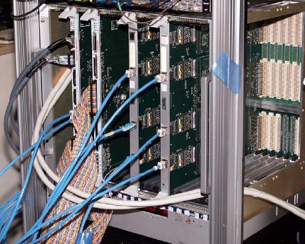 | 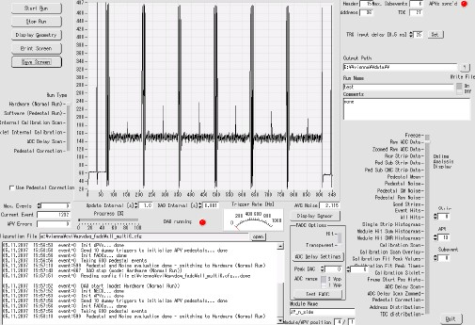
Figure 11: Picture of the VME crate housing the DAQ boards: NECO, Buffer and two FADC boards. | Figure 12: Screenshot of the DAQ software. The graph in the center shows the raw APV data of a single chip.

During our assigned two weeks (between 19th to 31st August 2009) of beam time in the CERN north area beam zone H6b of the SPS accelerator, we have received hadrons, mainly pions, with an energy of 120 GeV to simulate minimum ionizing particles. The settings file from last years run has been applied (H6b.802 (FM HAD (P0 off, H8=+180) PARLALLEL IN H6B SILC 2008). The DUT sensors have been installed in the center of the EUDET telescope as shown in figure 13.

Figure 13: Scheme of the setup with DUT, Telescope and scintillators.

The scintillators, used for triggering, were connected to the TLU box, which provided trigger information to both, the EUDET telescope and the APVDAQ system.
- Results
The offline analysis software is based on several parts: The first stage is using Labwindows/CVI to read the raw data files from the APVDAQ system (binary files with extension*.dat and several text files with the extensions *.pro,*.sig,*.txt,*.cfg) to perform cluster finding, pedestal subtraction and common mode correction. It writes the zero-suppressed data into binary files with the extensions *.hit and *.eta and a text file with the extension *.mod.
Since the online DAQ is storing six samples of the signal of each triggered event, another program is used to perform hit-time finding. This is done with a compiled Root-program called hitfitgui and the corresponding output files are called *.hit.fit (plus some plots in eps-format). The last stage is a Root-macro called AnaRun, which finally produces eps-files with plots containing Gaussian convoluted Landau fits of the signals.

Since the data analysis is still ongoing, all results below are preliminary and tentative. Among all data, we have selected to analyze the Signal-to-Noise-Ratio of the PAS sensors and correlations between strips, which are caused by crosstalk, first.

Signal-to-Noise-Ratio on PAS sensors

If a PAS sensor is hit in a region with no routing (green region in figure 14), the signal-to-noise behaviour should be comparable to the STD sensor. However, if the sensor is hit in the routing region (blue region in figure 14), the SNR should decrease. This has been observed and is shown below, where the SNR vs. strip number is uniform for the green region, while has a W-shape in the blue region.

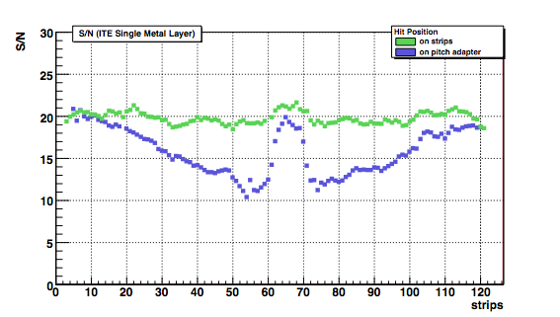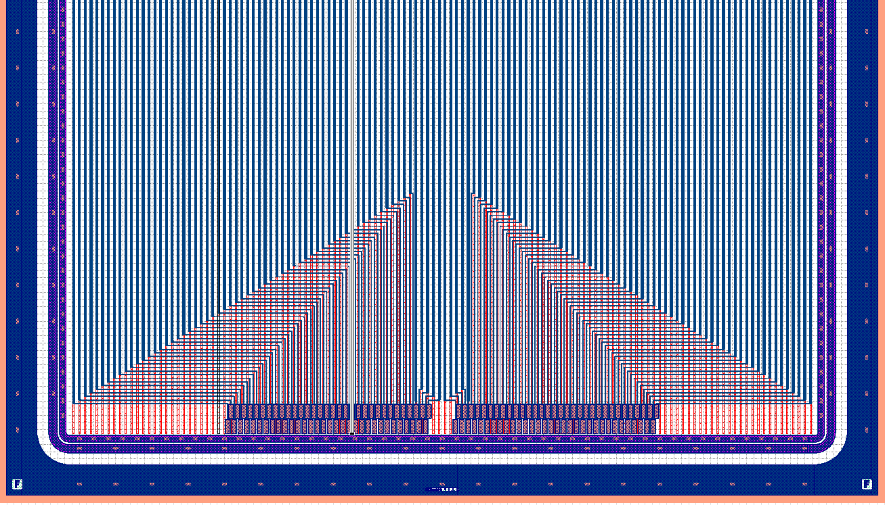

Figure 14: PAS Sensor (bottom) with signal-to-noise-plot (top). The green and the blue graph show the values for the corresponding regions on the sensor, respectively.

Correlations caused by crosstalk

To get an overview of the crosstalk introduced by the routing in the first and second metal layer, we calculated correlations using the Kendall τ rank correlation coefficient. For an event where a certain strip was hit, we compare the signal height on all other strips (the strips not hit in this event) to the signal heights of the same strip in all other events where the same strips was hit. If the difference in signal height has the same sign as the difference in signal height of the strip that was hit we count it as a concordant pair (n_{c}) and as discordant pair (n_{d}) if the sign is negative. For each pair of hit strip (x-Axis) and non hit strip (y-Axis) we get Kendall's τ which is defined as:
$$τ=\frac{n_{c}−n_{d}}{0\text{.}5n(n−1)}$$

Kendall τ rank correlation coefficient is plotted as colour in figures 15 and 16.

From figure 15 we see expected behaviour of a standard sensor. A correlation of τ =1 is seen for each pair of the same strip as expected from the definition of Kendall's τ. Faint lines parallel to this line are visible which are artefacts of the APV25 readout. This shows the very high sensitivity to even very small correlations.

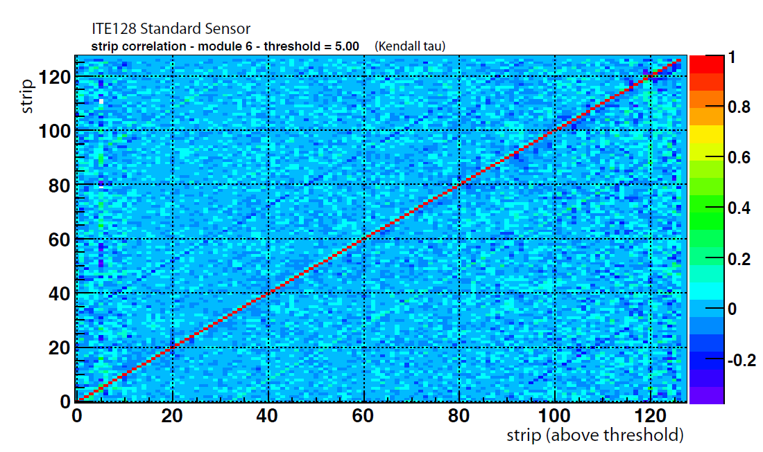
Figure 15: Correlations between signals on each strip of standard sensor (STD).

In figure 16, more structures are visible for a sensor with a pitch adapter in the first metal layer. Most of these structures can be attributed to the geometry of the pitch adapter, but investigations are not yet fully conclusive and are currently under further scrutiny.

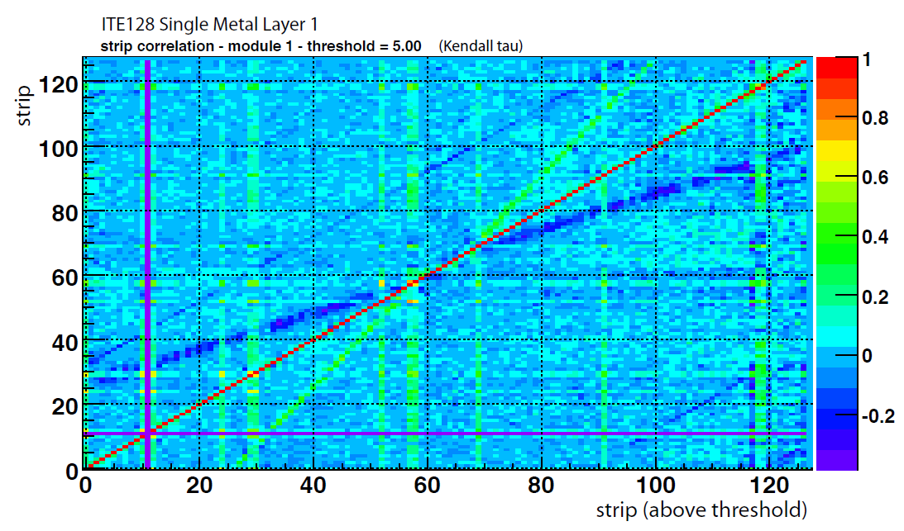
Figure 16: Correlations between signals on each strip of standard sensor (PAS).

- Conclusions

Within one year, a full cycle containing sensor design, sensor production, module design and assembly and a beam test have been performed. The sensors are especially suited to test the possibility of integrating the pitch adapter into the sensor. Therefore, two different versions of this concept have been evaluated, while a standard sensor was used for comparison. The first, simpler version is using the strip metallization itself as fan-in. We have seen in the signal-to-noise numbers recorded during the beam test that those sensors are suffering from lower efficiency in the routing region, caused by crosstalk.
The more complex sensor with dual metal layers does not suffer so severe from this problem. It still shows some crosstalk effects, but they are low compared to the simpler single-metal sensor. However, the yield during processing of the double-metal sensors was low. Therefore, a large number of strips on those sensors is suffering from pinholes, which makes the data analysis more complicated.
Nonetheless, data analysis is continuing to get more meaningful and significant plots. Some discussion started already to re-test the sensors again in an upcoming beam test, together with the yet unused direct-bonding sensor.

Acknowledgement

This work is supported by the Commission of the European Communities under the 6th
Framework Programme "Structuring the European Research Area", contract number
RII3-026126.

Corresponding author: Thomas.Bergauer@oeaw.ac.at, Nikolsdorfer Gasse 18, 1050 Wien, Austria

