

The third deliverable of JRA2/SiTPC: an endplate infrastructure

D. Attié, P. Colas, X. Coppolani, E. Delagnes,
F. Senée, M. Riallot
(CEA/Irfu, Saclay, France)

December 30, (Update: February 13, 2009)

Abstract

An infrastructure for commissioning an 8-chip endplate has been delivered early March 2008. It consists of a mechanical frame adapted to the endplate of the JRA2 field cage, and a PCB with the suitable circuitry to supply and read out 8 TimePix chips at a time and support 8 butted wire-bonded chips, corresponding to a connected active area of 56×28 mm².
In this report, a detailed description of the infrastructure is shown, and difficulties encountered in the commissioning and solutions to these are reviewed.

- Introduction
The EUDET JRA2 / SiTPC group aims at developing a digital TPC as a diagnostic tool for the EUDET facility, and at performing the first steps towards a possible digital TPC for the Linear Collider [1].
The first milestone was the design of the TimePix chip [2], it was successfully crossed at the end of 2006. The second milestone, the observation of minimum-ionizing tracks in a gas with TimePix was overcome in 2007. The next step, object of this note, was to provide an infrastructure to use several (up to 8) TimePix chips at a time.
The present interface board MUROS2 allows a maximum of eight chips to be readout at a time [3]. For this reason, we limit our scope to supplying the power and to reading out eight chips simultaneously.
- TimePix panel Description

A Printed Circuit Board (PCB) has been designed. It bears a 2×4 pad matrix on one side and a supply and readout circuitry to receive 8 TimePix chips (Figure 1). The circuitry includes decoupling capacitors, connections to the outside, high voltage for the detector, and straps to allow a chip to be bypassed in the event of a dysfunction. The shape of the PCB has been taken to fit in place of a panel of the LC-TPC Large Prototype, to allow measurements to be carried out using the field cage of the EUDET test facility in the PCMAG magnet at DESY. Thanks to the ultimate performance achieved with such a detector (32000 pixel per cm² with single-electron sensitivity, it is a very powerful diagnostic device to assess electric and magnetic field homogeneity and study gases. It is also an option for the Linear Collider TPC, provided coverage of large surfaces can be obtained. The work described here is also a step in this direction.

The overall size of the panel is 17 cm over 21 cm. The active area is 56×28 mm². It has a 6-layer structure to allow routing of the numerous needed command and output signals.

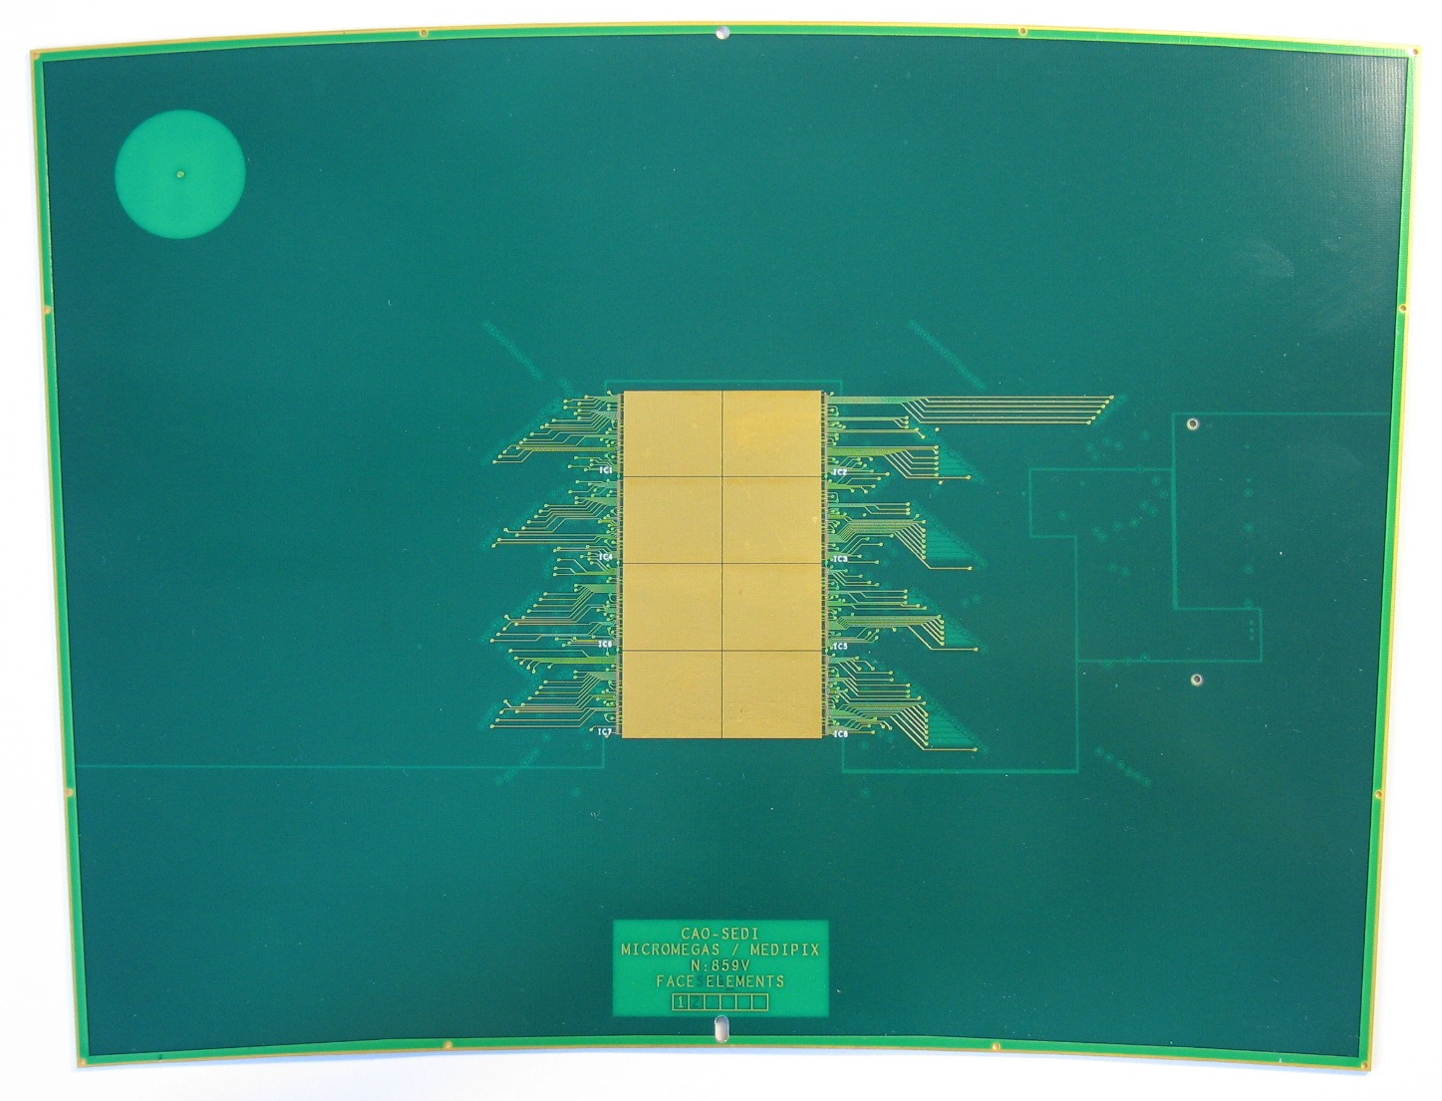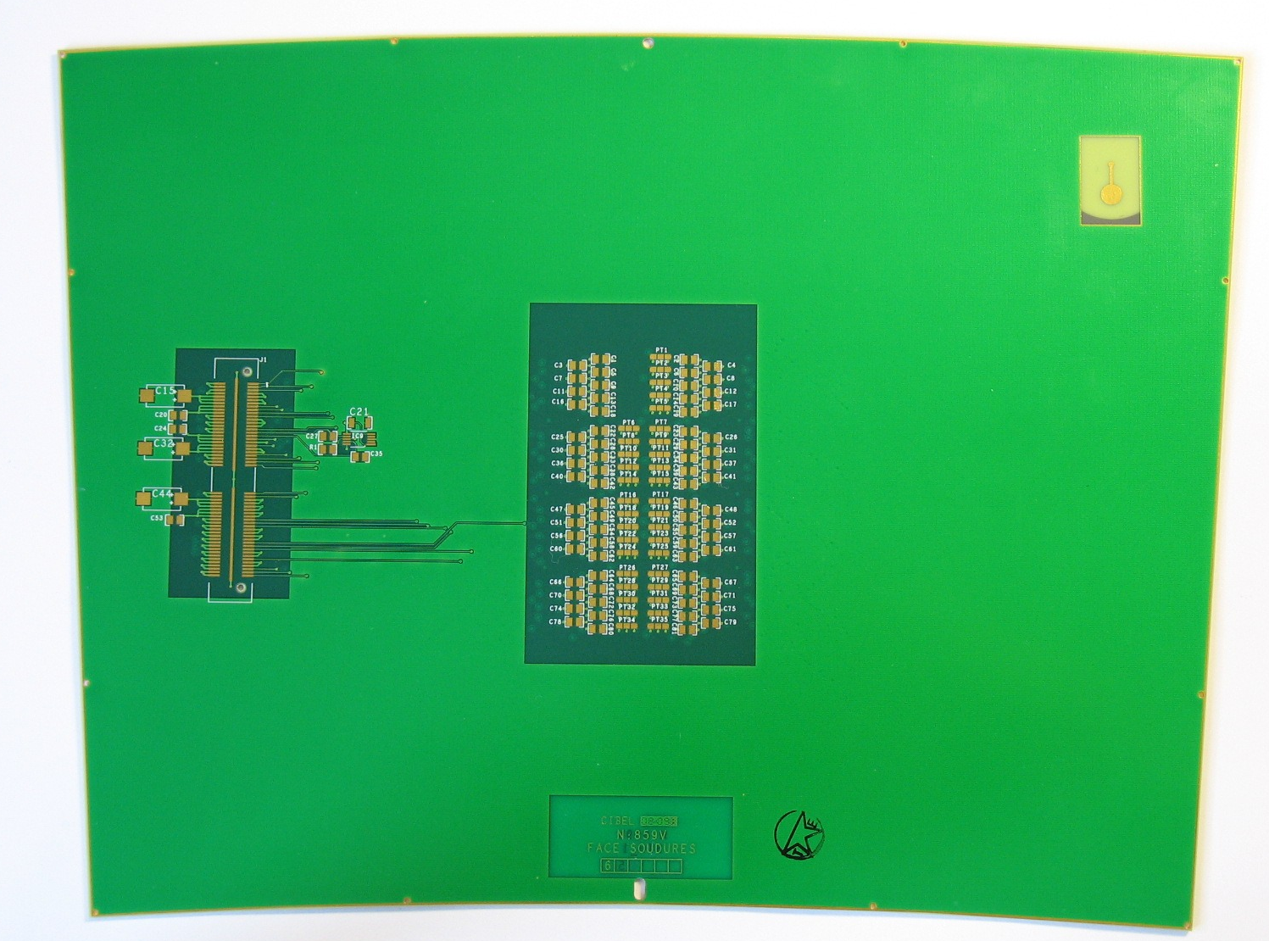
Figure 1 − Top view (on the left) and bottom view (on the right) of the TimePix panel circuit. The chips are bonded on the top and discrete components (decoupling capacitors and bypass straps) are on the bottom side.

Each chip is connected to the PCB by 75 wire bondings which bring the supplies, DAC voltages and output signals. All of these are connected in parallel, except twelve (six IN and six OUT): 2 for the LVDS clock signal (Positive and Negative), 2 for the data flow LVDS (P and N), and 2 for the Enable LVDS signal (1 when data are flowing and 0 otherwise). These signals have to go through each chip to indicate to the system how many chips are to be read. Between two chips, the Enable is transmitted in CMOS, thus using one single track, which brings to 5 the number of links between 2 chips. Figure 2 shows the principle of the serial readout.

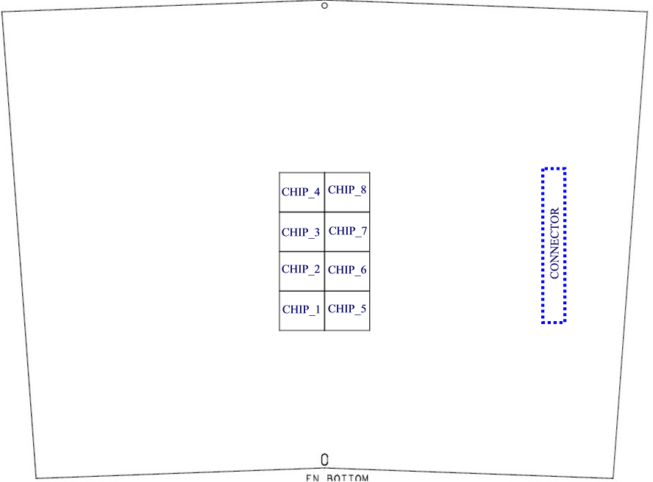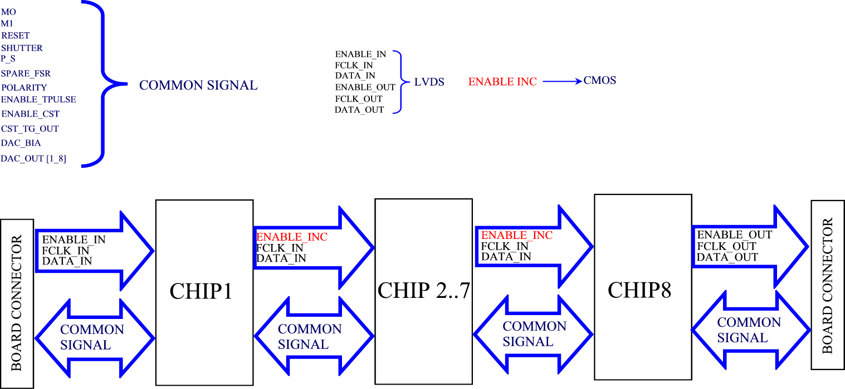

Figure 2 – Description of the TimePix panel serial readout.

- Bypassing a dead chip
The data are transferred from a chip to the next in chain. Because of the 5 signals which have to go thru all 8 chips, a single dead chip would impact the operation of the whole system. To avoid this, we set up a circuitry which allows a chip to be skipped, provided its two neighbours in the chain are working.

In the event where IC X is broken, the data can be derivated using a simple strap system.

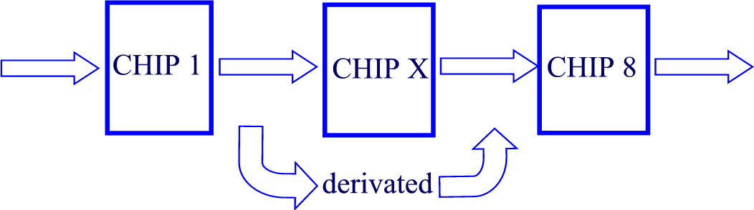
Data

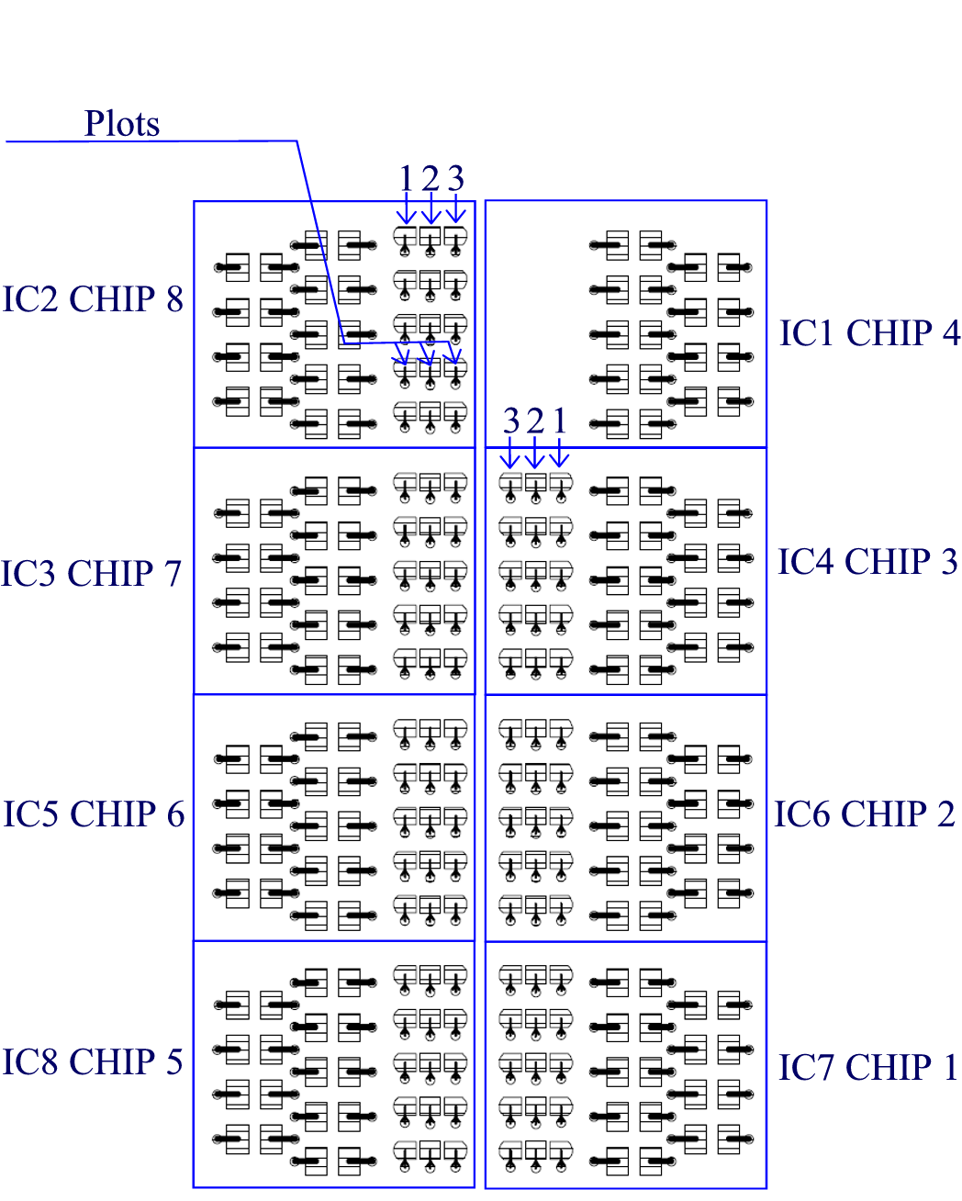

For a normal use of the card, the pads 2 and 3 of each test point have to be connected.

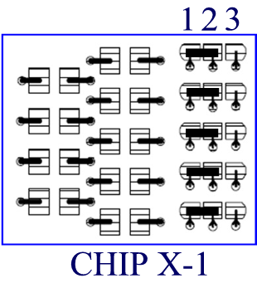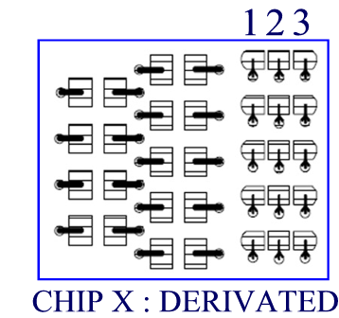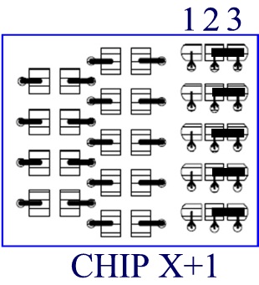

- Supplying the power to the chips
Nominally, each chip consumes about 0.45 W (~0.2 A at 2.2 V) static digital power, plus a variable analogue power up to 0.42 W. It thus needs 0.9 W to operate. After the wire-bonding of all the chips, we found that the MUROS2 internal power supplies were not sufficient. Additional voltage power supplies were directly connected to the board very close to the chips. The voltages V_{DDA,} V_{DD} and V_{DDLVDS} were tuned to have the constant value of 2.2 V at the power inputs of the chips. This problem was solved by adding an external power supply directly on the board, rather than relying on the MUROS device itself. The MUROS supply was disconnected.

The next step will be to control the power of the chips directly on the board using for example 4 Ampere power regulators, one for the digital part and one for the analog part (for 4 or 8 chips).

- Tests of the system

Tests were performed initially with 8 chips. After several tests we suspected that some chips were dead. We decided to remove all of them and replace only the first and the last chips to validate the circuit. Figure 3 shows the LVDS signals recorded using the two chip configuration serially connected. They are as expected (compare to Fig. 39, p.40 of the TimePix manual [4]. Then the software was corrected and reading out the 2 chips was successful.
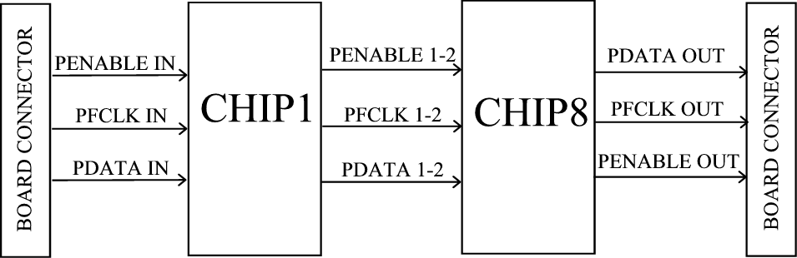
Figure 3 – LVDS signals of two TimePix chips serially connected.

- Conclusion and outlook

A TPC endplate panel was designed and built (Fig. 4) to readout up to 8 chips. It has been successfully tested on 2 chips, which validates the circuitry for up to 8 chips. A bypass system has been designed to increase the reliability of the system in operation. Software fix-ups were needed to demonstrate the operation of the system with 2 chips.
A new board will be designed to implement the new ideas which arose during the commissioning of this board. Internal power regulators will be added (separately for the analog part and the digital part). A new 10-layer design will allow keeping all the conductive tracks behind the chip area (so that extension to a larger matrix will be straightforward). If the board can be equipped with a GEM or Micromegas gas amplification system, tests in the EUDET prototype facility can be envisaged in 2009.

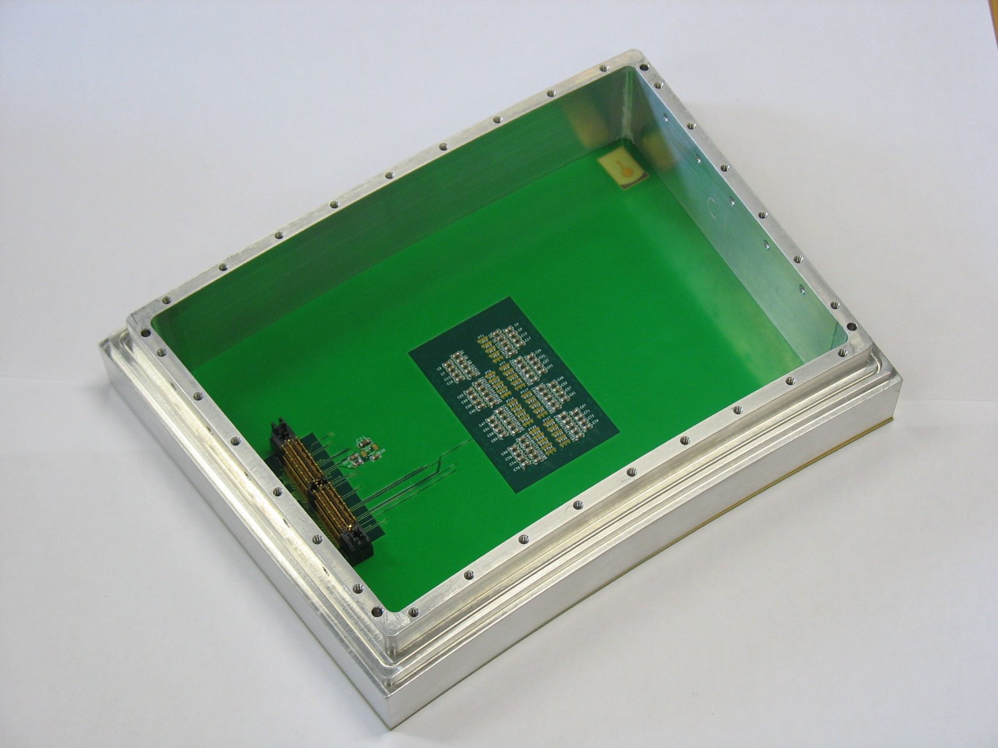
Figure 4 – The complete module with its back frame.

Acknowledgement
This work is supported by the Commission of the European Communities under the 6th Framework Programme "Structuring the European Research Area", contract number RII3-026126.

References

[1] EUDET contract number 026126, Annex 1 (description of work) http://www-flc.desy.de/eudet/contr_Amendm3/annex1mod_2008(vers_27oct)_final.pdf

[2] X. Llopart et al., Nucl. Instrum. and Methods A 581 (2007) 485.

[3] D. San Segundo Bello, ‘MUROS2 User’s Manual’ (2003) Nikhef, Amsterdam.

[4] X. Llopart, TimePix Manual Version 1, CERN (August 2006).

