

Towards a Digital TPC for the LC

H. Blank, C. Brezina, K. Desch, J. Kaminski, M. Killenberg, T. Krautscheid,
W. Ockenfels, M. Ummenhofer, P. Wienemann, S. Zimmermann
(University of Bonn, Germany)
M. Campbell, M. Hauschild, E. Heijne, X. Llopart
(CERN, Switzerland, Geneva)
D. Attié, P. Colas, X. Coppolani, E. Delagnes,
A. Giganon, I. Giomataris, M. Riallot, F. Senée, M. Titov
(CEA/Irfu, Saclay, France)
A. Bamberger, U. Renz, M. Titov, A. Zwerger
(University of Freiburg, Germany)
V. M. Blanco-Carballo, Y. Bilevych, M. Chefdeville, M. Fransen,
H. van der Graff, F. Hartjes, L. De Nooij, J. Rovekamp,
J. Schmitz, J. Timmermans, J. Vischers
(NIKHEF, Amsterdam, The Netherlands)
December 31, (Update: February 13, 2009)

Abstract

This report is focussed on progress made in 2008 towards a Time Projection Chamber with pixel readout. It is a summary of the tasks achieved in the SiTPC group of JRA2.

- Introduction
A Time Projection Chamber is an attractive option for precision tracking of charged particles. Depending on the time left for the R&D, a solution providing the ultimate resolution that can be expected with a gas can be envisaged : a digital TPC. The goal of the SiTPC task within the EUDET project aims at supporting the development of such a device.
The principle of operation of a digital TPC is to drift individual electrons under very low diffusion conditions. For instance in a magnetic field of 4T, with an Ar:CF₄:isobutane / 95:3:2 mixture, the transverse diffusion coefficient is 20 µ/√cm, thus the spread of the charge is consistent with the cluster size at 1m. Then single electrons are detected with a high efficiency and their position and arrival time are precisely determined by microscopic pads.
An advantage of such a device is to measure also the dE/dx from cluster counting, when this can be performed, and get rid of the large ionization fluctuations induced by delta rays. This is equivalent to truncating the mean energy deposition but more precise.

- The TimePix Chip
The TimePix chip is an evolution from the Medipix2 chip which allows for measurement of arrival time, energy measurement and single photon counting. The TimePix chip has the same size, readout architecture and floorplan as the Medipix2 chip allowing almost a full backward compatibility with the existing Medipix2 readout systems. It has 65000 square pixels. Each of them contains a 14-bit counter, a clock, the frequency of which can be tuned up to 100 MHz. The area of each pixel is 55 x 55 μm². The TimePix chips was the JRA2/SiTPC deliverable of 2006. Minimum-ionizing particle signals were observed a few months after, both with the GEM and Micromegas amplification system. The infrastructure to commission a test endplate has been created early this year (see EUDET-memo 2008-042).
A second production of 38 wafers has been carried out this year. The wafers have a diameter of 8’’, which exceeds for the time being the capabilities of the various places where prototype post-processing can be carried out (4’’ in Twente and 6’’ in Neuchatel, for instance). To preserve the possibility to carry out post-processing at the wafer level, they are diced one by one according to the needs for experimentation. Each wafer contains 105 chips and yields a bit more than 80 usable chips on average. The four institutes Bonn, Freiburg, Nikhef-Twente and Saclay gave a report on the use of their chips at the annual meeting in Amsterdam.
- Progress and studies with single chips

Many new results were obtained with single chips. With the GEM readout, single electrons or single electron clusters are seen as blobs of about 100 pixels. By assigning the time-over-threshold (TOT) mode to half of the pixels and the Time measurement mode to the other half, it has been shown that merged clusters can be resolved down to distances between clusters of a few hundred microns.

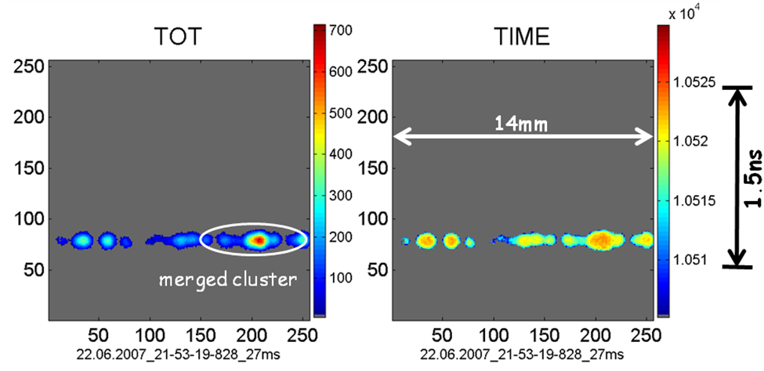

Fig. 1. The pixels modes are set to Time-Over-Threshold and Time measurement according to a chess-board pattern, so that the same track can be seen in TOT mode (left) and Time mode. The time value is represented by a colour scale. One sees how the TOT can help separating merged clusters.

The very high accuracy on the cluster center obtained with the GEM amplification allowed to see the tendency of these clusters to be in front of a GEM hole, allowing a map of the GEM holes to be obtained (Fig. 2).

Fig. 2. Distribution of the cluster centres of electrons from a distant source.

With the Integrated Micromegas readout, single ionization electrons are obtained. This allowed helicoidal tracks to be reconstructed in three dimensions in a magnetic field as seen in Fig. 3.

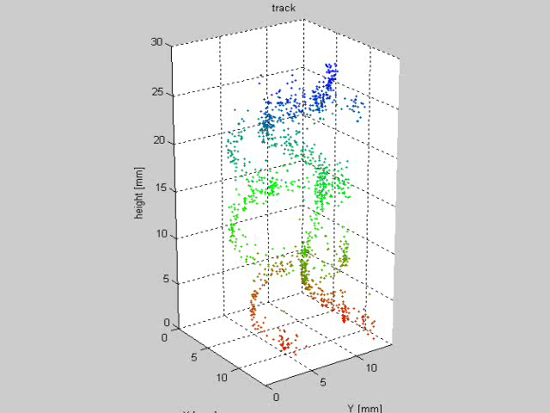

Fig. 3. Helicoïdal tracks of two electrons from a ⁹⁰Sr source in a magnetic field.

A new electron counting method has been carried out. Due to diffusion over centimetres the ionization electrons are fully separated and can be counted [Fig. 2]. By studying the single electron detection efficiency as a function of the amplification voltage, a Polya-like distribution has been shown to give a good parametrization of the gain fluctuations. This allowed a measurement of the average energy deposited in a Ar/isobutane (5%) mixture, and also the fluctuations of the number of primary electrons (Fano fluctuations) [1,2,3].

Several studies have been carried out to understand and improve the robustness of GridPix detectors, mainly in Nikhef-Twente. Meshes have been subjected to very strond mechanical vibrations by supplying a high frequency high voltage to the mesh and observing the movements of the mesh by optical means. A new anti-spark protection material for the chips has been successfully tried : Si₃N₄ has a high resistivity and good mechanical properties. It is a good candidate to replace hydrogenated amorphous silicon, as the first tests suggest that few microns of Si₃N₄ suffice to protect a chip, whereas 15 µm were necessary in the case of aSi. Also a twingrid has been operated for the first time without protection layer). Also post-processing has been carried out on chips to lower their pitch by hiding 3 pixels out of 4.

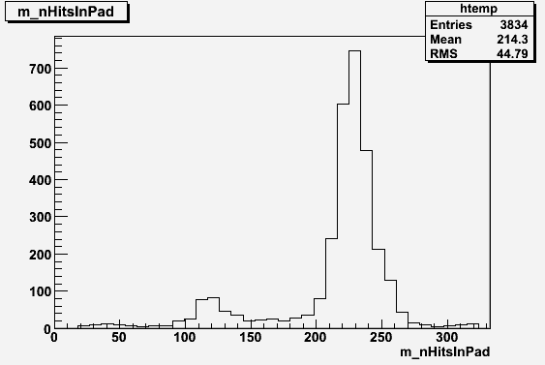

- Toward a multichip Readout

The deliverable for 2007 was an endplate infrastructure. It was indeed delivered in March 2008. It is a module that fits into the Large Prototype,

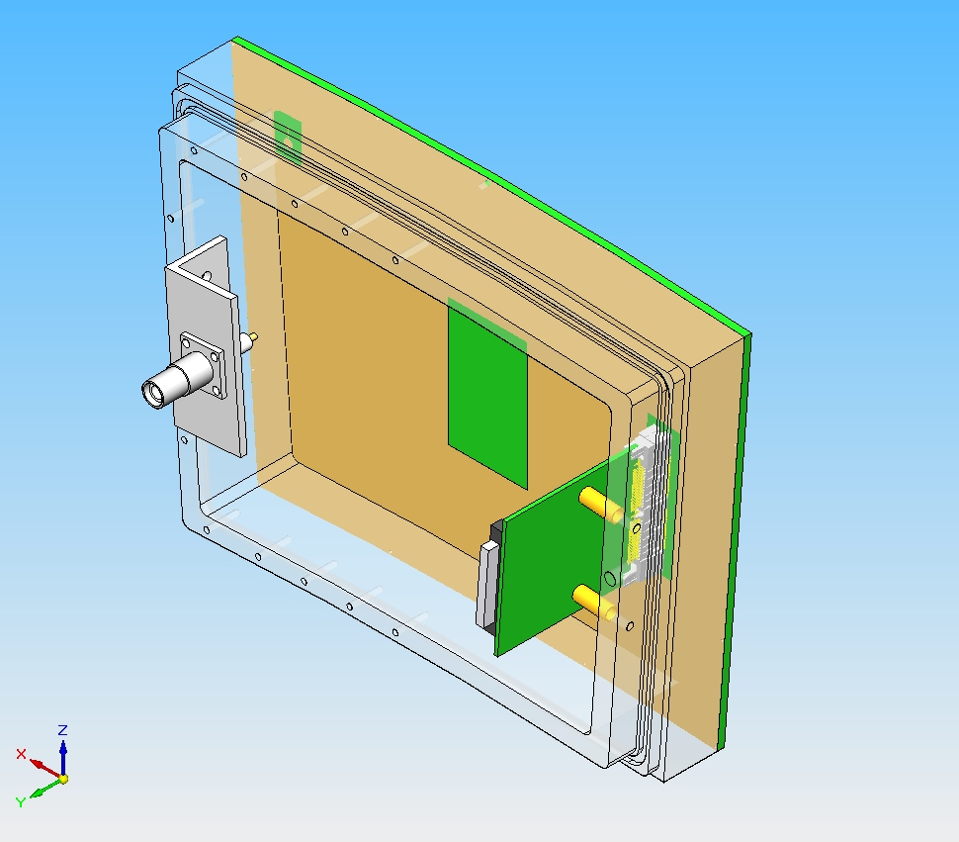
- Development of a software framework
- Summary
A total of 38 additional TimePix wafers, representing 4000 2-cm² chips have been made available this year for future use.
A number of detailed studies have been caried out. A map of the holes of a GEM foil could be obtained as a TimePix image. Operation of a GridPix detector in a magnetic field has been tested. Electron counting in converted x-rays has been carried out for the first time. Mechanical studies of the meshes subjected to high frequency vibrations have been carried out, and the first successful operation of a twingrid has been achieved. Chip processing allowed to group several pads together. Last but not least, Si₃N₄ has been shown to be a new and efficient protection for the sparks, making of it a good competitor with amorphous Silicon.
Also modules able to supply and read out up to 8 chips have been designed and will probably be able to take data in 2009 at the EUDET test facility.

Acknowledgement
This work is supported by the Commission of the European Communities under the 6th Framework Programme "Structuring the European Research Area", contract number RII3-026126.

References

[1] M. Chefdeville, H. van der Graaf, F. Hartjes, J. Timmermans, J. Visschers, V.M. Blanco Carballo, C. Salm, J. Schmitz, S. Smits, P. Colas, I. Giomataris
‘Pulse height fluctuations of integrated Micromegas detectors’, Nucl. Instrum. Methods A591 (2008) 147.

[2] M. Chefdeville, ‘Development of Micromegas-like gaseous detectors using a pixel readout chip as collecting anode’, PhD thesis at Universiteit von Amsterdam and Université Paris Sud XI, January 2009.

[3] P. Colas et al., ‘Electron counting and Energy Resolution Study from X-Ray Conversion in Argon Mixtures with an InGrid-TimePix Detector’, talk given at IEEE/NSS Dresden (october 2008)

