

Silicon Sensors for LumiCal

Status Report

W. Wierba, J. Błocki, W. Daniluk, A. Galas, E. Kielar, J. Kotuła, A. Moszczyński, K. Oliwa,
B. Pawlik, L. Suszycki, L. Zawiejski
Institute of Nuclear Physics Polish Academy of Sciences, Cracow, Poland

July 30, 2026

Abstract

The silicon-tungsten calorimeter LumiCal, located in very forward region of the future detector at the International Linear Collider, is proposed for the precise luminosity measurements based on the Bhabha scattering process. For this purpose, the precise measurement of the scattering polar angles is crucial. A silicon–tungsten sandwich calorimeter with fine–segmented silicon sensors has been designed. This paper describes current design of silicon sensors for the LumiCal prototype based on available silicon technologies and status of sensors manufacturing.

- Introduction
In the future detector for the International Linear Collider ILC [1], the very forward region is a particularly challenging area for instrumentation. The LumiCal detector [2] is expected to give the required precision of 10⁻⁴ luminosity measurement and to extend calorimetric coverage of small angles from ~40 to ~80 mrad. The luminosity measurement will be based on detection of Bhabha event rate. The precise measurement of the scattering polar angles [3] requires fine segmented silicon sensors and an ultimate precision in detector mechanical construction and metrology [4].
- Silicon Sensors
The proposed LumiCal detector will consists of 30 layers of tungsten of 1 radiation length thickness and 320 μm silicon sensors layers. The sensitive region extends from 80 mm to 195.2 mm in radius. Each such layer will include 48 azimuthal sectors. The sector will be segmented into 64 radial pads with a constant pitch of 1.8 mm. The sensor plane will be built from a few tiles because the current technology is based on 6-inch wafers. One silicon sensors half plane is shown in Fig. 1.
The tiles of the silicon sensors will be glued to a thin Kapton foil placed directly on a tungsten surface for electrical insulation.

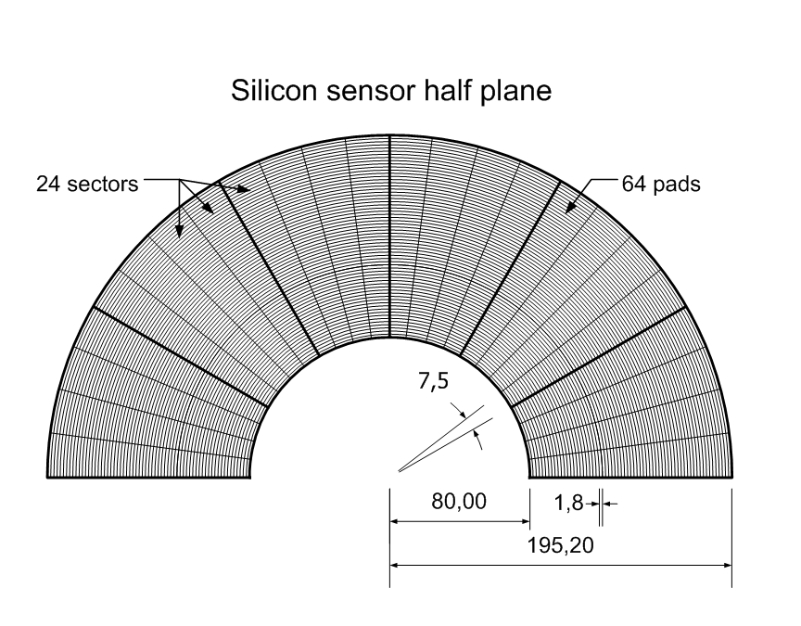

Fig. 1. Silicon sensors half plane

Reference marks are foreseen on the detector surface for precision positioning. The layout of the sensors and the mechanical design of the calorimeter does not allow sensor to overlap. To reduce of the impact of the gaps odd and even planes are rotated by 3.75°. The silicon diodes will be usual planar high resistive silicon sensors.
Figure 2. shows one silicon detector of the proposed structure of 4 sectors and 64 pads in radius. To cover one full plane of the LumiCal 12 silicon tiles with 3072 pads are needed.
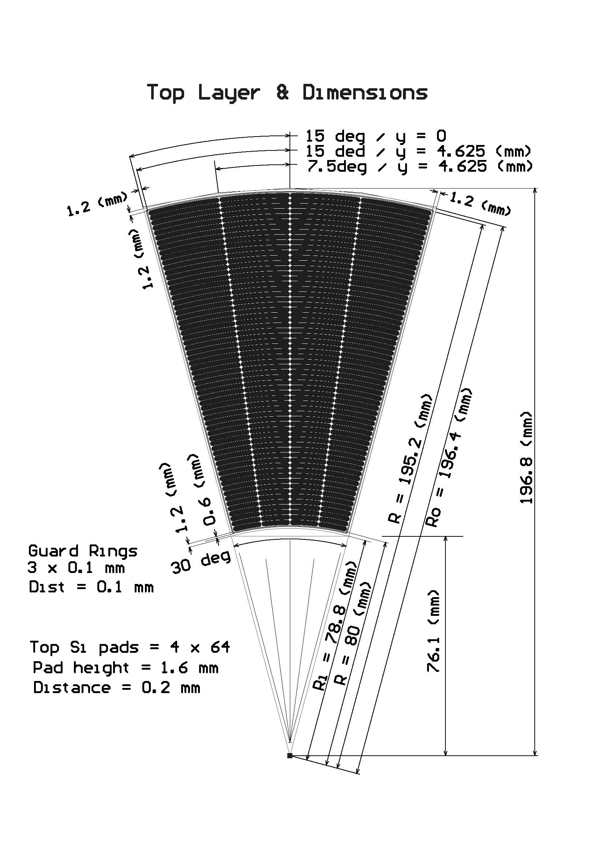

Fig. 2. The proposed segmentation of the silicon sensor.

The mechanical gap (clearance) between every two tiles is foreseen to be 0.1 mm as shown in Fig. 3. Counting also the guard rings of 0.6 mm wide and roughly 0.6 mm clearance for wafer cutting, the inactive gap between the tiles has a width of ~2.5 mm. This gap width has to be taken into account in the MC simulations. The azimuthal gaps are staggered by rotation for odd and even layers of the detector.
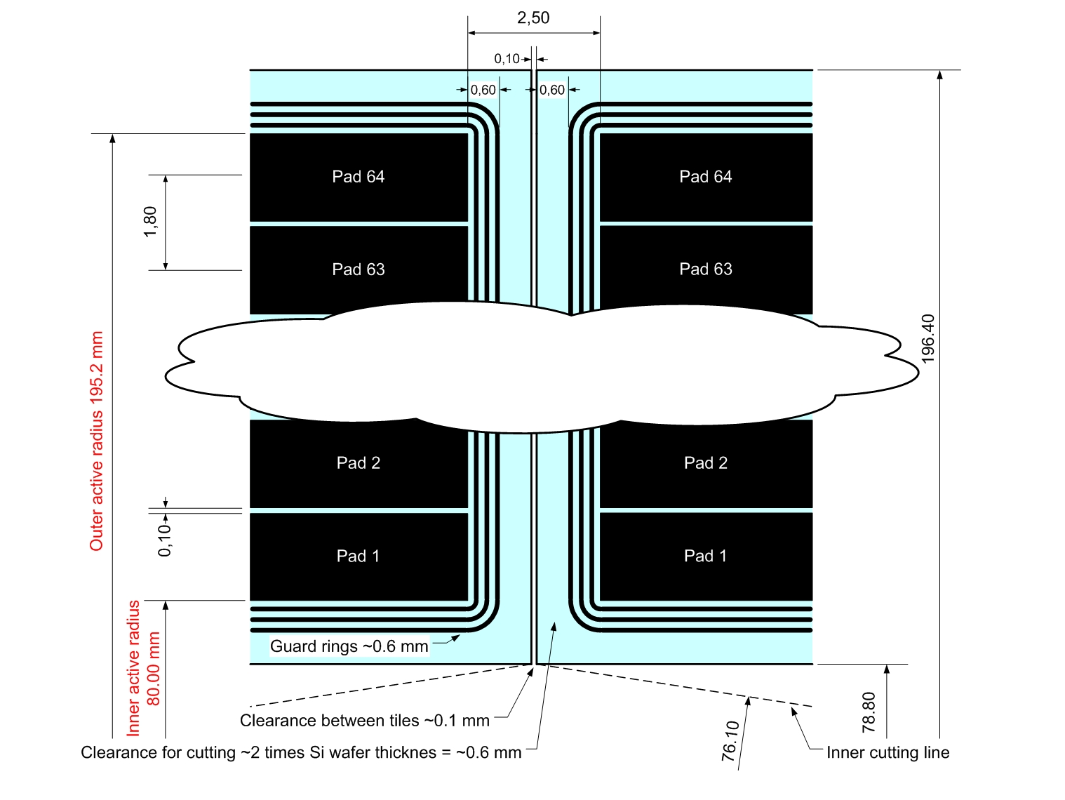

Fig. 3. Detailed drawing of the gap between tiles.
In collaboration with Hamamatsu firma the set of masks has been designed, produced and already paid. In Fig. 4 & 5 the more detailed drawings of the design are presented.

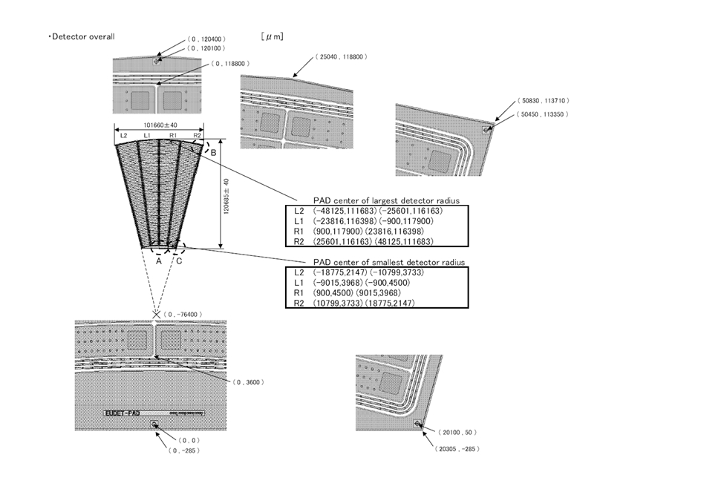

Fig. 4. Detailed drawing of the Silicon Sensors for LumiCal design.
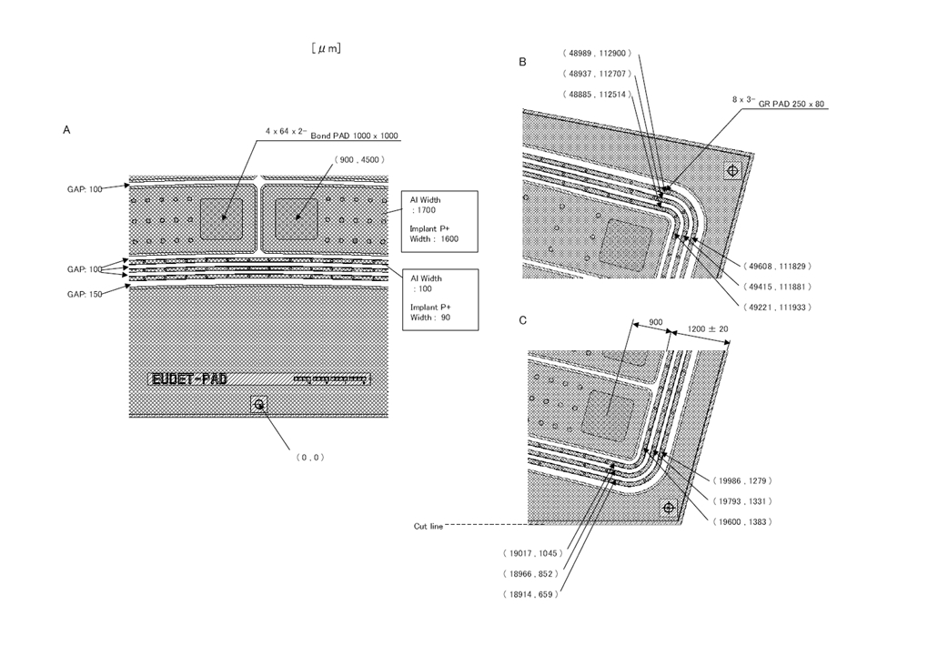

Fig. 5. Details of the design.

The basic parameters for silicon sensors are:
- N-type silicon, p⁺ strips, n⁺ backplane,
- Crystal orientation <100>
- 320 μm thickness ± 15 μm
- Strip pitch 1.8 mm
- Strip p⁺ width 1.6 mm
- Strip Al metallization width 1.7 mm.
Hamamatsu needs roughly 3 month to manufacture sensors, the order is in preparation.

- Fan out
To feed out the charge signals from detector pads we have designed the fan out on 50 μm Kapton foil. Fan out, presented in Fig. 6. covers 4 sectors of detector (one tile) and in present stage has two different traces layout to test the cross talks.
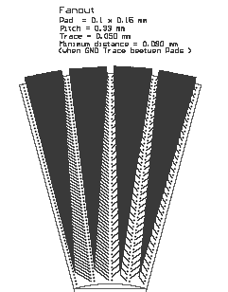

Fig. 6. Fan out.

The major problem is to connect electrically fan out traces on Kapton foil with pads of silicon detector. We can not use wire bonding because there is no space in height for it. One solution is bump bonding – quite complicated and expensive technology. We try to solve this problem using electrically conductive glue as shown in Fig. 7.
To be able to play with different glues not using expensive silicon sensors, we have designed ‘dummy’ sensor – pads in silicon sensor shape on standard PCB shown in Fig. 8 left. The fan out glued to the ‘dummy’ sensor is presented in Fig. 8 right.
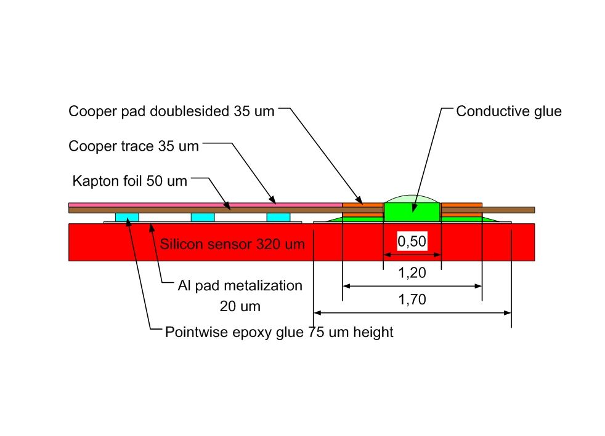

Fig. 7. Cross section of the fan out electrically conductive gluing to sensor pad.

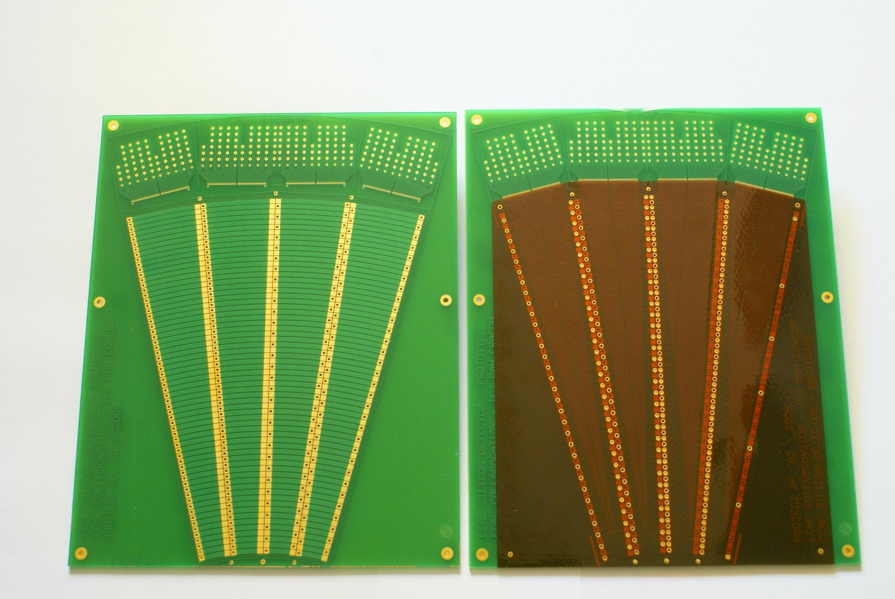

Fig. 8. ‘Dummy’ sensor on PCB (left), fan out glued to the ‘dummy’ sensor (right).

- Conclusions
Sensors prototypes hopefully will be ready by the end of this year or in first weeks of 2009. Three institutions in Poland, Germany and Israel have to order sensors in Hamamatsu in the same time, that together we will order higher amount of sensors which reduces significantly the price per tile.
We are not satisfied with quality of the fan out on Kapton foil produced in one polish firm and we have to find and test other PCB manufacturer.
Searching for the proper electrically conductive glue and test it is now a main task. We are in contact with experts from different collaborations trying to use their experience.

Acknowledgement
This work is partly supported by:
The Polish Ministry of Science and Higher Education
under Agreement No. 141/6.PR UE/2007/7
and
Commission of the European Communities under the 6th Framework Programme “Structuring
the European Research Area”, contract number RII3-026126.

References
- International Linear Collider: http://wwwlinearcollider.org/cms
- TESLA Technical Design Report, DESY 2001-011, ECFA 2001-209, March 2001; H. Abramowicz et al., IEEE Transactions of Nuclear Science, 51 (2004) 2983;
R&D for ILC – Detector, Instrumentation of the Very Forward Region, The Forward Calorimetry (FCAL) Group, DESY PRC R&D Report 02/01, April, 2006;
Large Detector Concept, LDC outline document: http://www.ilcldc.org/documents .
- A.Stahl, Luminosity Measurement via Bhabha Scattering: Precision Requirements for the Luminosity Calorimeter.,LC-DET-2005-004, Apr 2005.
- J. Błocki et al., Laser measurement of the LumiCal detector displacement, Report No. 1985/PH , 2006, IFJ PAN, Cracow, Poland.

AGH University of Sciences and Technology, Cracow, Poland

