

LumiCal mechanical design proposal

and

integration with ILD

W. Wierba,
J. Błocki, W. Daniluk, A. Galas, E. Kielar, J. Kotuła, A. Moszczyński, K. Oliwa,
B. Pawlik, L. Suszycki, L. Zawiejski

Institute of Nuclear Physics Polish Academy of Sciences, Cracow, Poland

on behalf of the FCAL collaboration

July 28, 2026

Abstract

Two LumiCal calorimeters will be located in very forward region of the future ILD detector at the planned International Linear Collider (ILC) on both sides of the interaction point (IP). Both LumiCal’s will be used for precisely luminosity measurement and consist of thirty tungsten plates intersected with segmented silicon sensors planes. The actual position of each silicon detector plane relative to each other has to be stable within ~10 µm and the position of the calorimeter relative to the beam line and the interaction point should be known with accuracy of a few hundred micrometers. To achieve this goal the structure of the calorimeter has to be very stiff. The aim of this paper is to describe the proposed mechanical structure of the detector, which can fulfill the stiffness requirement. The space for fan out, front-end electronics and cooling system is also discussed. The integration with ILD detector is focused on possible fixing LumiCal inside ILD and space for cables and cooling pipes.
- Introduction

In the future detector for the International Linear Collider (ILC, with colliding beams of electrons and positrons e⁺e⁻) [1], the very forward region is a particularly challenging area for instrumentation. The LumiCal detector [2] is expected to give a required precision luminosity measurement and to extend calorimetric coverage of small angles of electron emission from 27.5 to 83.1 mrad. The luminosity measurement will be based on detection of Bhabha event rate and a relative precision of the integrated luminosity of 10⁻⁴ will be enable. A precise measurement of the scattering polar angles requires an ultimate precision in detector mechanical construction and metrology.

- Design overview
On both sides of the interaction point there will be one LumiCal detector. Each calorimeter is in a form of a barrel which is divided into two parts along the vertical plane .The proposed LumiCal detector will consists of 30 layers of tungsten of 1 radiation length thickness and 320 μm silicon sensors layers. The sensitive region extends from 80 mm to 195.2 mm in radius. The outer radius of calorimeter is foreseen to be 260 mm to cover the space for front end electronics, readout cables, cooling and precision positioning sensors. The mechanical inner radius is 76 mm.
The proposed design overview is presented in Fig. 1.

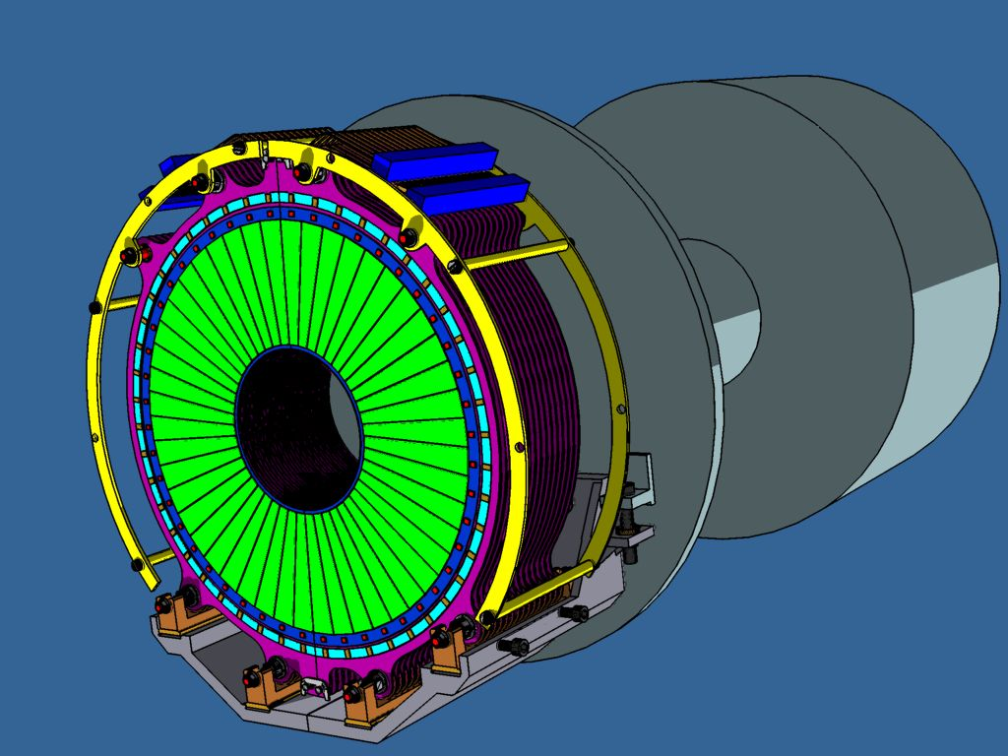

Fig. 1. LumiCal mounted on supporting tube.
- Tungsten plates
The tungsten plate thickness will be 3.5 mm (1 radiation length) and the shape is shown in Fig. 2.

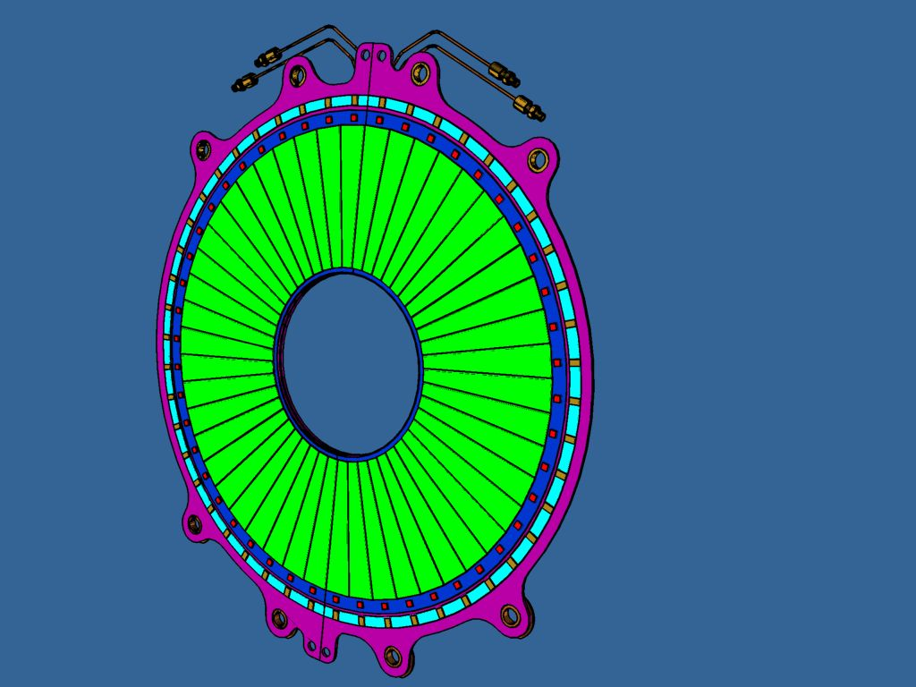

Fig. 2. One tungsten plane with silicon sensor glued on and front end electronics.

The tungsten plates have to be divided into two parts to allow detector to be clamped on vacuum beam pipe.
More detailed drawing of one half plate is presented in Fig. 3.

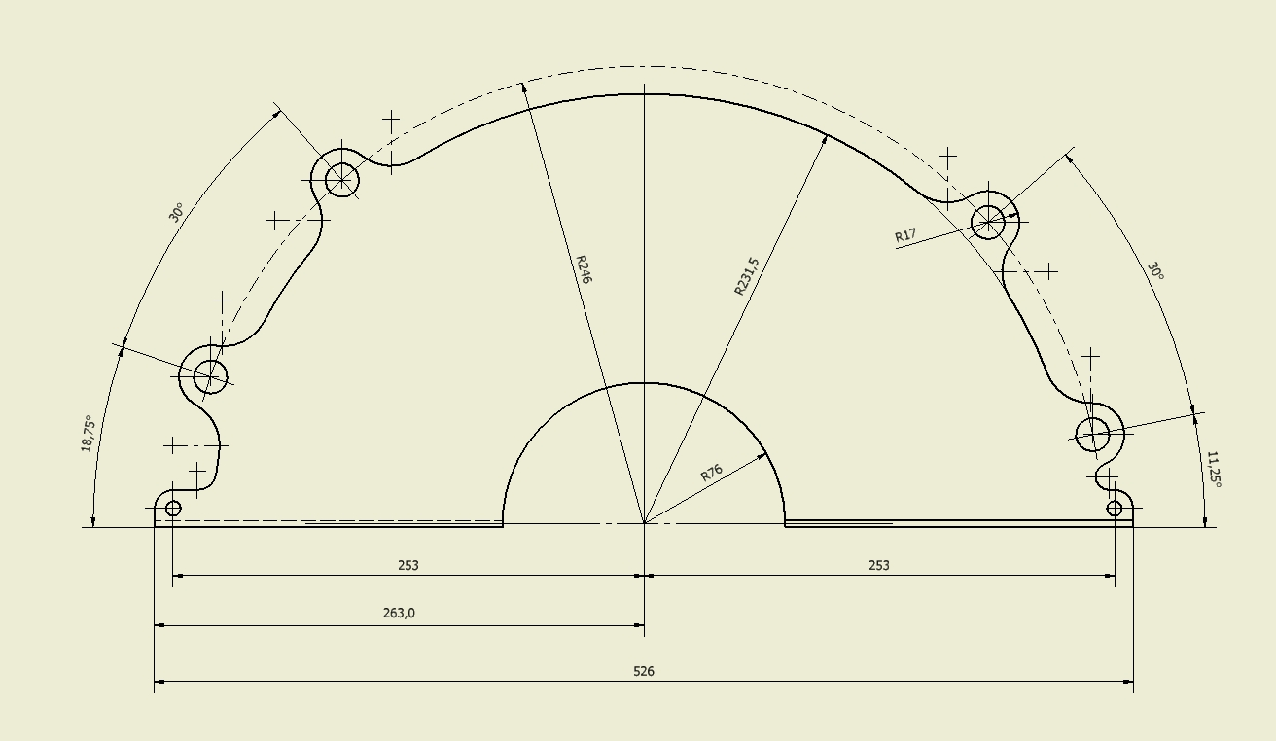

Fig. 3. Detailed shape of one tungsten half plate.

To define the center of gravity of one part of the detector the following formulae has been used

$x_{s}=\frac{4}{3π}⋅\frac{R_{2}^{3}−R_{1}^{3}}{R_{2}^{2}−R_{1}^{2}}$.

For R₂ = 231,50 mm and R₁ = 76 mm, we have x_{s} ≈ 106 mm, as it is shown in Fig. 4. It is assumed that there are two support points for the half of the barrel in an equal distance (57 mm) from the gravity center in the horizontal direction (see Fig.4).

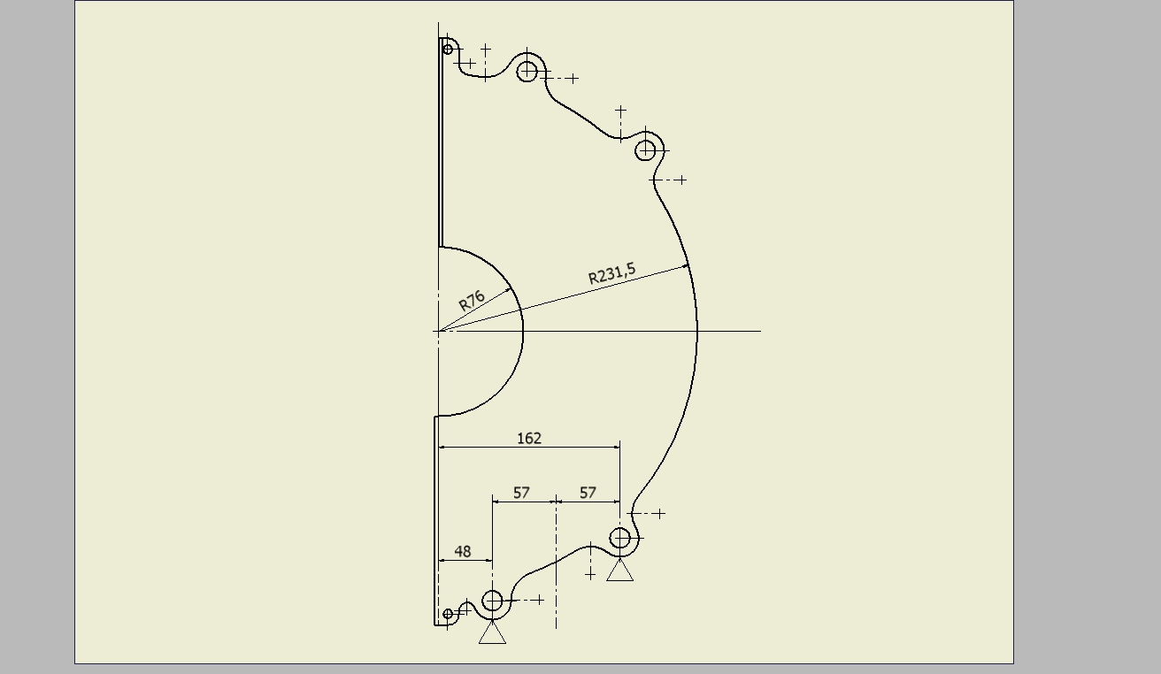

Fig.4. The position of the gravity center.

In fact, for each tungsten plate a plane of the division into two parts is not along the vertical plane but rather along a plane which is rotated around the central axis of the barrel by +3.75 deg or -3.75 deg as it is shown in Fig. 5.

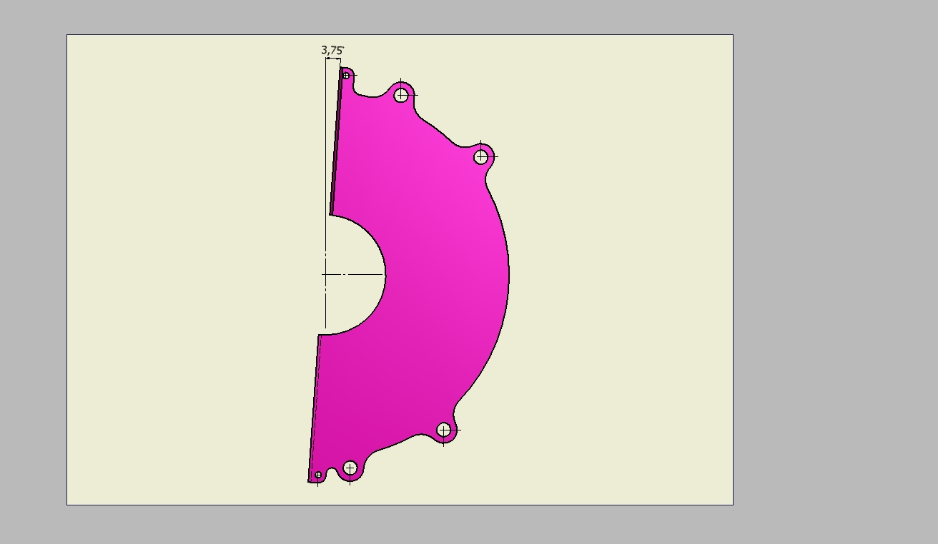

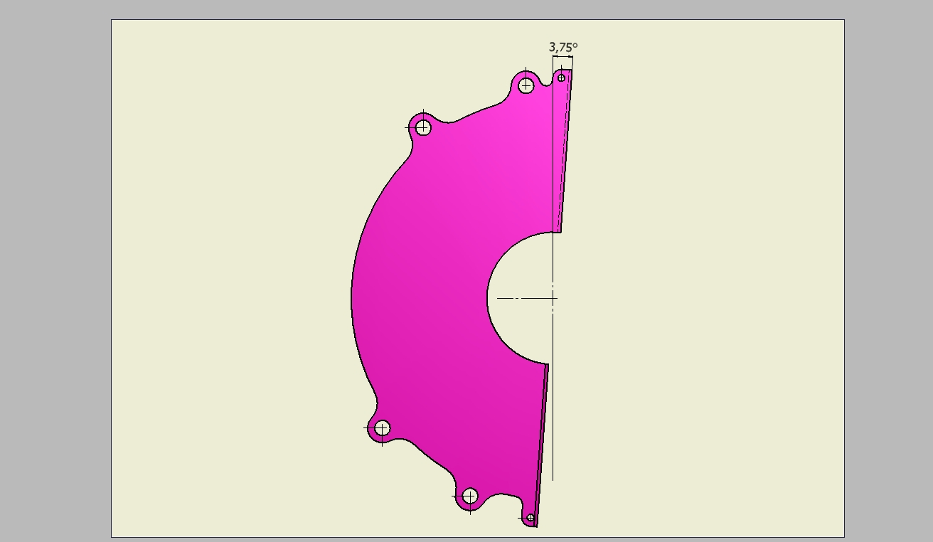

Fig. 5. The tungsten plate (+3.75 & -3.75 deg).

It has to be pointed out that the tungsten plate (+3.75 deg) has the same shape as the tungsten plate (-3.75 deg). It means, that the barrel is composed of only one type of the tungsten plate.
To assemble the calorimeter we need two types of rings shown in Fig. 5. These rings are used as inserts (see Fig. 6) what means that after connecting them with the tungsten plate the inner ring hole is very precisely bored. Now, using special bolts (M12) the barrel can be assembled and placed on the support (see Fig. 7). What is important is that the tension in bolts should be about 15 MPa. The half of the barrel is composed of thirty tungsten plates to which on the one side silicon detectors have been glued.

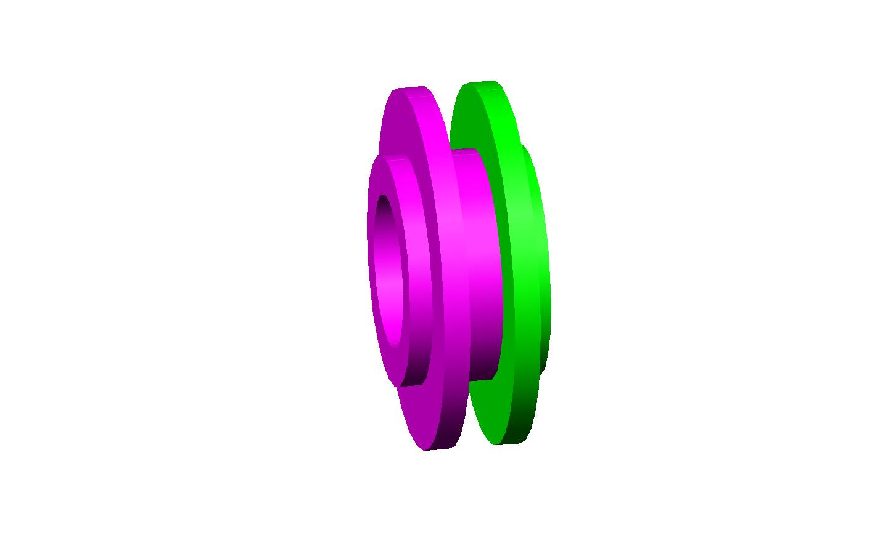
Fig. 5. Rings.

The main advantage of the new design is its simplicity. The structure is composed of very limited number of elements. We have one type of the tungsten plate, two types of the rings, the special M12 bolts and two supporting C frame.
- Half barrel closing
Each LumiCal detector is divided into two half barrels clamped on the vacuum beam pipe. Every tungsten plane and silicon sensors are divided into two half parts for that purpose as shown in Fig. 7.
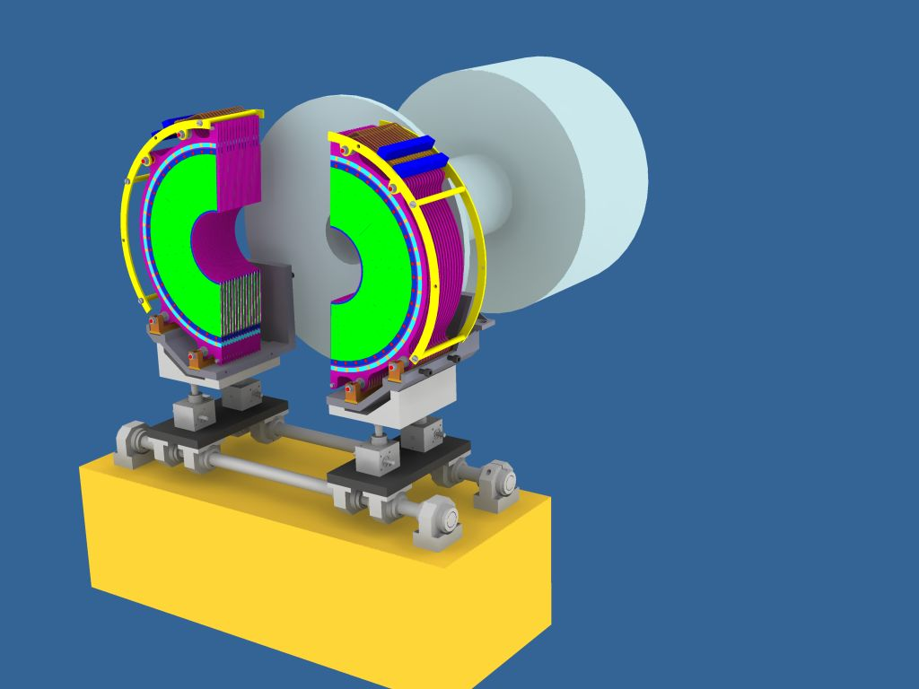

Fig. 7. Closing the LumiCal on beam pipe with help of temporary support.

Left and right part of LumiCal barrel should not have a gap in tungsten absorber when closed. There are three possibilities shown in Fig. 8.
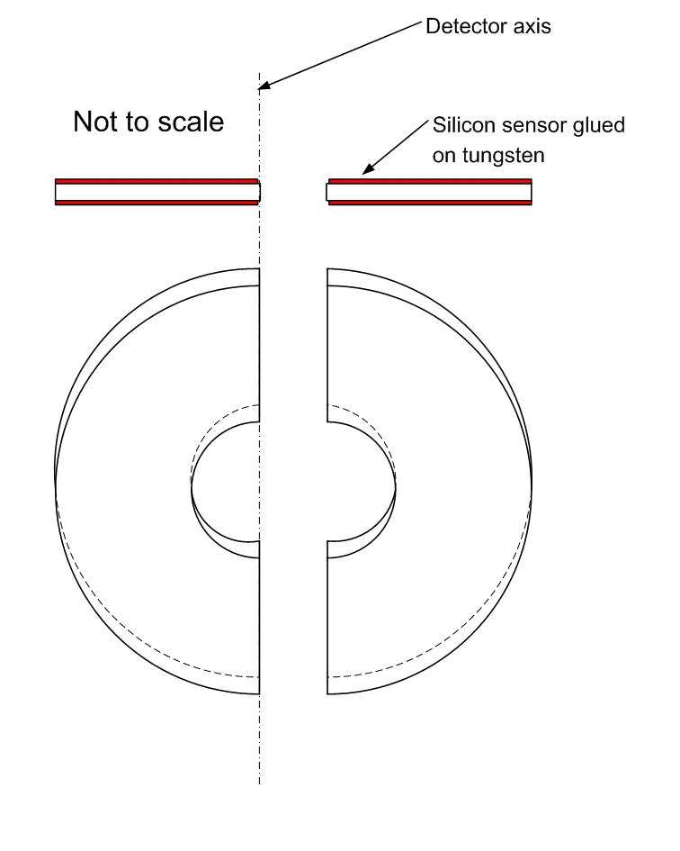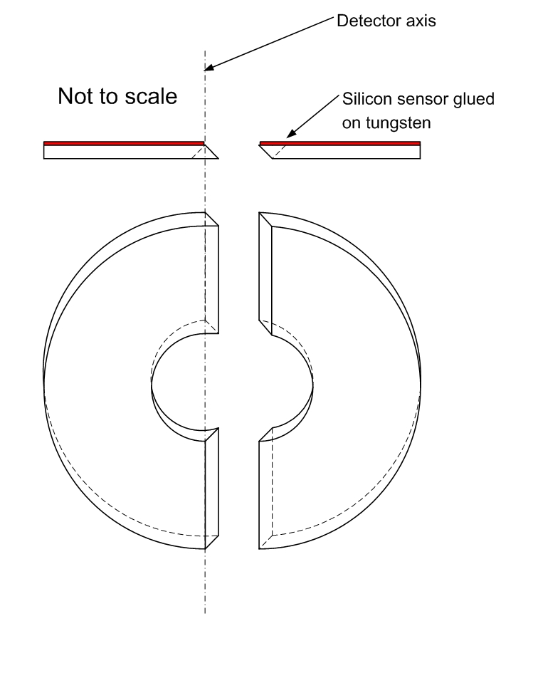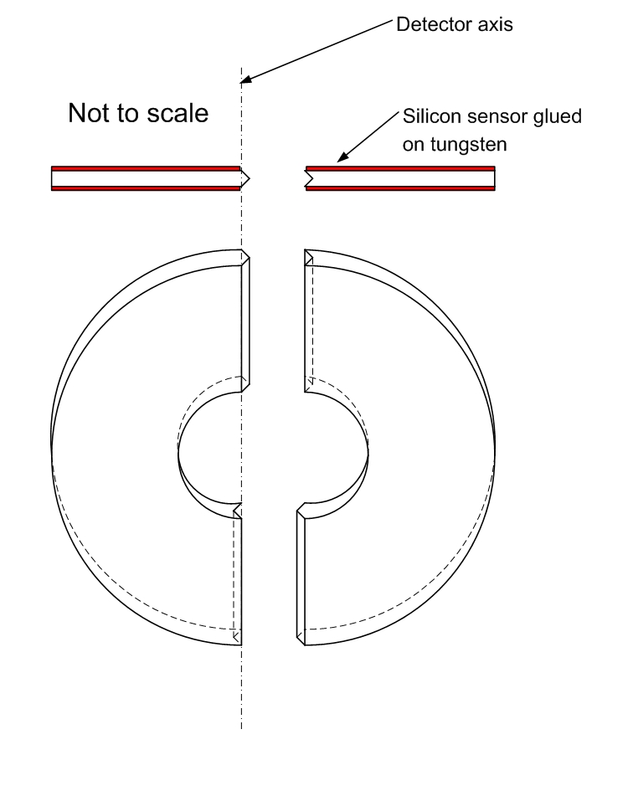

Fig. 8. Possible closing of tungsten half planes.

First solution on left does not avoid the gap in tungsten, the second one (in middle) is quite easy to manufacture and acceptable but it is not possible to glue silicon sensors on both sides of tungsten absorber. The third solution has no gap, allows to glue silicon sensors on both sides of tungsten absorber, but is complicated to manufacture. Idea that silicon sensors are glued on the both sides of the fifteen tungsten plates has a remarkable advantage because the number of silicon planes which the position should be monitored is reduced from thirty to fifteen. In addition, the structure fulfills the symmetry condition what is very important from the point of view of thermal deformations. But, due to problem in manufacturing the closing in shape shown on right in Fig. 8. we have decided to use the 45 degree solution (in middle in Fig. ).
- Space for electronics
One LumiCal will have 92160 electronic readout channels. On one half plane it should be a place for 1536 electronic channels. We foresee a space as shown in Fig. 9.

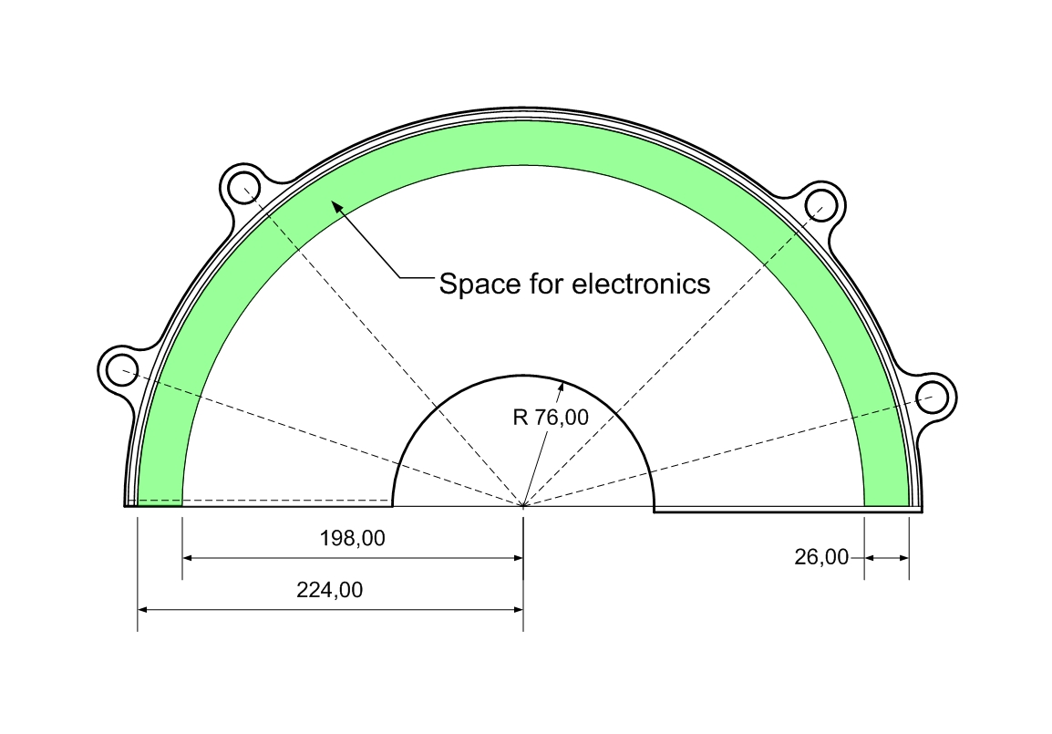
Fig. 9. Space for front end electronics on one half plane.
The cross section of a spaced for electronics is presented in Fig. 10.

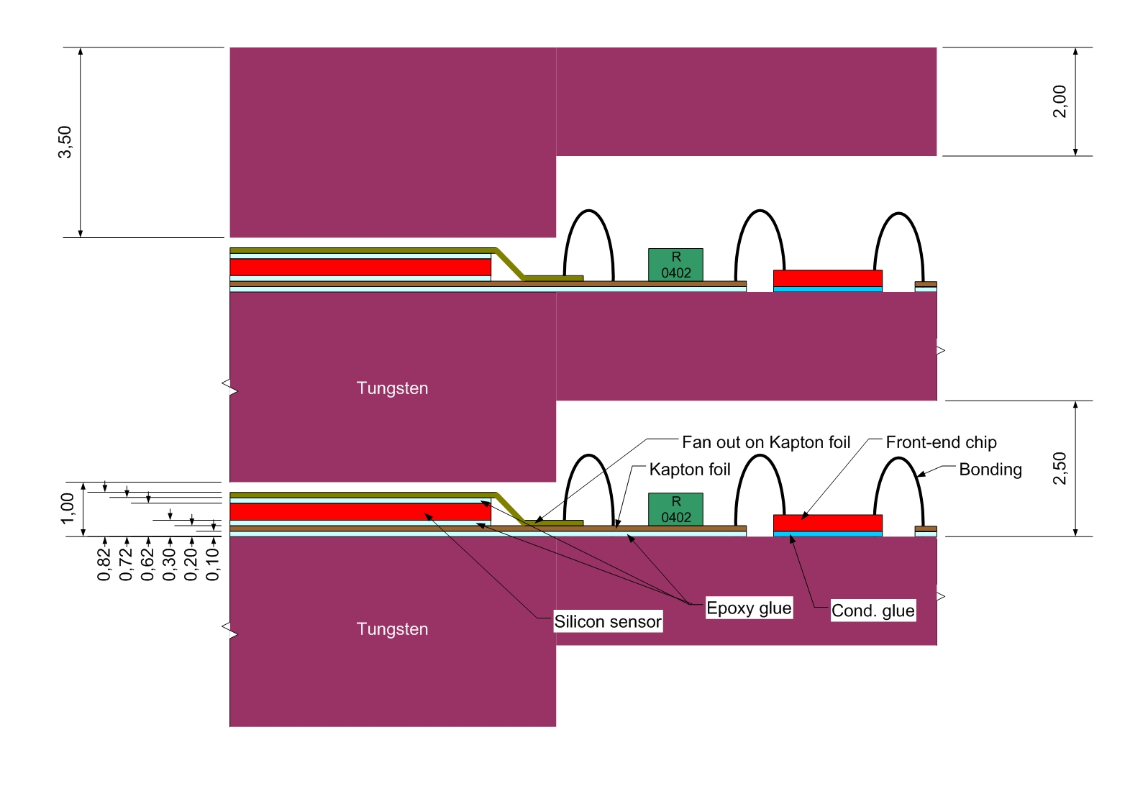
Fig. 10. Cross section showing fan out connections to the front end electronics chips.

There is enough space to use a standard wire bonding for electric connections. The major problem is to connect electrically fan out traces on Kapton foil with pads of silicon detector. We can not use wire bonding because there is no space for it. One solution is bump bonding – quite complicated and expensive technology. We try to solve this problem using electrically conductive glue as shown in Fig. 11.
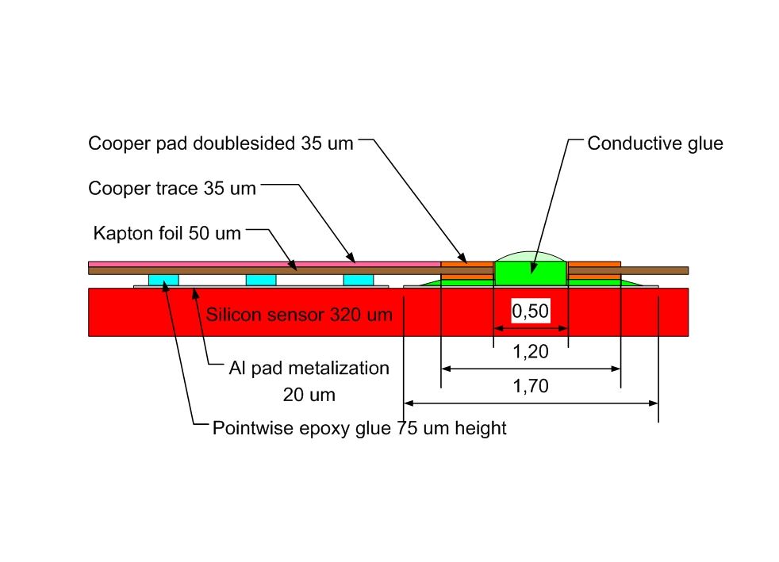

Fig. 11. Fan out gluing.
- Influence of mechanical design on LumiCal performance
Material used for absorber, bolts and spacing rings have some influence on the LumiCal performance and their temperature and electrical behavior have to be taken to account in the next design step.
  - Thermal expansion
It is foreseen to use the cooling water as a temperature stabilization medium for the LumiCal. Lets assume the temperature change of 1 ºC which seems to be a save estimation. Probably, it is possible to stabilize the temperature of one LumiCal within ± 0.2 ºC.
The most important parameter for luminosity measurement is an inner radius of LumiCal silicon sensors. This parameter should be known and stable with the accuracy better than 4 µm. The silicon sensors are glued on the tungsten absorber with Kapton E foil insulation.
Tungsten has a very small coefficient of thermal expansion α (CTE = 4.3 x 10⁻⁶ K) in comparison with aluminum (~5 times higher) or standard steel (~3 times higher). The inner radius of LumiCal absorber (76 mm) will expand thermally by 0.33 µm/ºC. The outer active radius (195.2 mm) will change by + 0.84 µm/ºC and the outer mechanical radius of detector (260 mm) will expand by + 1.12 µm/ºC. Silicon has coefficient of thermal expansion α (2.5 x 10⁻⁶ K) ~2 times smaller than tungsten. Simplified drawing is shown in Fig. 12.

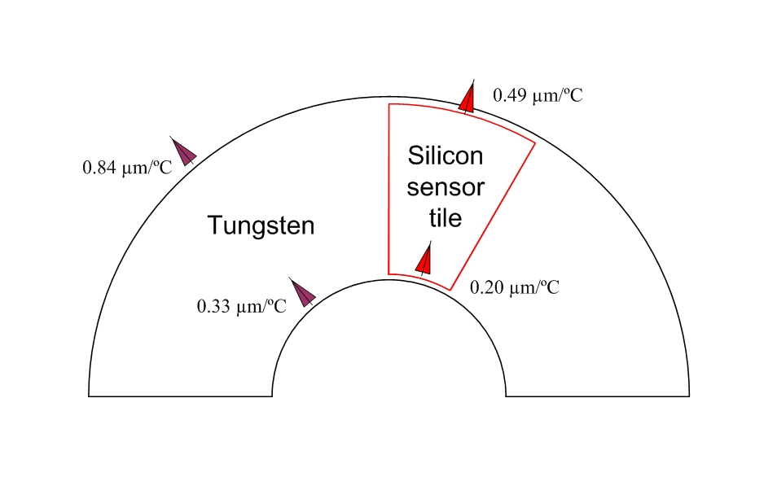
Fig. 12. Thermal expansion of the half plate of tungsten absorber and silicon sensor tile glued to the tungsten.

Silicon sensor tiles are glued (epoxy adhesive, CTE = 25 x 10⁻⁶ K) to the tungsten absorber with some Kapton E foil (CTE = 16 x 10⁻⁶ K) insulation, it is clearly seen, that silicon sensor tiles and Kapton foil have to be stuck pointwise to tungsten. In that case, we can roughly estimate that the inner active radius of LumiCal will expand less than 0.5 µm/º C and outer radius less than 1.5 µm/º C. In real life the thermal expansions of tungsten and silicon will compensate a little (depending on position of the glue dots).
MC simulations have proved that inaccuracy in distances among tungsten plates and silicon sensors along the LumiCal axis less than 50 µm has negligible influence to the luminosity measurement. Simplified view of bolt, spacers and rings is shown in Fig. 13.

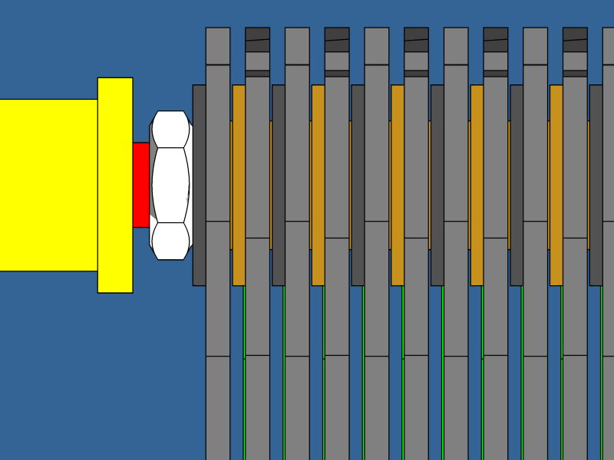

Fig. 13. Precision rings (grey) pressed into tungsten plates (light grey) and spacers (dark yellow) on M12 bolts (red) fastened the LumiCal structure.

The total length of LumiCal is 135 mm. Using steel M12 bolts and rings the detector will expand + 2.41 µm/ºC and with brass material + 2.63 µm/ºC. This estimation looks very good, the distances between two silicon sensors will change in z less than 0.1 µm/ºC that seems to have negligible influence on luminosity measurement accuracy.
  - Cooling
Front end electronics will be the major source of heat in the LumiCal. Thanks to the power cycling during brakes (199 ms) between trains (5 Hz, 1 ms) the dissipated power in one LumiCal will be around 30 W. Lets overestimate 60 W per detector which gives ~2 W per sensor plane. The water flow of 0.43 l/min. per plane will take heat off with 0.1 ºC temperature increase. The total cooling water flow in one LumiCal will be less than 15 l/min (more than 3 times overestimated).
Some details of cooling system are shown in Fig. 14.

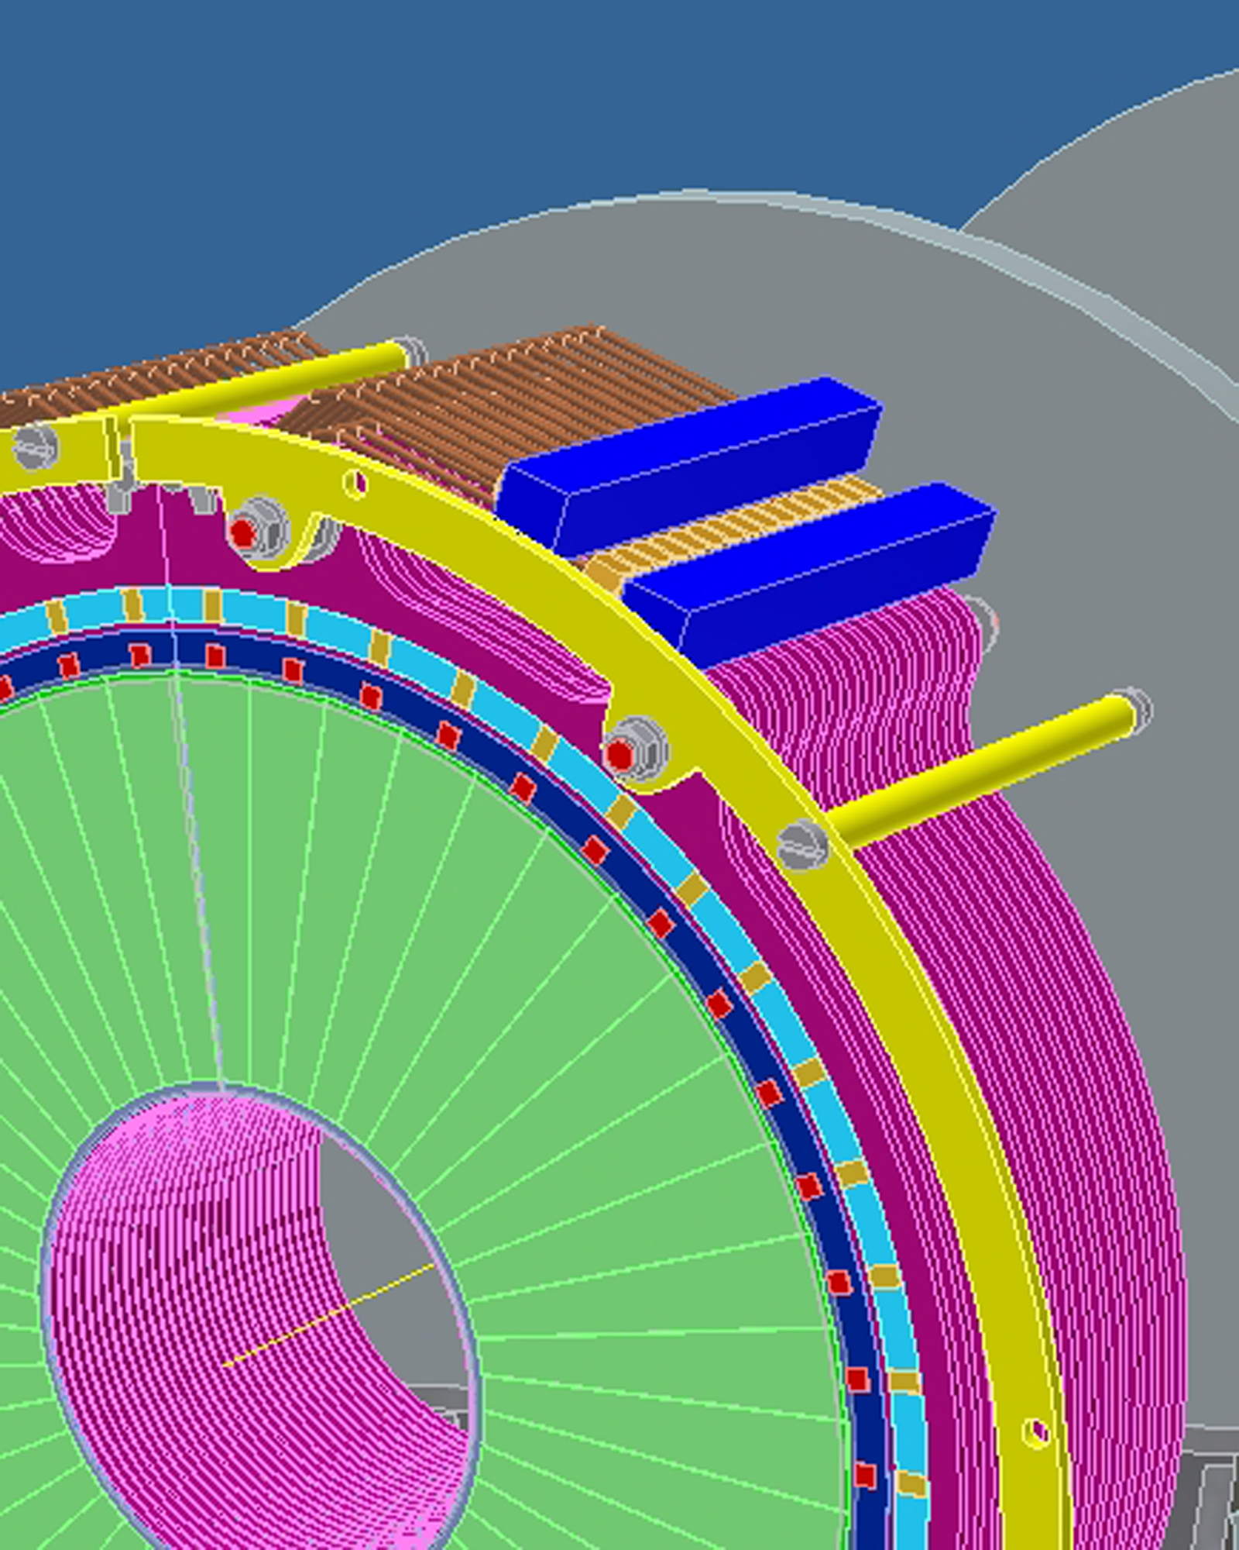

Fig. 14. Water cooling system.

The front end electronic chips will be placed directly on tungsten surface (holes in printed circuit board on Kapton foil because of low TC = ~0.19 W/m*K for Kapton – see Fig. 10) with thermal (and electrical) conductive glue – thermal epoxy (TC = ~1÷4 W/m*K). Tungsten has thermal conductivity (TC = ~200 W/m*K) a little bit smaller, but comparable with aluminum (TC = ~237 W/m*K). For the proposed placement of frond end chips and cooling water pipes we have roughly estimated the temperature of electronic chips to be +1.5 ºC and the tungsten under front electronics to be ~+0.3 ºC over the cooling water temperature (depends on thermal contact between water pipe and tungsten – not yet detailed designed).

  - Front end electronics grounding
The fast low noise front end chips will be glued directly on tungsten surface with electrical (and thermal) conductive glue (resistivity = 0.01 ÷ 0.5 Ω*cm). The resistance between electronic chip with 5 mm² substrate connected via 100 µm thick conductive glue (resistivity max. 0.5 Ω*cm) to the tungsten will be ~0.01 Ω or more less. The resistivity of tungsten (5.51 * 10⁻⁸ Ω*m) is 3 times higher than of copper (1.71 * 10⁻⁸ Ω*m) but still sufficient for electrical grounding and EMI shielding.
- Integration with ILD
The works on integration with ILD detector are concentrated on how to fix the LumiCal inside detector. The LumiCal will be fixed to the supporting tube as presented in Fig. 15.

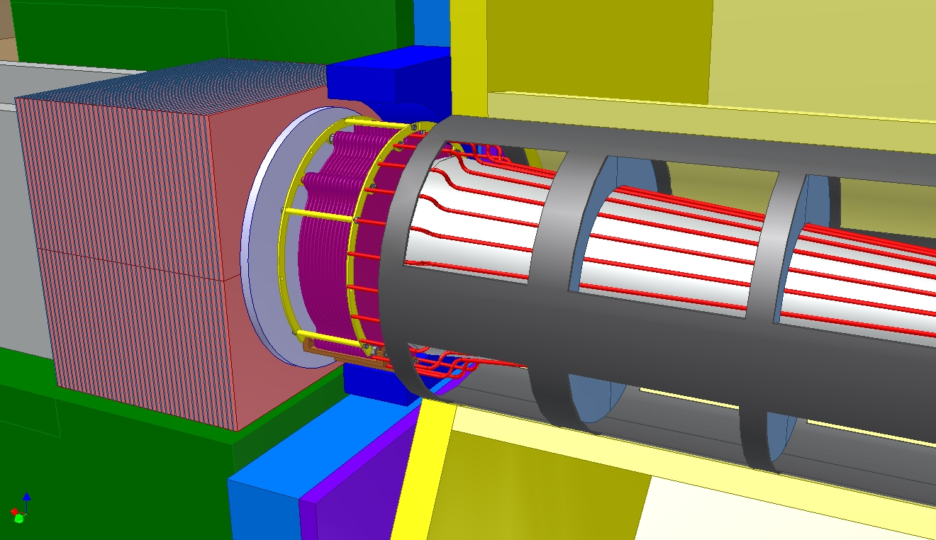

Fig. 15. LumiCal in front of LHCal, conical shape of the beam pipe.

The discussion with ILD are concentrated on the special ‘shelf’ for LumiCal positioning and fixing, see Fig. 16.

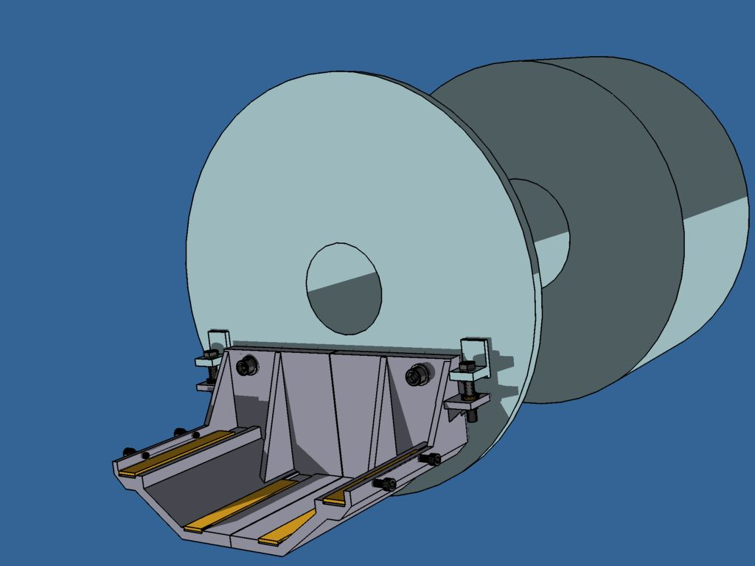

Fig. 16. “Shelf” screwed to the supporting tube to fiź LumiCal inside ILD detector.

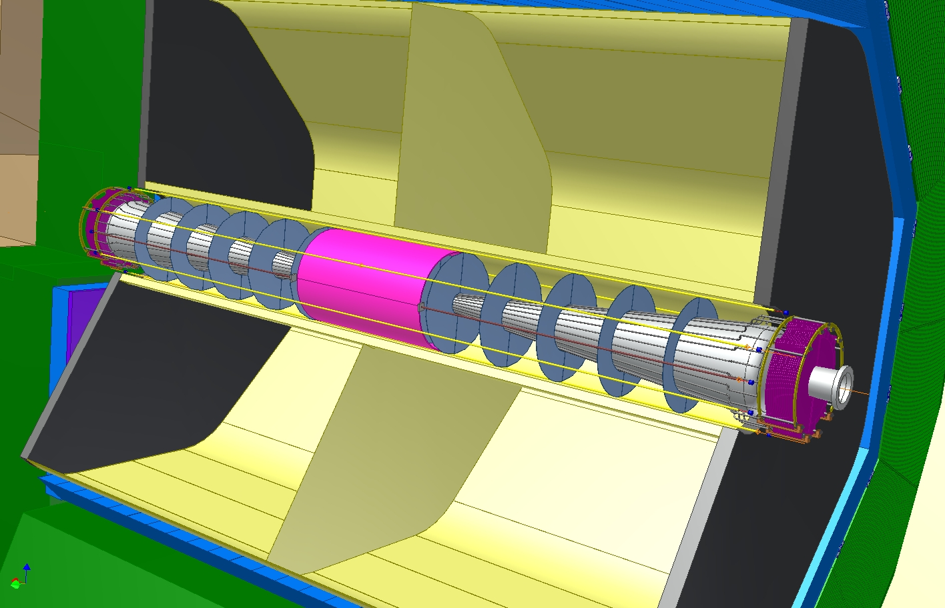

Fig. 17. Proposed laser beams for LAS.

- Conclusions
The mechanical design of the LumiCal is in a very good shape, we have proved the stiffness of proposed construction. The design is quite simply, the structure is composed of very limited number of precisely manufactured elements.
First attempt has been made to discuss place for front end electronics and evaluate the cooling needs. We have estimated the thermal expansion of mechanical structure influence on luminosity measurement accuracy. First results shows, that only the inner acceptance radius of LumiCal has to be controlled very precisely. Temperature stabilization of LumiCal within 2°C seems to be necessary. Additional online alignment sensors near the beam pipe are foreseen.

Acknowledgement

This work is partly supported by:
The Polish Ministry of Science and Higher Education
under Agreement No. 141/6.PR UE/2007/7
and
Commission of the European Communities under the 6th Framework Programme “Structuring
the European Research Area”, contract number RII3-026126.

References
- International Linear Collider: http://wwwlinearcollider.org/cms
- TESLA Technical Design Report, DESY 2001-011, ECFA 2001-209, March 2001; H. Abramowicz et al., IEEE Transactions of Nuclear Science, 51 (2004) 2983; R&D for ILC – Detector, Instrumentation of the Very Forward Region, The Forward Calorimetry (FCAL) Group, DESY PRC R&D Report 02/01, April, 2006; Large Detector Concept, LDC outline document: http://www.ilcldc.org/documents .
- A.Stahl, Luminosity Measurement via Bhabha Scattering: Precision Requirements for the Luminosity Calorimeter.,LC-DET-2005-004, Apr 2005.
- J. Błocki et al., Laser measurement of the LumiCal detector displacement, Report No. 1985/PH , 2006, IFJ PAN, Cracow, Poland.
- J. Błocki et al., A proposal for the mechanical design of the LumiCal detector, Report No. 1990/PH , 2006, IFJ PAN, Cracow, Poland.

International Linear Detector for the future International Linear Collider
AGH, University of Science and Technology, Cracow
list of members can be found: http://www-zeuthen.desy.de/ILC/fcal/

