

Laser Alignment System for LumiCal
Status report

W. Daniluk, E. Kielar, J. Kotuła, T. Lesiak, A. Moszczyński, K. Oliwa, B. Pawlik,
W. Wierba, L. Zawiejski, W. Słomiński,

July 28, 2026

Abstract

The status of work on Laser Alignment System for LumiCal detector is presented. LumiCal,
which is a part of International Large Detector, one of the detector concepts planned for future experiments on International Linear Collider, will be used for precisely luminosity measurement. The optical method for the displacement measurements of the LumiCal was tested using laboratory setup with two laser beams and CCD camera as the basic elements. The measurements achieved the accuracy ± 0.5 μm in X and Y direction and ± 1.5 μm in Z direction. The system was sensitive to temperature changes on the level ~ 1 μm over 1⁰ C. The possible extension of the system for an absolute distance measurements between the left and right part of LumiCal as well as measurements of the displacement of the individual sensor layers inside Lumical are discussed.

1 Introduction

In the future International Large Detector (ILD) [1], prepared for the International Linear Collider (ILC) [2], the luminosity detector LumiCal will be located in a very forward region, which is a particularly challenging area for instrumentation. The LumiCal detector [3], which contains two silicon-tungsten calorimeters, is expected to give a required precision luminosity measurement and to extend calorimetric coverage of small angles of electron emission from 35 to 84 mrad. The luminosity measurement will be based on the detection of Bhabha events rate and a relative precision of the integrated luminosity of 10⁻⁴ will be achievable. To fulfill this task it is necessary to build a detector with micrometer precision and to have the online running system – laser alignment system (LAS) [3,4] for a precise measurement of the positions of LumiCal with an accuracy of a few hundred micrometers and the displacement of its internal layers with an accuracy of a few micrometers. The integration of the LumiCal with ILD raises several questions related to available free space also for elements of LAS and mechanical detector installation procedure. Another problem can stem from an assurance of the access to the detector. Accordingly, further extensions and modifications of the LAS will be necessary.

2 Requirements

The luminosity measurement requires precise alignment of the two LumiCal calorimeters (Left, Right), each to the other, and very precise positioning of each of them with respect to the beam line and the interaction point, as illustrated in Fig. 1.
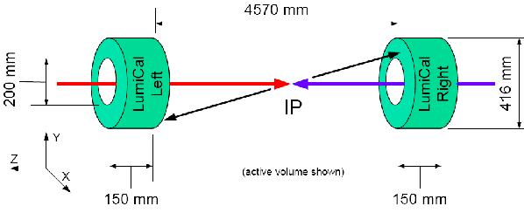

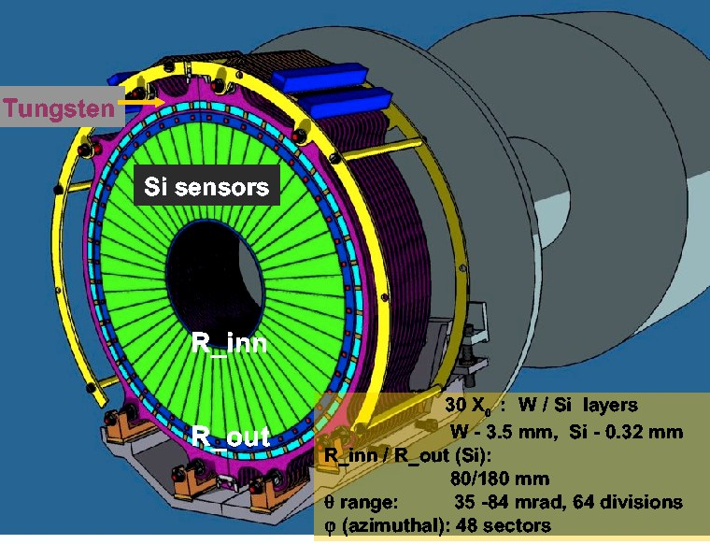
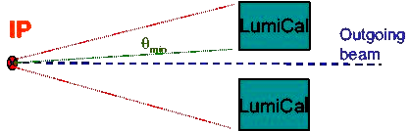

Figure 1. The parts of the LumiCal detector located in respect to Interaction Point (IP). Top: Left and Right calorimeters; Bottom: The structure of the single calorimeter.

Monte Carlo simulations have shown [3,5] that the inner radius of sensors layers have to be known with the accuracy better than 4 μm, the distance between calorimeters along the beam axis must be known to an accuracy of (60 – 100) μm over the 4.5 m distance, and the transversal displacement (X, Y) with respect to the beam should be known with the accuracy better than (100 – 700) μm. According to [2] the crossing angle for electron and positron beams at ILC will be 14 mrad and LumiCal will be centered on outgoing beam. What is particularly important for precisely luminosity measurement is the knowledge pertaining to the position of inner radius of active material (sensors) which defines the minimal polar angle θ_{min} (Fig. 1). The expected error on the relative luminosity measurement depends on this angle: ΔL/L ~ 1/θ_{min}. The initial value for this radius can be measured in the lab using optical methods and precision movable table with the cross check of interferometer. The beam pipe is proposed as a suitable reference for the distance along the beam and transversal displacement and can be precisely surveyed before installing under different conditions (i.e. temperature). The temperature and tension sensors should be installed on the beam pipe to control and correct the mechanical dimensions. Additionally, the Beam Position Monitors are mounted at a well known position inside the vacuum pipe, which allows for determining the actual position of LumiCal with respect to the beam position. The similar method can be used by choosing well known positions of QD0 magnets as reference frame. The online monitoring of the detector position should not interfere with the beam pipe, hence a non contact system is preferred. For this purpose an optical laser system with a CCD matrix sensor to measure the transversal (X, Y) and longitudinal (Z) displacement of the LumiCal with respect to the beam pipe flange has been chosen. The position sensors will be placed between the rear side of the detector and beam pipe flange. To minimize the influence of radiation in that area, the radiation hard CMOS matrix sensors will be used. The use of a few position sensors per calorimeter would give the possibility of measuring also the angle between detector axis and beam direction. For absolute measurements of the distance between two calorimeters it will be necessary to implement the frequency scanned interferometry (FSI) system.

3 Measurement setup

The principle of the method for short displacement measurements of the LumiCal is shown in Fig. 2. The laboratory setup includes the semiconductor laser module LDM635/1LT from Roithner Lasertechnik with the wavelength of 660 nm and BW camera DX1-1394a from Kappa company 640 x 480 with Sony ICX424AL sensor 7.4 μm x 7.4 μm unit cell size.
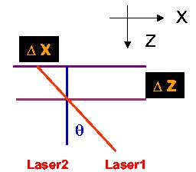
The corresponding lasers are mounted in a special precision alignment holder on the optical bank. The CCD camera is placed on the XYZ ThorLabs ½” travel translation stage MT3 with micrometers (the smallest div. 10 μm). To control independently the camera displacement the Renishaw optical head linear encoder RG24 with resolution of 0.1 µm was used. In the case of the sensor saturation, the reduction of the amount of laser light was done using three neutral density filters with the attenuation factor of 2 each. The principle of the method for the LumiCal displacement measurements with LAS is presented in Fig. 2. The camera was translated in one (X,Y) direction in 50 μm steps and the picture was taken. To measure the longitudinal (Z) displacement the second laser beam lighting the sensor with the angle of 45 degrees was used.

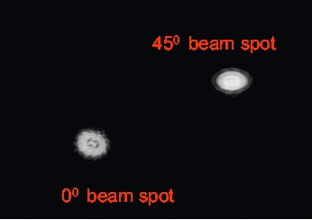
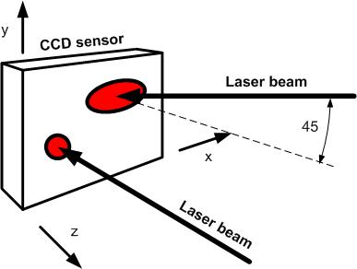

Figure 2. Simplified diagram of the method with two laser beams which create the spots observed on CCD camera.

The picture of the laboratory setup, which is shown in Fig. 3, was used to test the LAS and to find its accuracy and sensitivity to posible changes of the temperature environment.

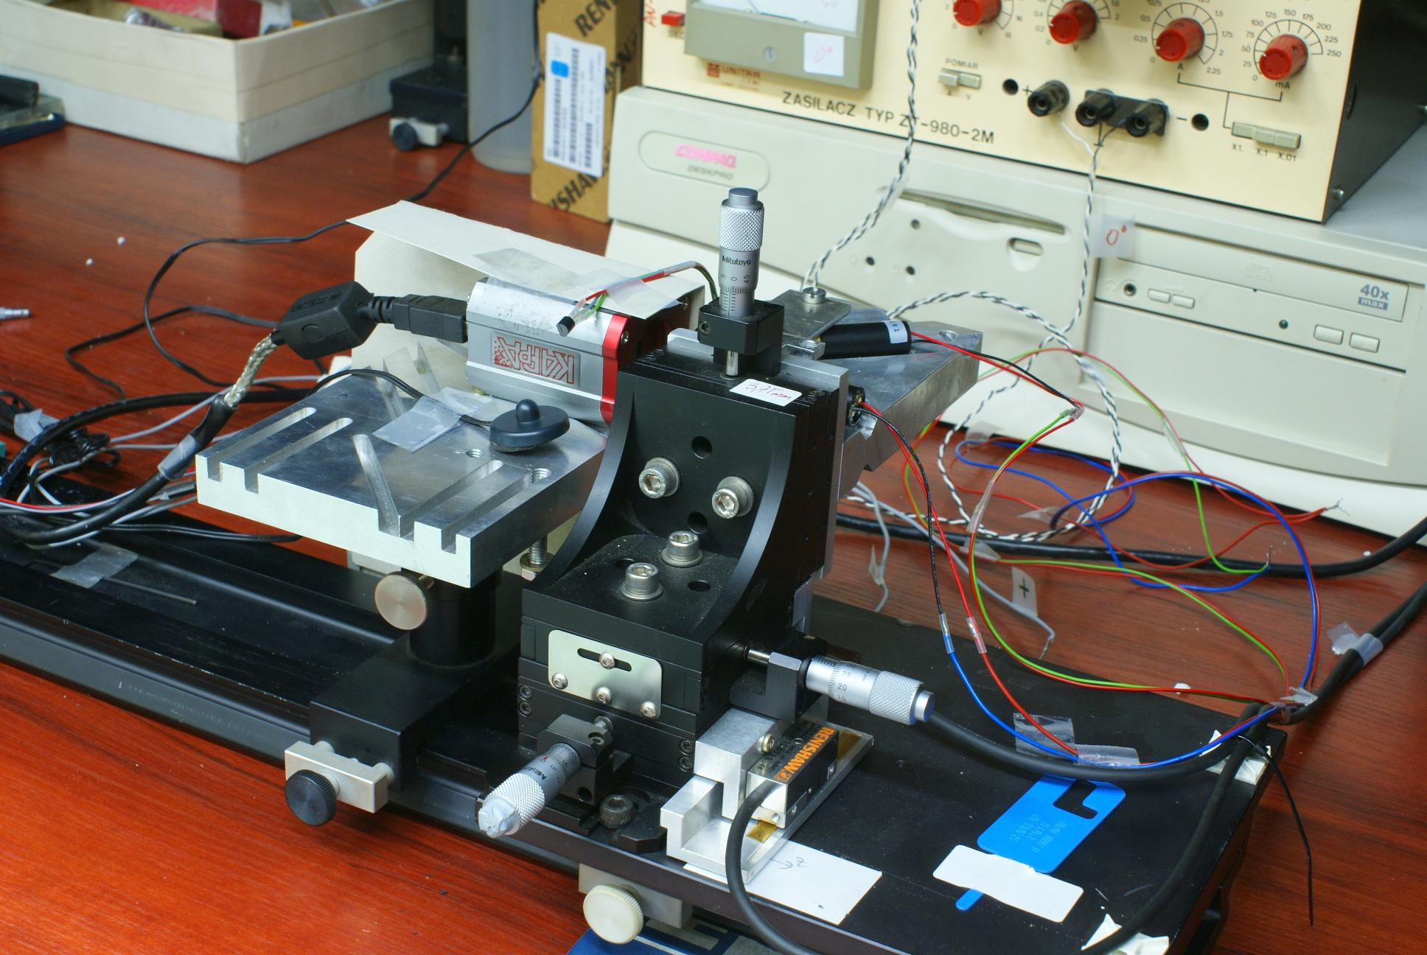

Figure 3. Picture of the laboratory setup with two laser beams.

4 Results

The results obtained with the help of the developed algorithm, which calculates the center of each beam spot, are shown in Fig. 4. The difference between real (as obtained with Renishow optical head linear encoder) and calculated (using algorithm) position was for X (Y) direction ± 0.5 μm and for Z directions ± 1.5 μm.

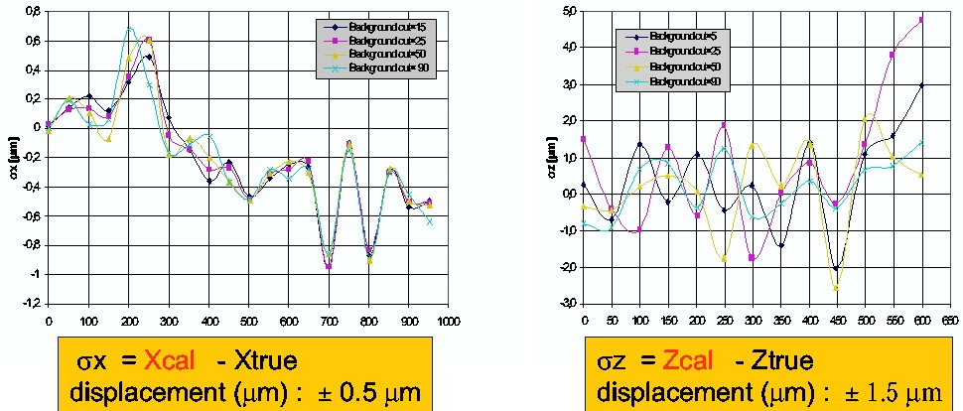

Figure 4. Difference between calculated and real position in X (Y) and Z direction.

For both kinds of measurements the results are presented with different background cuts on the light intensity (in the range 0 - 255).

The temperature effect on the displacement measurements

The sensitivity of the position measurements to temperature was studied in several measurements where temperature changes were ± 5 degrees (by heating or cooling down the LAS environment). For each temperature point, the mean position of the spot centers from multiple measurements was calculated using the algorithm. Figure 5 shows as an example changes in the values of both laser spots centres as calculated relative to reference values.
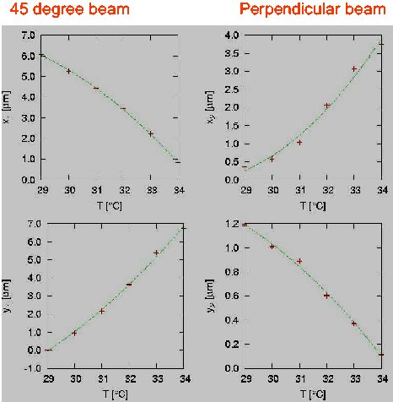

Figure 5. The shift of the laser beam spot positions according to temperature rise in thermally insulated chamber.

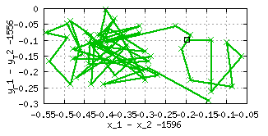
The observed changes in spots positions did not exceed 1 μm on 1⁰ C. In other long term ( > 24 hours) measurements, where the temperature was stabilized (changes not larger than ± 0.1⁰ C were accepted), the effects coming from the nature of the laser spot and the systematic uncertainties in used algorithm were observed. Figure 6 shows in such measurements the relative changes in the positions for both spots.

Fig. 6. The relative distance in the long term measurements with a fixed value of the temperature.

The observed changes in calculated X (Y) spots positions were on the level of 0.6 μm. The measurements indicate that even with temperature stabilization, other effects partially related to the nature of the laser spot and uncertainties in used algorithm can contribute to measurement results.

5 The development of LAS

Several activities on the LAS development are ongoing:
● The readout electronics for dedicated silicon sensor CMOS with automatic
calculation of the detector displacement and compact shape of the system.
● Integration of the LumiCal and LAS in the framework of the ILD detector.
● The method of measuring the displacement of the individual sensor layers
inside the LumiCal.

5.1 CMOS sensor and readout electronics

Figure 7 shows the scheme of readout electronics for dedicated silicon CMOS sensor which allows for automatic position calculations. The information collected by CMOS sensor will be readout on-line and transformed to the output format acceptable for host PC computer, where all displacement calculations will be performed [6]. The test of readout chain is ongoing.

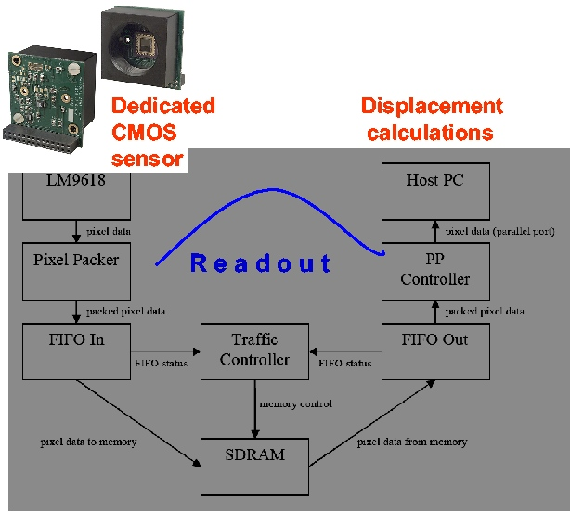

Fig. 7. Schematic diagram of the readout electronics for automatic position calculations using dedicated CMOS sensor.

5.2 Integration with the main detector LDC (ILD)

LumiCal is a part of ILD detector and several modifications of LAS will be necessary. Figure 8 shows the location (Left/Right) of calorimeters inside the structure of ILD detector. At least six laser beams operating inside special carbon support tube are required. There are several concepts which involve the use of other optical alignment systems like RASNIK [7] or the method based on interferometers and frequency scanned interferometry (FSI) system [8].

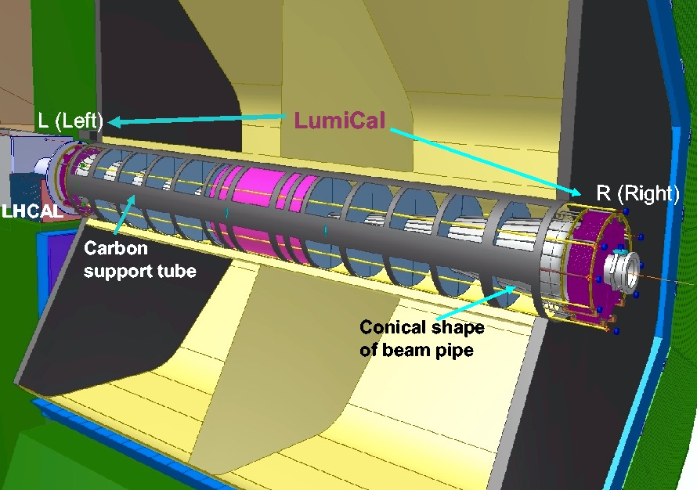

Fig. 8. The LumiCal inside ILD detector geometry.

Figure 9 shows the possible extension of LAS, where optical elements like interferometers, lasers, mirrors or retroreflectors can be used for absolute measurement of the distance between calorimeters in standalone mode or in common laser alignment system, which can be built with vertex detector VXD.

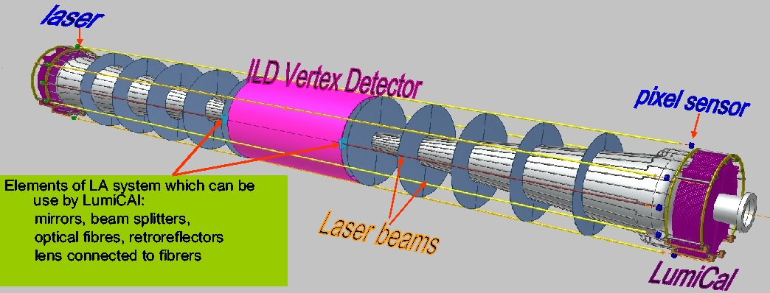

Fig. 9. Proposal of the system with six laser beams for displacement measurement of LumiCal or with interferometers (FSI) in possible common laser alignment system built with vertex detector VXD.

The possibility of the displacement measurements for a single calorimeter relative to beam pipe or QD0 quadrupol is illustrated in Fig. 10.

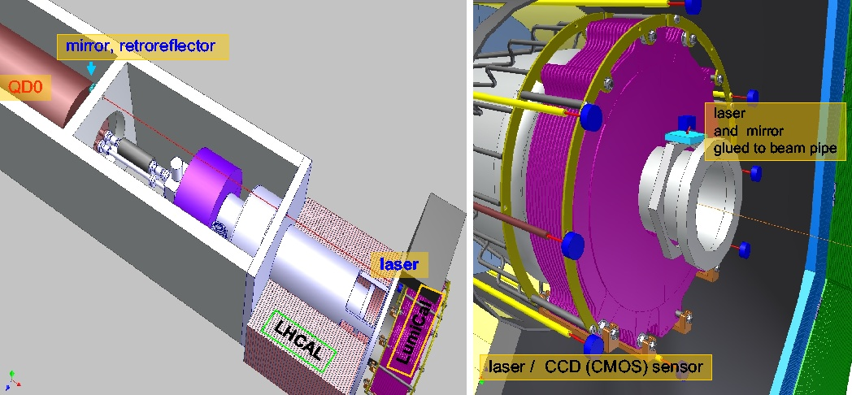

Figure. 10. The beam line elements located inside ILD detector which can be used for LAS of LumiCal detector.

5.3 Measurement of the individual sensor layers

Figure 11 shows one of the possibilities for on-line measurements of the individual the sensor layers. The measurements use a special transparent CMOS sensor placed on each sensor layer and infrared (IR) laser beam traversing all sensors.

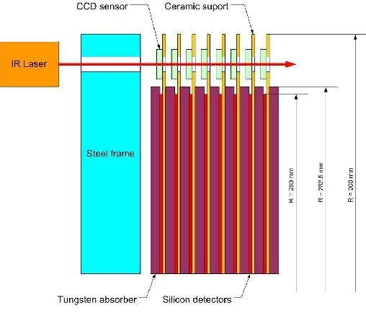

Fig. 11. The possible solutions for measurements of the displacement internal layers of the
LumiCal detector.

This kind of alignment method for forward tracker prototype with silicon microstrips will be studied in more detail with test beam measurements [9] at the end of 2008. In the other method, which can be used for comparison with the previous one, the spanned wire is going through the holes in sensor planes and works as antenna. It picks up electrodes to measure the position of layer. It will be active during time slots between banch trains. The expected accuracy of this method will be below 1 μm. Figure 12 shows an idea of this method.
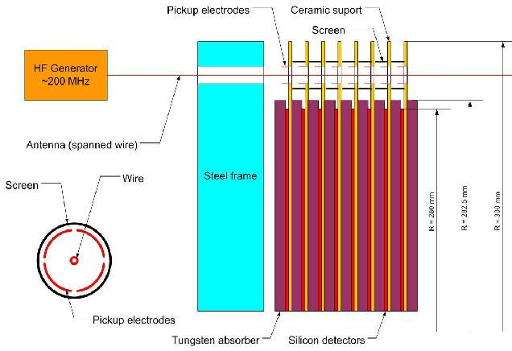

Fig. 12. The other possible method for individual sensor layers position measurements inside the LumiCal.

6 Conclusion

It was proved that the method for measuring the short detector displacement presented in the paper gives the accuracy better than the required one. The complete LumiCal alignment system should include a method of the absolute distance measurement between both calorimeters with the use of the frequency scanned interferometers. Such a system can be built together with other components like vertex detector. Further modifications of the LAS are expected as an effect of the integration with ILD. The work on LAS development, which concentrates on automatic detector position calculations and on the internal silicon layers displacement of LumiCal, is ongoing.

Acknowledgements

This work is partly supported by:
The Polish Ministry of Science and Higher Education
under Agreement No. 141/6.PR UE/2007/7
and
Commission of the European Communities under the 6th Framework Programme “Structuring
the European Research Area”, contract number RII3-026126.

References

[1] Reference Design Report, Vol. 4 Detectors, ILC-Report-2007-001;

ILD, the International Large Detector: http://www.ilcild.org.

[2] International Linear Collider: http://www.linearcollider.org/cms.
[3] TESLA Technical Design Report, DESY 2001-011, ECFA 2001-209, March 2001;
H. Abramowicz et al., IEEE Transactions of Nuclear Science, 51 (2004) 2983;
R&D for ILC – Detector, Instrumentation of the Very Forward Region, The Forward Calorimetry (FCAL) Group, DESY PRC R&D Report 02/01, April, 2006;
The FCAL Collaboration: http://www-zeuthen.desy.de/ILC/fcal.
[4] W. Wierba, J. Zachorowski, K. Oliwa, Laser measurement of the LAS detector
displacement, Report No. 1391/PH, IFJ PAN Cracow 2003;
W.Wierba, J.Zachorowski, LAS detector alignment - talk given at the Collaboration
Meeting “R&D for the TESLA-Detector: Instrumentation of the Very Forward
Region”, ECFA/DESY workshop, Amsterdam, 1. -4. April 2003;
W. Wierba, “Very forward calorimeters readout and machine interface”,
PRAMANA – journal of physics, Indian Academy of Sciences, VOL. 69
No. 6, Dec. 2007;
W. Wierba “LumiCal mechanical design and alignment system” ILC Interaction
Region Engineering Design Workshop, IRENG 2007, September 17-21, 2007,
SLAC, USA.
L.Zawiejski, Laser Alignment System – status report, EUDET Annual Meeting,
Ecole Polytechnique, Palaiseau, France, 8. – 10. October 2007.
B. Pawlik, “Forward Calorymetry Status”, ECFA Workshop, Warsaw,
June 8-12,2008, Poland;
L.Zawiejski, Laser Alignment System – status report, EUDET Annual Meeting,
Nikhef , Amstrdam, Holland, 6. – 8. October 2008.
[5] A.Stahl, Luminosity Measurement via Bhabha Scattering: Precision Requirements
for the Luminosity Calorimeter.,LC-DET-2005-004, Apr 2005.
[6] J. Błocki et al., “CMOS optical sensor and readout electronics for LumiCal
alignment system”, Report IFJ PAN No: 2003/E, 2007.
[7] D.Goldstein, D.Salzberg, Nuclear Instruments and Methods in Physics Research A 506 (2003) 92.
[8] A. F. Fox-Murphy et al., Nuclear Instruments and Methods in Physics Research A
383 (1996) 229;
John R Green, PhD Thesis, “Development of a Prototype Frequency Scanning
Interferometric Absolute Distance Measurement System for the Survey &
Alignment of the International Linear Collider”, University of Oxford, 2007;
Hai-Jun Yang et all., “Frequency Scanned Interferometry for ILC
Tracker Alignment”, arXiv:physics/0506197v1, June, 2005;
Hai-Jun Yan et al., Nuclear Instruments and Methods in Physics Research
A 575 (20070 395).

[9] A. Savoy-Navarro, “JRA2-SITRA status”, a talk given at JRA2 plenary session,

EUDET Annual Meeting, Amsterdam, 2008, Holland.

Institute of Nuclear Physics PAN, Cracow, Poland
Jagiellonian University, Cracow, Poland

