

Production Readiness Report for the JRA3 task
H. Abramowicz, M. Anduze, D. Bailey, R. Cornat², P. Cornebise, A. Falou², J. Fleury, K. Gadow, J. Giraud, P. Göttlicher⁵, M. Goodrick, D. Grondin⁶, B. Hommels⁷, G. Guilhem³, M. Idzik, K. Kschioneck⁵, A. Levy¹, W. LohmannError: Reference source not found, N. Meyer⁶, R. Poeschl³, M. Reinecke⁶, F. Sefkow⁶, C. De La TailleError: Reference source not found, R. Thompson2, W. Wierba, M. Wing, L. Zawiejski10

December 28, 2008 (Update: July 28, 2026)

Abstract

In this report the status of the developments within the JRA3-D4 framework is described as well as the upcoming development steps towards the production readiness of all project parts. Timelines of all different parts are presented.

- Electromagnetic Calorimeter
The design for the electromagnetic calorimeter has been finished and documented in two EUDET Memos [1, 2] which were summarised at the annual EUDET Meeting.

We are currently constructing the demonstrator which will allow us to study most of the
mechanical features of the final EUDET Module. These studies will comprise heat dissipation,
by using specially designed 'faked' PCB boards, interconnection, mechanical rigidity and aspect of the assembly of the 1.5m long highly fragile detector elements. A very important point of the studies is the comparison of the measured heat dissipation to existing simulations. The cooling system employed for the demonstrator has been designed in a way that it can be scaled up to the dimensions of the EUDET Module. These studies are expected to be finished by the end of February. The results will be summarized in a EUDET Report.

The alveolar structure (i.e. the combined housing/absorber structure) for the EUDET Module
is expected to be ready by the beginning of April 2009. From that moment on we will be ready to
compile the EUDET Module or to invite other users for Transnational Access for e.g. a combined test
of VFE Electronics and the EUDET DAQ. At the same time the H type structures carrying the sensitive parts of the detector as well as containing of the absorber will have been manufactured.

Up to 40 Silicon Wafers are expected sequentially from Hamamatsu until May 2009.
These will be tested subsequently in terms of IV and CV measurements upon arrival in
order to qualify them for the employment in the EUDET Module. A special emphasize will
be put on the investigation of cross talk effects as has been observed in recent Si Wafers.

A first set of ASUs (Active Signal Unit) comprising PCB glued to the Silicon Wafers and containing an EUDET compliant ASIC is expected to be ready by the beginning of June such that the detector
can be equipped and read out for the end of June 2009. More details on the development of the Very Front End electronics can be found below, see Page 5. The studies of the wafers is accompanied by investigating a suited way to apply the bias voltage to the wafers. A first set of capton sheets have been ordered at CERN and will be examined in the coming weeks.

The interface to the DAQ is realised by a Detector Interface Card (DIF). While the general features
of this card are established the concrete design in terms of e.g. space requirements of the different components are ongoing. The final design of the DIF depends also on the final characteristics of the
ASICs (see above) as well as on requirements imposed by components further upstream in the DAQ chain. We expect to have a prototype ready at the time the when the ASICs arrive, i.e. beginning of June 2009. As the DIF card will be similar for other calorimeter types such as the Hadronic Calorimeter(s) (see below) the start of operation of the DIF card with the EUDET Module will benefit from the collaboration with these groups.

The illustration 1 shows the rough timetable of the project. More details about the ongoing work can be found under http://flc.web.lal.in2p3.fr/poeschl/ecal_sched.html.

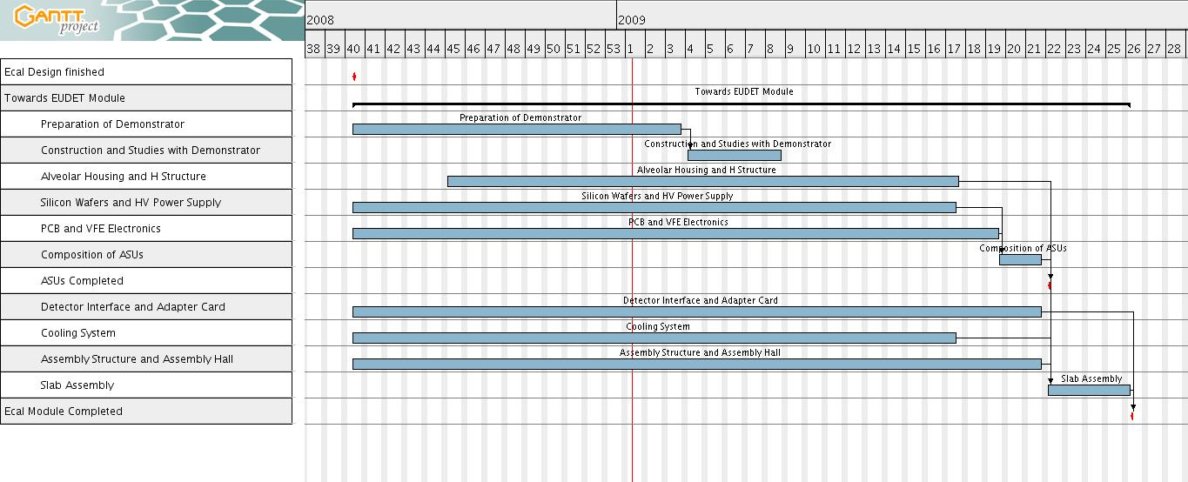Illustration 1: Coarse timeline towards completion of EUDET Ecal Module.
- Hadronic Calorimeter

The timeline of the AHCAL project part [3, 4] is shown in Appendix A. The task numbering in this section refers to the column “Task No.” in the timeline table. Remark to the timeline in Appendix A: Single weeks are not resolved.

Tasks. 1-2 (not EUDET):
Although the development of the scintillating tiles with the integrated MGPDs (Multi-Pixel Geiger-Mode Photo Diodes) is not part of the EUDET project, it has to be depicted here. It defines pre-conditions for the development of the HCAL Base Unit (HBU, tasks 5-10). The prototype tiles for the HBU are produced widely in mechanical processes (drilling, milling). About 160 pieces are expected end of Jan. 2009. For the EUDET module, the tiles have to be produced completely in moulding techniques for cost- and production-time reasons. Theses tiles are expected end of Aug. 2009.

Tasks 3-4: Front-end ASICs (SPIROC1 and SPIROC2):
For the prototype modules, the ASICs SPIROC1 and SPIROC2 (version 1 and 2) are used. Both types are expected in a tested state in small numbers at the end of Jan. 2009. If tests of the prototype show a sufficient functionality, the series production of SPIROC2 can start in May 2009. SPIROC2 will be in a much thinner package (1.4mm TQFP208), which is necessary to achieve the dense structure of the AHCAL modules needed for an operation at the ILC. If SPIROC2 shows major problems in the operation, a redesign (SPIROC3) is necessary beginning of 2009.

Tasks 5-10: HCAL Base Unit (HBU):
The HBU prototype (HBU0) integrates the tiles (tasks 1-2) with the front-end ASICs (tasks 3-4) and the light-calibration system [3]. The HBU0 contains two ASICs of SPIROC1 and two of SPIROC2. Despite the too large package (4.3mm height) and major limitations within the digital part SPIROC1 is still foreseen in the HBU0 design because its analogue part has been extensively tested. The HBU0 layout will be finished mid of Jan. 2009. The HBU0 is expected completely assembled mid of March 2009. After the first tests of the HBU0 (end of April 2009), a redesign (EUDET module) with only one type of ASIC and in the final dense setup (5.4mm height of non-absorbing material) is necessary. The EUDET module is expected to be finished piece by piece from end of August 2009 on.

Tasks 11-17: Detector interface (DIF):
The DIF forms the interface between the DAQ and the inner detector electronics. The DIF prototype is based on a commercial FPGA board. The protocols to the ASICs (inner detector) and on the other side to the LDA (DAQ) are defined. A first firmware version, based on the communication of the DIF via a Labview PC and USB is expected mid of March 2009. For an operation of the AHCAL via the final LDA, the task 41 has to be fulfilled in a prototype version. A DIF redesign is necessary in order to test the final detector setup in the absorber stack. This redesign needs coordination of the tasks 15, 20, 27 and 40 (Feb. 2009). The final DIF including the final firmware is expected end of Aug. 2009.

Tasks 18-29 (Modules CALIB and POWER):
The prototype modules CALIB (control of the AHCAL calibration system) and POWER (detector power supplies) are realized as mezzanine modules on top of the DIF prototype. The prototypes are expected to be finished together with the HBU0 prototype mid of March 2009. Redesigns of the modules are mainly necessary for an adaptation to the final setup within the absorber structure (see DIF section). The final modules are expected end of August 2009.

Tasks 30-32 (Interconnecting Flexleads):
Two different types of flexleads have been produced for the interconnection between the HBU modules within the detector, the first for the signalling, the second for power distribution. Both types are expected fully assembled mid of Jan 2009. The flexleads are foreseen to be used for the final detector setup as well.
Tasks 33-40 (Mechanical Infrastructure):
The prototype cassette including reflector foils are expected end of Jan. 2009. This prototype setup enables tests of the prototypes within laboratory environments as well as for testbeams. Till end of Feb. 2009, the final cassette will be developed together with the mechanical interface at the absorber’s end-face (see DIF, CALIB and POWER section).

Task 41 (DAQ software):
The prototype version of the operating system (DAQ) will be based on a single PC with a Labview Control system. The interface to the DIF prototype module is realized via a USB interface. This prototype DAQ setup can be realized and modified during the first tests efficiently. Mid of April 2009 a first version of the final DAQ setup (DIF-LDA-ODR chain) including the DOOCS operating system is needed. The final DAQ will be optimized during the system tests till end of Aug. 2009.

- Forward Calorimeters

The timeline for the milestones and deliverables of the VFCAL project are given in Figure 2 of the Annex1 of the Consortium agreement. The tasks follow the notation of Figure 2.

Task ID 203: Silicon Sensor production ( Task ID 204: Sensors available in June 2009)
Based on detailed design studies (EUDET-Memo-2007-12, EUDET-Memo-2007-17) the specifications for sensors were defined. In spring 2008 the masks were developed by Hamamatsu Photonics and in September the manufactoring of 40 sensors was agreed. The sensors will be delivered beginning of March 2009. The laboratories at Cracow, DESY and Tel Aviv are prepared to start after march 2009 the standard measurement for the sensor characterisation.

Task ID 205: Design of a Laser Positioning System (Task ID 206: Prototype ready end of 2008)
The prototype of the Laser Positioning System was designed and a prototype monitoring displacements in the sub-μm level was built. The system and detailed performance studies are described in the EUDET-Report-2008-05. On the basis of the expertise acquired we will contribute to the design of the ILD detector.

Task ID 207: Development of Sensor Test Facilities (Task ID 208: Sensor Test Facilities Ready end of 2008
Sensor Test Facilities for sensor characterisation and test in the laboratory have been upgraded in DESY and Cracow and developed in the University of Tel Aviv.
For sensor irradiation studies a specialised set-up has been designed and built. It has been used successfully in several test-beam campaigns at the Technical University in Darmstadt.
For performance tests in the test-beams at CERN and DESY equipment and a data acquisition system has been built and used together with the EUDET pixel telescope. All facilities are described in the EUDET-Memo-2008-32.

Task ID 209-211: Development, Design and Production of Readout Electronics (Task ID 212: Readout electronics ready end 2008.)
ASICS for the analog FE electronics and the ADC have been designed and first prototypes are obtained in spring 2008. Measurements of the characteristics were done. The analog ASIC results matched the requirements defined by simulations of the detector. The ADC ASIC needed several improvements, and a second submission has been done in September 2008. New prototypes of the ADC ASIC have been obtained in December and are now under investigation. The status and the results of the measurement of the ASIC characteristics are summarised in the EUDET-Report-2008-08.

- Data Acquisition

Throughout this year, this task has focused on having prototype data acquisition system available. This has been achieved and is described in detail in EUDET Report-2008-06 [6]. Prototypes of all hardware components have been produced, tested and demonstrated to be working. This DAQ system consists of four major hardware components:
- an electronics card (DIF) which provides the interface between the detector and the DAQ system behind it. This is detector specific and we have three prototype cards for the electromagnetic calorimeter;
- a concentrator card (LDA) collects data from 10 DIFs and sends data on using just one long optical fibre;
- a PCIExpress board which acts as an off-detector receiver and collects data from 4 LDAs is housed in a DAQ PC;
- a clock and control card (CCC) controls the timing and configuration of the detectors.

The individual components are now being integrated to provide a test of the full DAQ chain. Controlling all of this is the DOOCS software, developed for the XFEL project at DESY [7], which is a flexible and scalable framework. The architecture for this has been defined and an interface has been written to the DAQ PC and ODR as well as demonstrating that data can be passed from the ODR to an LDA emulator.

Full system tests will start in January with a full prototype given to detector groups for integration in March/April 2009 with the expectation of having the DAQ system complete and ready for use by July 2009.
- Front End Electronics
The front-end electronics for EUDET ECAL and HCAL is completely embedded inside the detector and thus integrated inside microelectronics ASICs in order to match the high density requirements. Three prototypes have been realized in 2006 and 2007 :
- HaRDROC is a 64 channels ASIC that reads the RPCs of the digital option of Hadronic calorimeter. It also allowed to validate all the readout architecture that connects to the 2nd generation DAQ described in section 4 while minimizing the number of lines beween front-end boards.
- SKIROC is a 36 channels ASIC produced in 2006 in order to validate the low noise analog signal readout together with the 12bit on-chip digitization to readout the SiW ECAL.
- SPIROC is a 36 channels ASIC developed in 2007 in order to readout the SiPM of the AHCAL with the full functionality necessary for ILC electronics, mainly auto-trigger, on –chip digitization , power pulsing and readout. It reuses many parts developed for HARDROC and SKIROC in order to take full advantage of the commonalities between the different calorimeters making EUDET electronics a real infrastructure.
In june 2008, the second version of SPIROC has been fabricated in which a set of internal parameters allowed to operate the ASIC either in ECAL mode or AHCAL mode, greatly simplifying the design and further optimizing the manpower necessary to operate and test the calorimeter modules.
This chip named SPIROC2 will be used in 2009 to qualify the first front-end boards with on-detector electronics, ILC mode operation and power pulsing. It will service both ECAL and AHCAL. The readout part is identical to the one of HaRDROC servicing the competitive digital HCAL. The chip is packaged in TQFP208 ultrathin plastic package for the HCAL and directly bonded on the front-end boards (ASU) for the ECAL.
The performance of the two chips HaRDROC2 and SPIROC2 is described in the datasheets in reference.

References
[1] M. Anduze and R. Poeschl: “ECAL Si/W – Design and Fabrication of moulds for the EUDET Module”, EUDET memo 2008-07
[2] M. Anduze et al.: “RA3 Electromagnetic Calorimeter Technical Design Report”, EUDET memo 2008-11
[3] K. Gadow et al.: “Hadronic Calorimeter JRA3 Technical Design Report”, EUDET memo 2008-02
[4] K. Gadow et al.: “HCAL technical design”, EUDET memo 2008-23
[5] J. Cvach et al.: “Calibration Prototype for the EUDET HCAL”,
EUDET Report 2008-07
[6] V. Bartsch, M. Wing and T. Wu, “Status of the data acquisition system for the EUDET calorimeters”, EUDET-Report-2008-06.
[7] WWW: doocs.desy.de

Appendix A : AHCAL Timeline

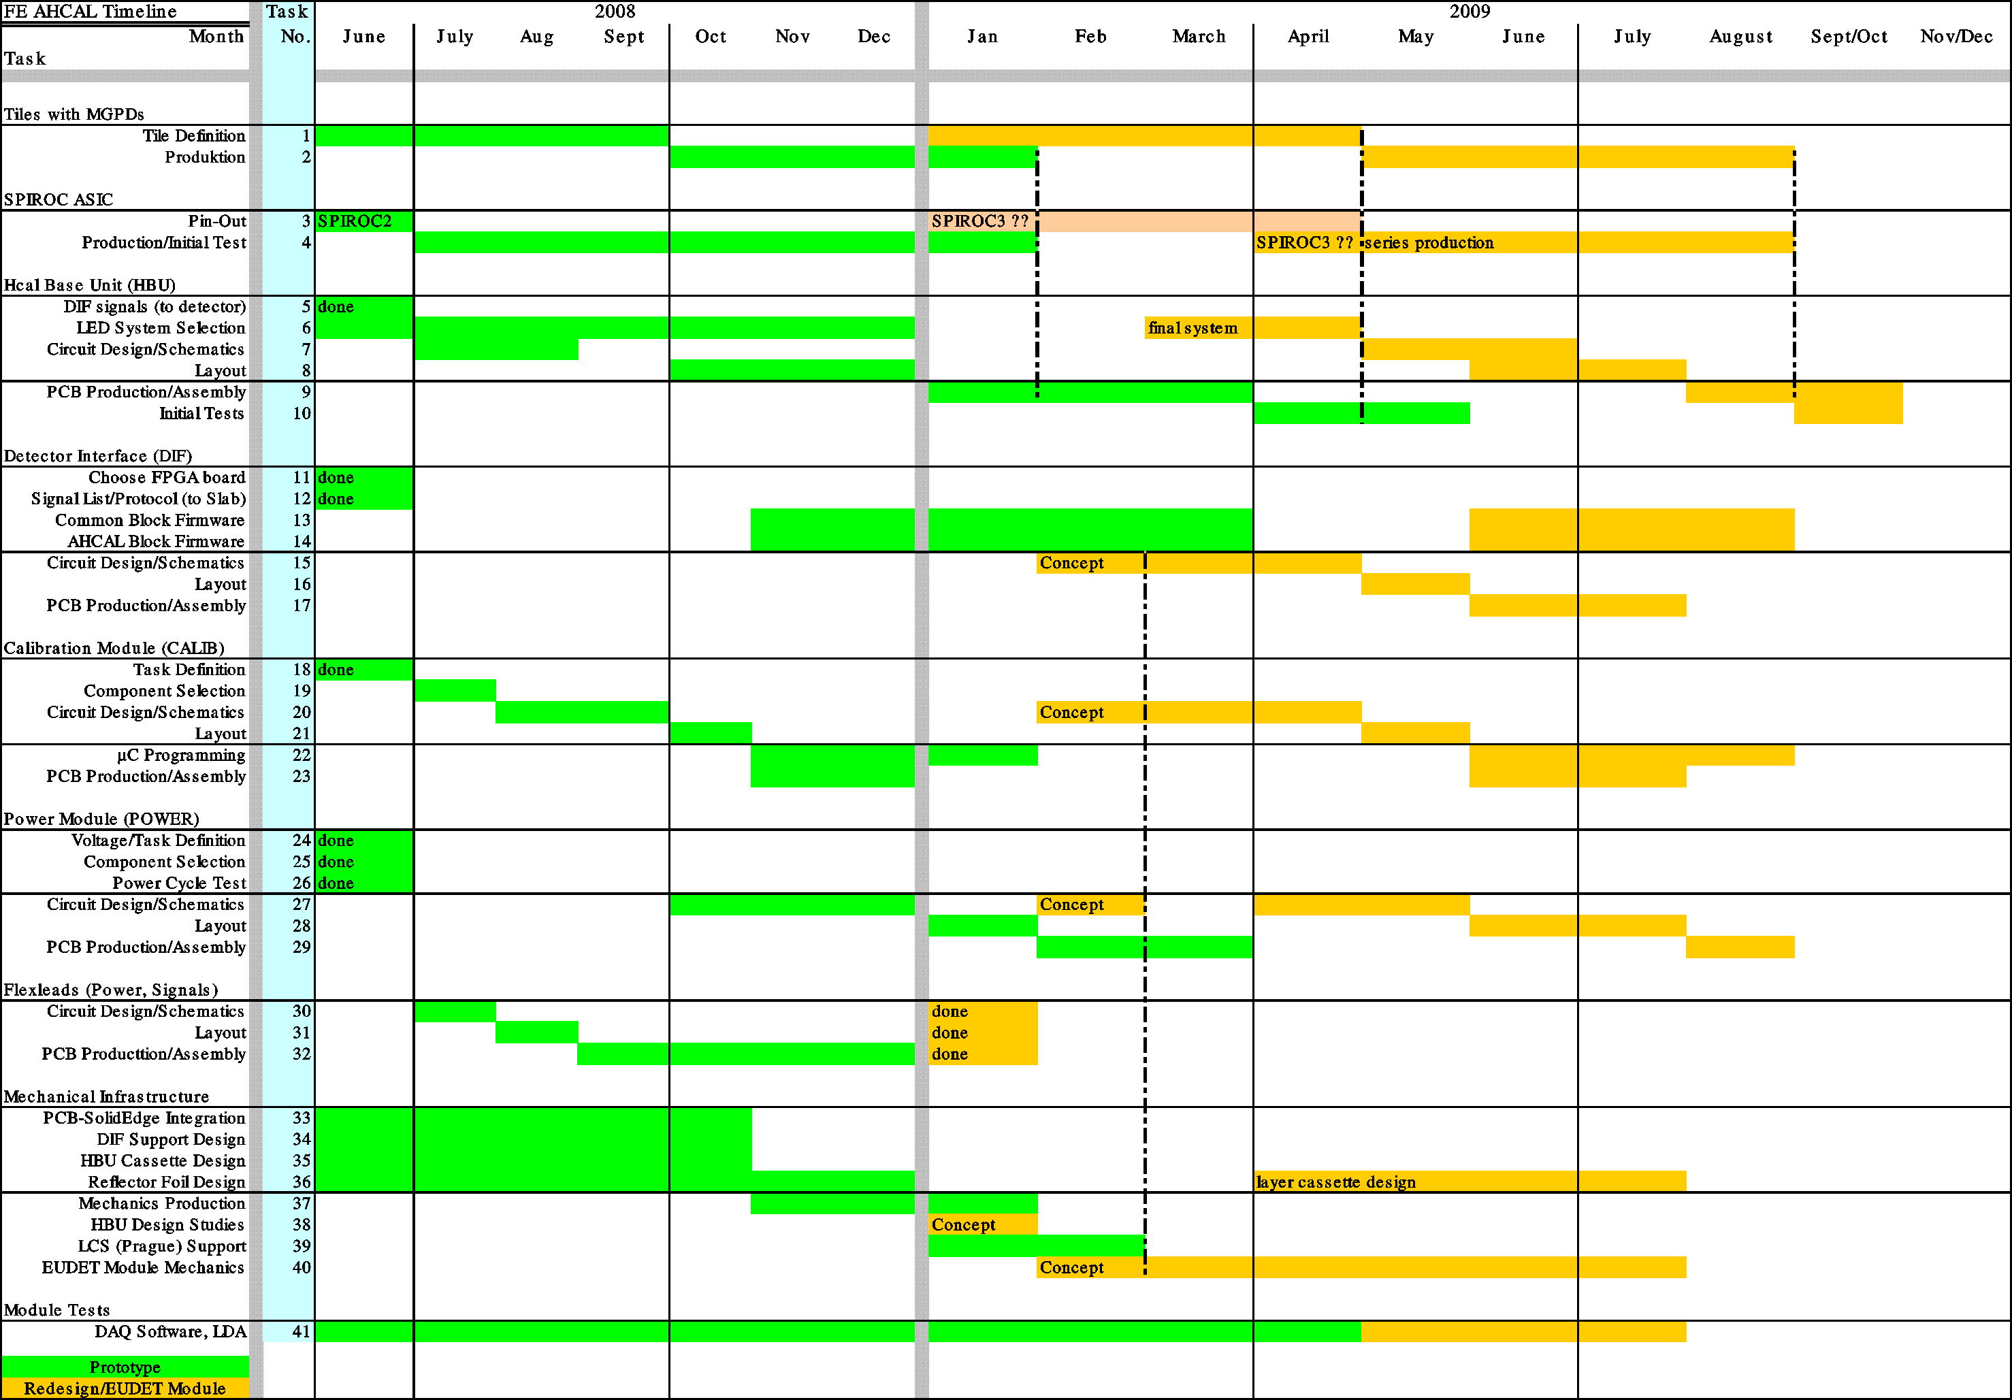

lustration : Timeline for Hcal Project.

Tel Aviv University, Tel Aviv, Israel
LLR – CNRS/IN2P3, France
University of Manchester, UK
LAL - CNRS/IN2P3, France
LAL - OMEGA – CNRS/IN2P3, France
DESY, Hamburg and Zeuthen, Germany
LPSC – CNRS/IN2P3, France
University of Cambridge, UK
AGH University of Science and Technology, Cracow, Poland
INP PAS Cracow, Poland
University College, London, UK
LLR – CNRS/IN2P3, France
University of Manchester, UK
LAL - CNRS/IN2P3, France
LAL - OMEGA – CNRS/IN2P3, France
DESY, Hamburg and Zeuthen, Germany
LPSC – CNRS/IN2P3, France
University of Cambridge, UK

