

Laser Alignment System for LumiCal

J. Aguilar¹² ,W. Daniluk¹, E. Kielar¹, J. Kotuła¹, A. Moszczyński¹, K. Oliwa¹, B. Pawlik¹, W. Wierba¹, L. Zawiejski¹

Abstract

The status of the laser positioning system for the LumiCal detector and plans future development plan are reported. LumiCal will be used to precisely measure the luminosity in experiments at the future ILC (CLIC) collider and knowledge about its displacement is necessary to achieve the required accuracy in luminosity measurement better than 10⁻³. The optical method for the displacement measurements of LumiCal was tested using laboratory setup of two laser beams and CCD camera as the basic elements. The precision of the displacement measurements is estimated to be 0.5 μm in X and Y direction and 1.5 μm in Z direction The system was sensitive to temperature changes on the level below 1 μm / 1⁰ C. The extension of the system, taking into account integration of LumiCal with the ILD detector, will include transparent sensors and laser beam lines from frequency scanned interferometer. The other activity concentrates on a method for measurement of the displacement of the individual sensor layers inside LumiCal.

.
_______________________________
- Institute of Nuclear Physics PAN, Cracow,Poland
- University of Science and Technology, AGH, Poland

1 Introduction

In the framework of the International Large Detector (ILD) [1], one of the two detector concepts considered for the International Linear Collider ILC [2], the luminosity detector LumiCal will be located in a very forward region together with BeamCal and Pair Monitor other detectors studied by FCAL Collaboration. Figure 1 illustrates this situation. The LumiCal detector [3], which contains two silicon-tungsten calorimeters, is expected to give a required precision luminosity measurement and to extend calorimetric coverage mainly for electrons and photons at low polar angles between 30 and 80 mrad. The luminosity measurement will be based on the determination of the Bhabha events rate and a relative precision of the integrated luminosity (ΔL/L) better then of 10⁻³ will be achievable. To fulfill this task it is necessary to build a detector with micrometer precision and to have an online laser positioning system for a displacement monitoring of LumiCal [4] with an accuracy of a few hundred micrometers as well as the displacement of its internal layers with an accuracy of a few micrometers. The integration of LumiCal with the ILD raises several questions related to available free space for the laser alignment system (LAS) and the detector installation procedure. Another problem can stem from requirements to have easy access to subdetectors. Hence, further extensions and modifications of the LAS are necessary.
Inside ILD (ILC) detector structure, LumiCal detector contains two electromagnetic calorimeters located on both sides of the interaction
point ( IP), 2.5 m from it.

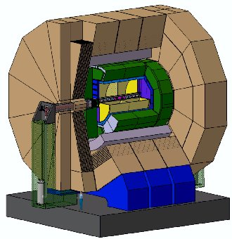

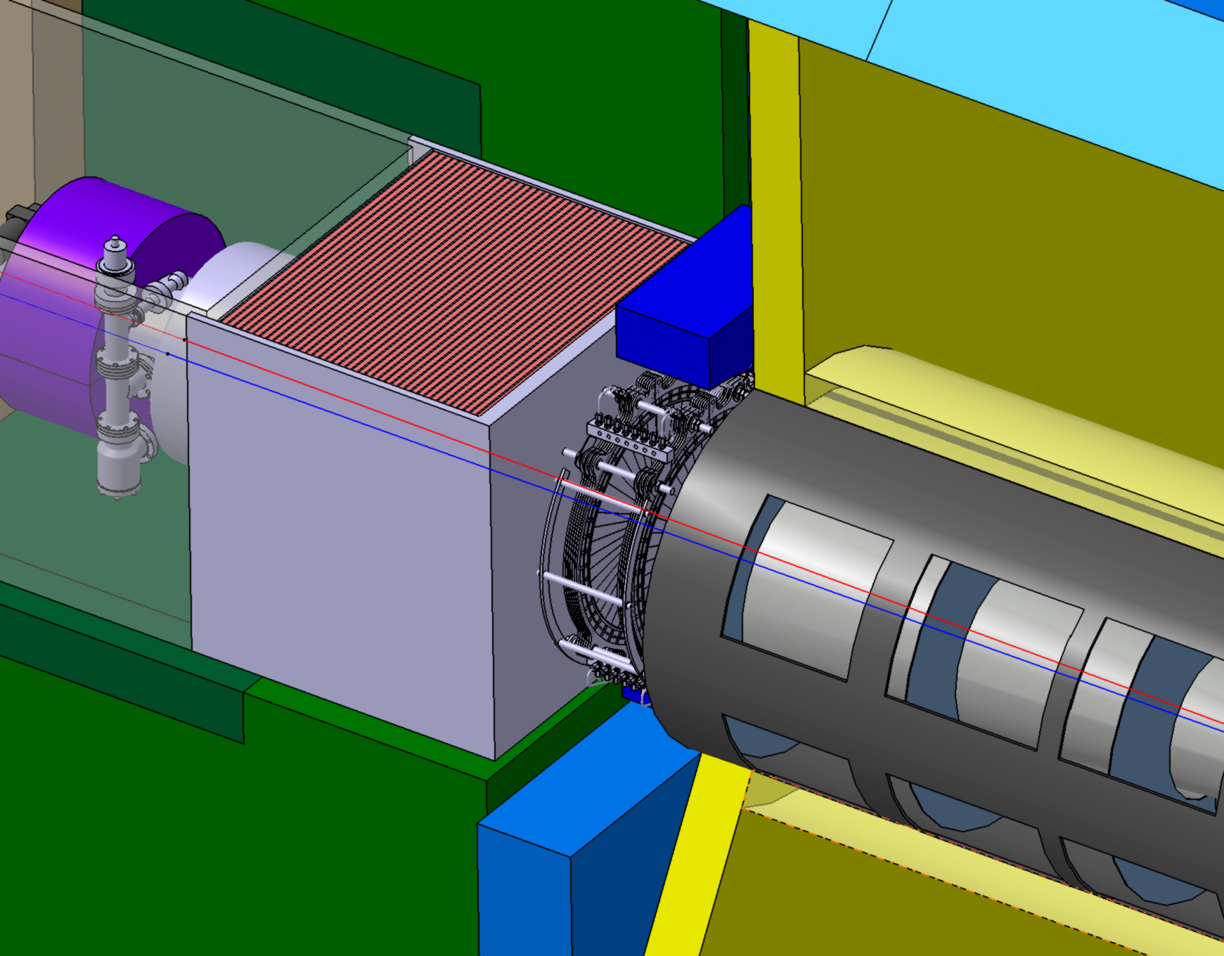

BeamCal, Pair Monitor PpppppPppMooPpmonitorPair MooovrMmmmmmMonitor mmmmMonitorMonitor
LumiCal llllllllllllllllllllllllllllllllllllllllLLLlllllllllLLLLLLLlllllll
LHcal
ECAlLLLLLLLLLllLL
HCALLLLLL
TPCCcC

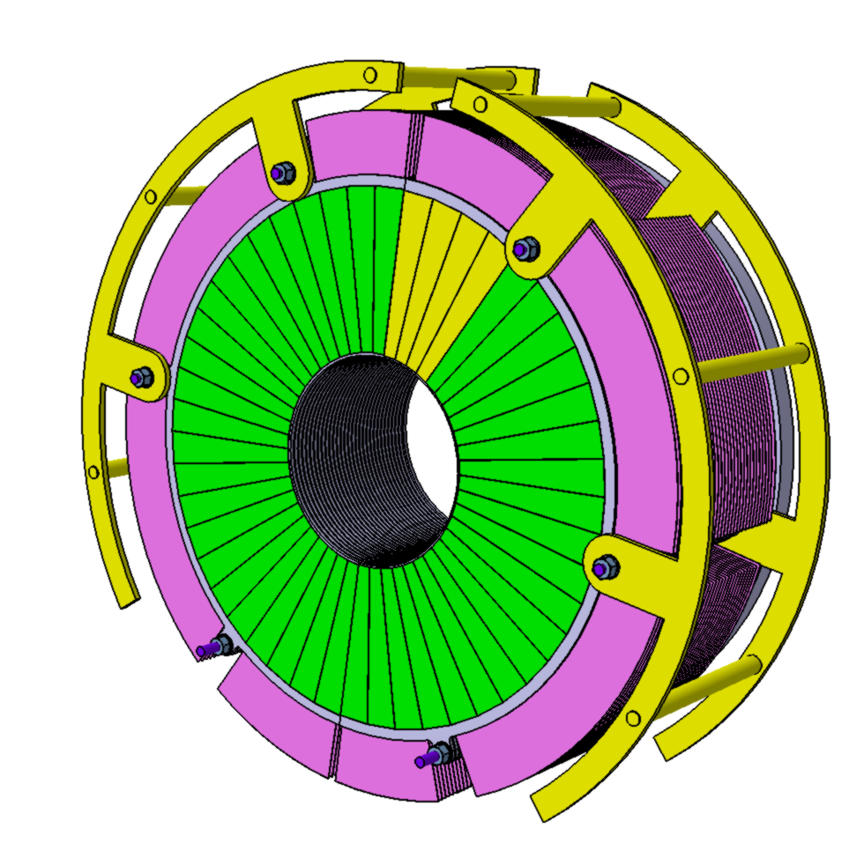

A prototype of the silicon-tungsten sandwich LumiCal
calorimeter. The yellow sectors were used in testbeam
measurements at DESY (Augst 2010)

Figure 1. The LumiCal detector together with other forward calorimeters inside ILD detector structure.

2 Limits for accuracy in position measurements

The luminosity measurement requires precise alignment of the two LumiCal calorimeters (Left, Right) with respect to each other, and with respect to the beam line and the interaction point, as illustrated in Figure 2. Monte Carlo [5] studies have been performed to estimate the influence of the LumiCal displacements (both calorimeters treated as the whole as well as their internal layers) on accuracy of the relative luminosity, ΔL/L, measurements.

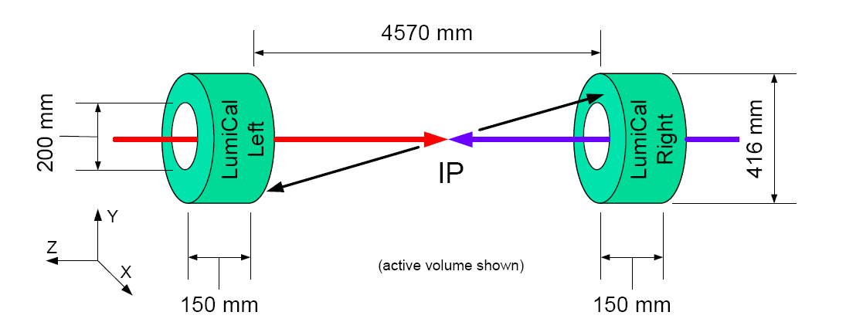
5000 mm
560 mm
152m m
mmmmmmmmmmmmmm

mm

mmmmmm
175 mm
175 mm
Distance between
two LumiCal’s
should be
known with accuracy
less than 100 µm.

LumiCal calorimeters -
centered on outgoing beam

Up
Down
θ_{min}

IP

LumiCal X, Y position
with respect
to the reference frame –
QD0 magnet, beam pipe,
should be known with
accuracy better
than ~100 µm)

Figure 2. The parts of the LumiCal detector located in respect to Interaction Point (IP).
Top: Left and Right calorimeters; Bottom: The structure of the single calorimeter.

The results of Monte Carlo simulations have shown that the inner radius of sensors layers has to be known to the accuracy of better than 4 μm, the distance between calorimeters along the beam axis must be known to an accuracy of 100 μm over the 5. m distance, and the transversal displacement (X, Y) with respect to the beam must be known to an uncertainty of
better than 600 μm. According to [2], the crossing angle for electron and positron beams at ILC will be 14 mrad and LumiCal will be centered on outgoing beam. What is particularly important for precise luminosity is knowledge of the inner acceptance radius of LumiCal, which defines the minimal polar angle θ_{min} (Fig. 2). Practically, the radial position of the sensors has to be measured with an uncertainty of 4 μm. The initial value for this radius can be measured in the lab using optical methods and precision movable table. The beam pipe is proposed as a suitable reference for the distance along the beam and transversal displacement and can be precisely surveyed under different conditions (i.e. temperature) before installing. Additionally, the Beam Position Monitors are mounted at a well known position inside the vacuum pipe, which allows for determining the actual position of LumiCal with respect to the beam position. A similar method can be used by choosing well known positions of the QD0 magnets as reference frame. Online monitoring of the detector position should not interfere with the beam pipe, hence a non contact system is preferred. For this purpose an optical laser system with a CCD matrix sensor to measure the transverse (X, Y) and longitudinal (Z) displacement of LumiCal with respect to the beam pipe flange has been chosen and tested in laboratory. To minimize the influence of radiation in that area, radiation hard sensors can be used instead. The use of a few transparent position sensors per calorimeter would give the possibility of also measuring the angle between detector axis and beam direction. For absolute measurements of the distance between two calorimeters it will be necessary to include a frequency scanned interferometry (FSI) system.

3 The laser positioning system

For the LumiCal position measurements and monitoring, the laser positioning system was proposed and then built and tested in laboratory environment by INPPAS Cracow [4]. Figure 3 shows the laboratory setup which was used to test the principle and determine the accuracy of the position measurement. The base elements were: a CCD camera, laser beams, mirrors and filters. The camera was placed on the XYZ travel translation stage with 10 micrometers steps and the corresponding lasers were mounted in a special

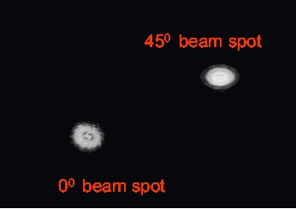
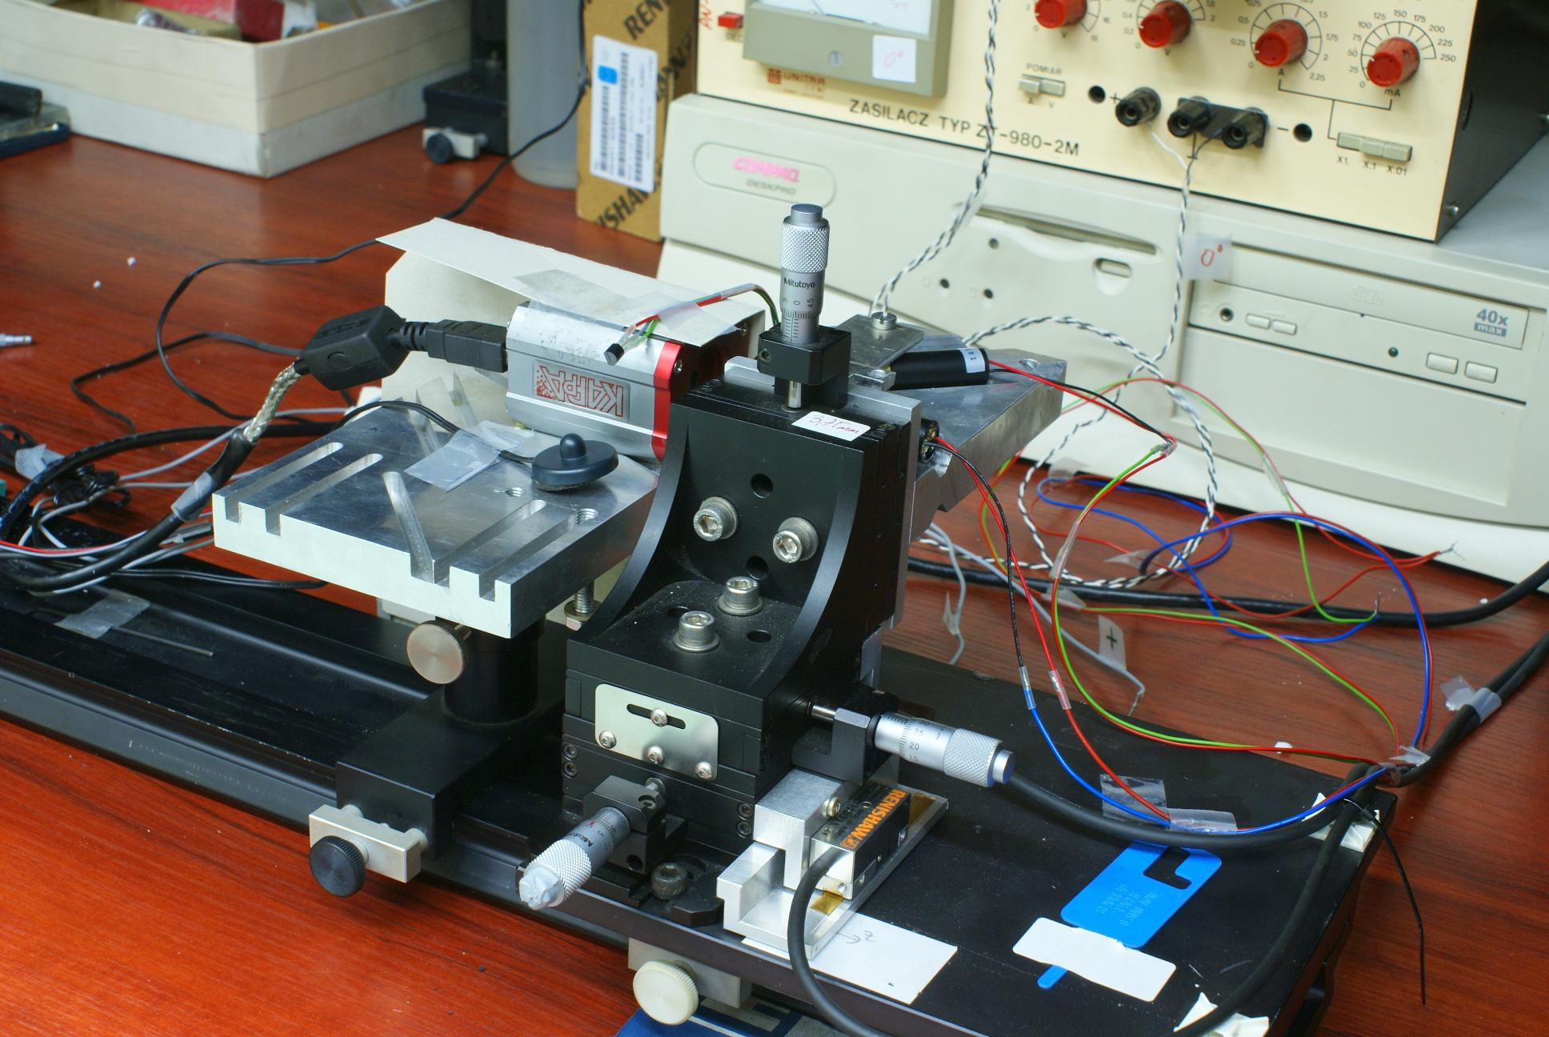

Figure 3. The laboratory setup used in tests of the laser positioning system.

holder in front of the camera. The camera displacement has been controlled independently by using an optical linear encoder with resolution of 0.1 μm. The reduction of the laser light intensity needed to avoid saturation in the pixel sensor was done with colour-neutral filters. In the final test measurements two laser beams were used. One was perpendicular to the face of a CCD camera while the other formeds 45 degrees angle with the face. Reading out the CCD camera one can find two laser spots of different shapes as shown in Figure 4. The spot position of the perpendicular laser beam gives displacement in (X-Y) plane whereas the distance between the two spots

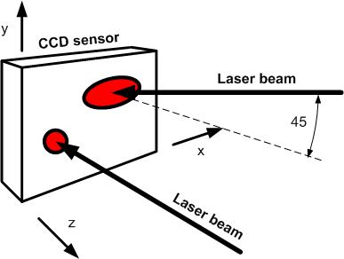
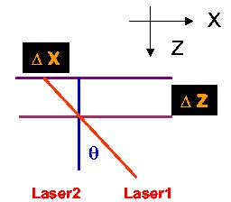

Figure 4. Simplified scheme of the method of X,Y and Z displacement measurements with two laser beams created the beam spots observed on the face of CCD camera.

is used to calculate in the Z direction. The centres of the spots were calculated
using an algorithm to calculate an average of the pixel coordinates within the spot weighted by the light intensity. A threshold on the pixel signal is applied to remove electronic noise. The obtained accuracy in X and Y position measurements was 0.5 μm and in Z direction 1.5 μm [4]. The sensitivity of the system to the temperature changes was found to be below 1 μm / 1⁰C in the long term measurements. These results completely satisfy the necessary precision required for LumiCal position monitoring.
Taking into acount these results, the LumiCal laser positioning system will be developed, where more sensitive sensors including transparent ones and laser beam lines from frequency scanned interferometry (FSI) will be included. The possible displacement measurements between two (L-R) calorimeters are shown in Figure 5. At least 6 transparent
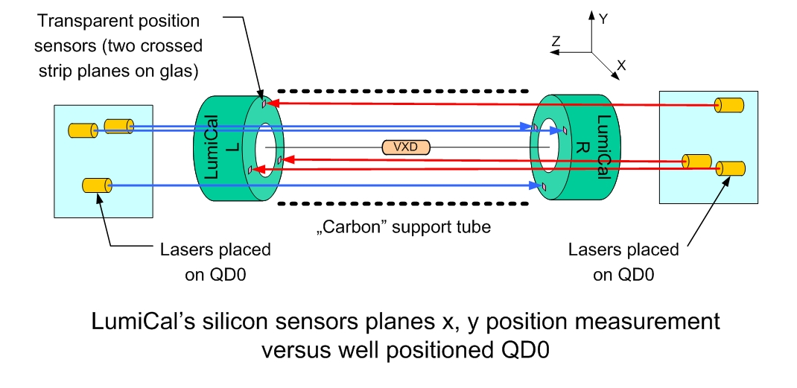

Figure 5. A schematic view of the possible laser alignment system with transparent sensors used for position meaurement of the LumiCal calorimeters.

sensors for space orientation both calorimeters inside carbon tube (probably with additional vacuum pipes) are required. The system aso needs laser beam lines from FSI interferometer.

4 LumiCal – Monte Carlo simulation of LAS system

The first step in design the final prototype LumiCal alignment system was estimation of the expected resolution in distance measurements, taking into account the properties of the individual elements of the system: their resolution in responses to laser beam inpact, stiffness or changes with temperature. This was done using the SIMULGEO pogram [6]. Figure 6 shows two cases of laser beam configurations with FSI distance measurements corresponding to situations when the LumiCal is close (running conditions) or when it is open. For FSI laser beams, an accuracy 1 μm was used. In measurements of the relative distances to the beam pipe, the precision obtained for X, Y and Z measurements of modules (L0, L1, L2, L3) was below 100 μm and below 600 μrad for modules’ rotation angles. This is illustrated in Figure 6 (right).

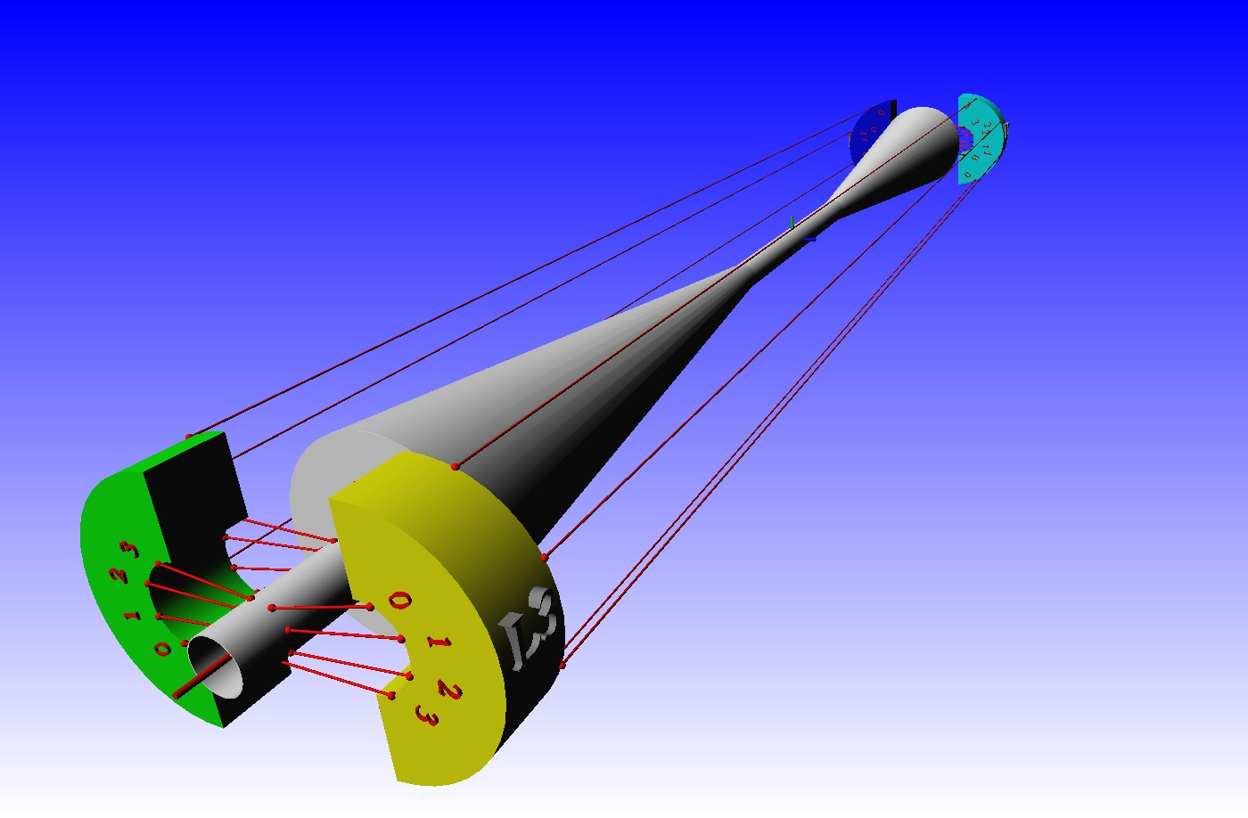
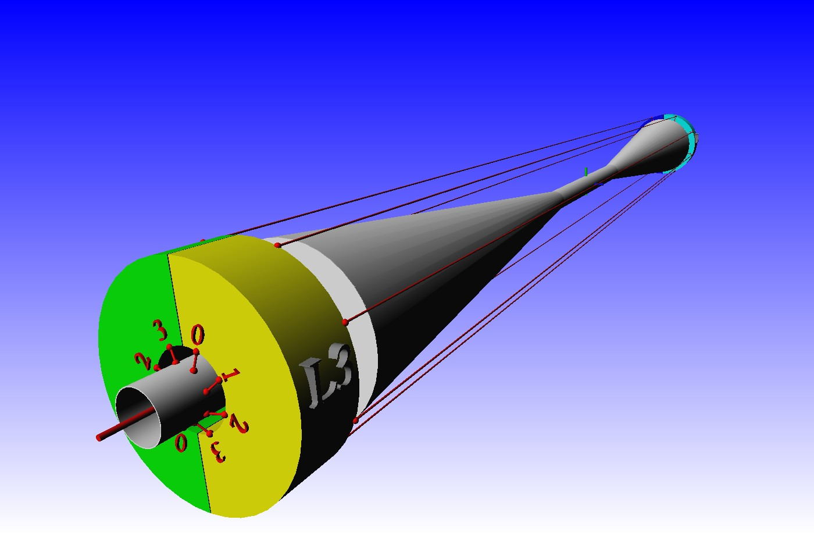
During a run
A maintenance mode)
FSI lines
FSI lines
FSI lines
L0
L1
L2
L3

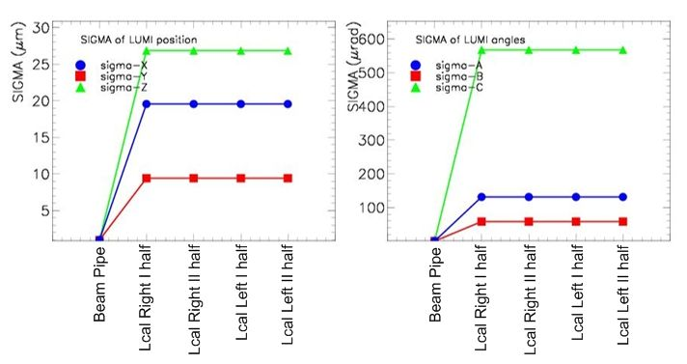

Figure 6. Left: The simple FSI system used in Monte Carlo studies of the LAS prototype.
The simulation are used to estimate accuracy in the LumiCal position measurements relative to the beam pipe position as reference frame. The number 0, 1, 2 and 3 indicate the different LumiCal detector modules; Right : Result of studies: the resolution in X, Y and Z distances and rotation angles for the LumiCal modules measured relative to beam pipe.

5 LumiCal Laser Positioning System and ILD

LumiCal will be placed inside the ILD detector as shown in Figure 7. The installation of LumiCal laser alignment system requires additional infrastructure around the beam pipe. In an simplified approach e.g. six laser beams necessary for the laser positioning system described above should be installed inside the carbon support for the beam pipe.
In stand-alone approach to the final prototype LumiCal LAS system, the laser beam lines of frequency scanned interferometry (FSI) [7] can be used for the displacement measurements both (L,R) calorimeters relative to QD0 magnet (or beam pipe) as well to the distance betwen them. A modified system with transparent position sensors (TS) together with infra-red laser beam (or red light diodes ) is also being considered.

QD0
red light
laser
TS
Transp.
sensor

Figure 7. Top: The LumiCal calorimeters inside ILD detector geometry with laser beam lines which can be used in the distance measurement between calorimeters; Bottom: possibility of use the positions information of QD0 magnet and beam pipe for LAS of LumiCal detector where transparent sensors and FSI beams will be the base elements of the system.

6 Displacement of the internal silicon layers

For required precision in luminosity measurements, measurement of the inner radius of the sensor layers should be accurate to about 4 μm. For this purpose it is necessary to build system for measurements of the displacement of LumiCal internal sensor layers. One possibility is to use transparent micro-strip sensors which were built and succesfully tested inside EUDET program as a system for silicon tracking alignment for the ILD detector [8] . Figure 8 shows a possible configuration of the transparent sensors used for LumiCal calorimeter.
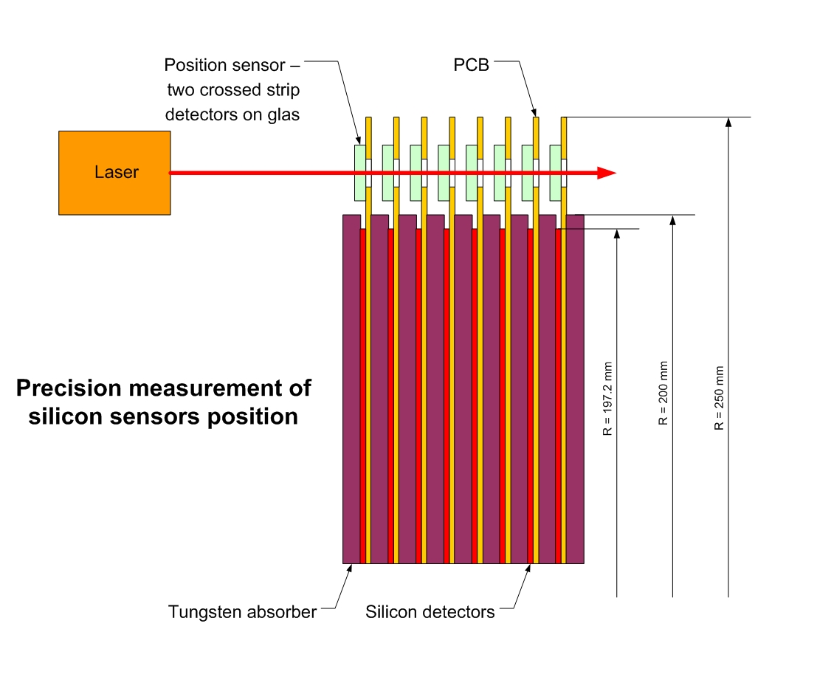

Figure 8. The preliminary design of the system for displacemet measurement of the internal silicon layers inside LumiCal calorimeter. It contains several transparent micro-strip sensors put on selected internal layers of the calorimeter together with infra-red laser beam.

7 Conclusions

Precise measurement of the displacements of the LumiCal calorimeters as well as their internal layers is necessary to achieve the required accuracy in luminosity measurements.

A simple method was proved to monitor displacements of the LumiCal detector using two laser beams with 0 and 45 degree angles and a CCD sensor. The accuracy reached 0.5 μm for shifts in the plane perpendicular to one of the laser beams and 1.5 μm in the direction along this laser beam is better than required from physics.

In the next step, taking into account integration with ILD detector, more advanced alignment system including FSI and transparent micro-strip sensors will be used. The mesurements will use the QD0 magnet or the beam pipe as a reference frame since their positions will be known with very high precision. For displacement measurements of the internal silicon layers, the special system based on the transparent sensors is considered.

Acknowledgements

This work is partly supported by:
Commission of the European Communities under the 6th Framework Programme “Structuring
the European Research Area”, contract number RII3-026126,
The Polish Ministry of Science and Higher Education
under Agreement No. 141/6.PR UE/2007/7
and
The FP7 multi-site Initial Training Network (MCPAD) on particle detectors in physics
experiments.

References

[1] The Internatonal Large Detector, Letter of Intent, February 2010, DESY 2009-87,

FERMILAB-PUB-09-682-E; KEK Report 2009-6, http://www.ilcild.org;

[2] International Linear Collider: http://www.linearcollider.org/cms.
[3] The FCAL Collaboration: http://www-zeuthen.desy.de/ILC/fcal;
EUDET-Memo-2009-10; EUDET-Memo-2010-06;
H. Abramowicz et al., “Forward instrumentation for ILC detectors”, DESY-10-142,
to be published in JINST.
[4] W. Wierba, J. Zachorowski, K. Oliwa, “Laser measurement of the LAS detector
displacement”, Report No. 1391/PH, IFJ PAN Cracow 2003;
EUDET-Memo-2008-14; EUDET -Report -2008-05;
“Report for the ILC Detector R&D panel Instrumentation of the Very Forward
Region”, PRC Document , Updated version, November 2009, DESY PRC, 2009;
L.Zawiejski, “Forward Detectors – status report”, ILD MDI worshop, 27 January,
Paris, 2010; “Laser alignment system for LumiCal”, EUDET Annual Meeting, 29
September, DESY, 2010.
[5] A.Stahl, “Luminosity Measurement via Bhabha Scattering: Precision Requirements
for the Luminosity Calorimeter”, LC-DET-2005-004, Apr 2005;
B. Pawlik, “LumiCal Monte Carlo simulation using Geant3 and Geant4
programs”, Talks at FCAL regular meetings.
[6] SIMULGEO: Simulation and reconstruction software for opto-geometrical system.
CMS NOTE 1998/079.
[7] A. F. Fox-Murphy et al., Nuclear Instruments and Methods in Physics Research A
383 (1996) 229;
Hai-Jun Yang et all., “Frequency Scanned Interferometry for ILC
Tracker Alignment”, arXiv:physics/0506197v1, June, 2005;
John R Green, PhD Thesis, “Development of a Prototype Frequency Scanning
Interferometric Absolute Distance Measurement System for the Survey &
Alignment of the International Linear Collider”, University of Oxford, 2007;
Hai-Jun Yan et al., Nuclear Instruments and Methods in Physics Research
A 575 20070 395;
M. Warden, P. A. Coe, D. Urner, A. Reichold, “MONALISA: A precise system for
accelerator component position monitoring”, EUROTeV-Report-2008-08.
[8] The Internatonal Large Detector, Letter of Intent, February 2010, p. 109, DESY
2009-87;
M. Fernandez, J. Gonzalez, R. Jaramillo et al., EUDET-Memo-2009-23;
R. Orava et al., EUDET-Memo-2009-20.

