

Redesign of LumiCal mechanical structure

W. Daniluk, E. Kielar, J. Kotuła, A. Moszczyński, K. Oliwa,
B. Pawlik, W. Wierba, L. Zawiejski and J. Aguilar

Institute of Nuclear Physics Polish Academy of Sciences, Cracow, Poland

on behalf of the FCAL collaboration

Abstract

Two calorimeters which constitute the LumiCal detector will be located in a very forward region of the future ILD detector at the planned International Linear Collider. They will be positioned on both sides of the interaction point (IP), 2.5 meters from it. Both calorimeters will be used for precisely luminosity measurement and will consist of thirty tungsten plates intersected with segmented silicon sensors planes. The actual position of each silicon detector plane relative to each other has to be stable within ~10 µm and the position of the calorimeter relative to the beam line and the interaction point should be known with the accuracy of a few hundred micrometers. To achieve this goal the structure of the calorimeter has to be very stiff. The aim of this paper is to describe the last changes made in the mechanical structure of the LumiCal to fulfill the requirements for space for electronics.

- Introduction
In the future International Large Detector (ILD) [1] for the International Linear Collider (ILC) (with colliding beams of electrons and positrons, e⁺e⁻) [2], the very forward region is a particularly challenging area for instrumentation. The LumiCal detector [3] is expected to give a required precision luminosity measurement and to extend calorimetric coverage of small angles of electron emission from 31 to 77 mrad. The luminosity measurement will be based on detection of Bhabha event rate and relative precision of the integrated luminosity of 10⁻⁴ will be possble. A precise measurement of the scattering polar angles requires an ultimate precision in detector mechanical construction and metrology.

- Design overview
On both sides of the interaction point there will be one LumiCal detector. Each calorimeter is in a form of a barrel which is divided into two parts along the vertical plane.The proposed LumiCal detector will consist of 30 layers of tungsten of 1 radiation length thickness and 320 μm silicon sensors layers. The sensitive region extends from 80 mm to 195.2 mm in radius. The outer radius of calorimeter is foreseen to be 280 mm to cover the space for front end electronics, readout cables, cooling and precision positioning sensors. The mechanical inner radius is 76 mm. The proposed design overview is presented in Fig. 1.

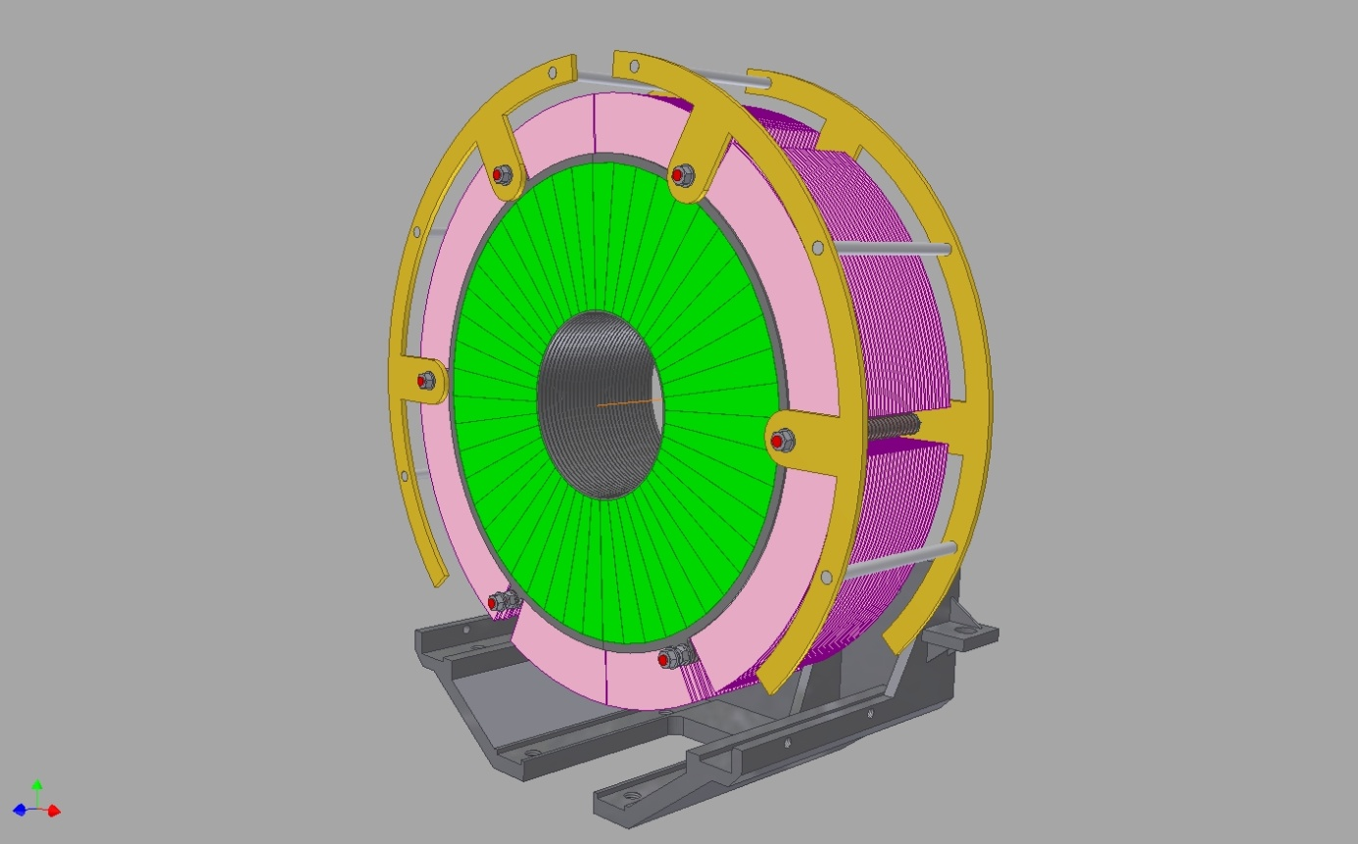

Figure 1: LumiCal isometric view.

In comparison to the mechanical structure of LumiCal described in [4,5] we have lowered the diameter of tungsten plates from 231,5 mm to 200 mm. This reduces the amount of heavy material in the space which is not equipped with silicon sensors. We have also changed the positions of bolts screwing the LumiCal structure to obtain symmetry and more space for electronics.
- Tungsten plates
The tungsten plate thickness will be 3.5 mm (1 radiation length) and the shape is shown in Fig. 2.

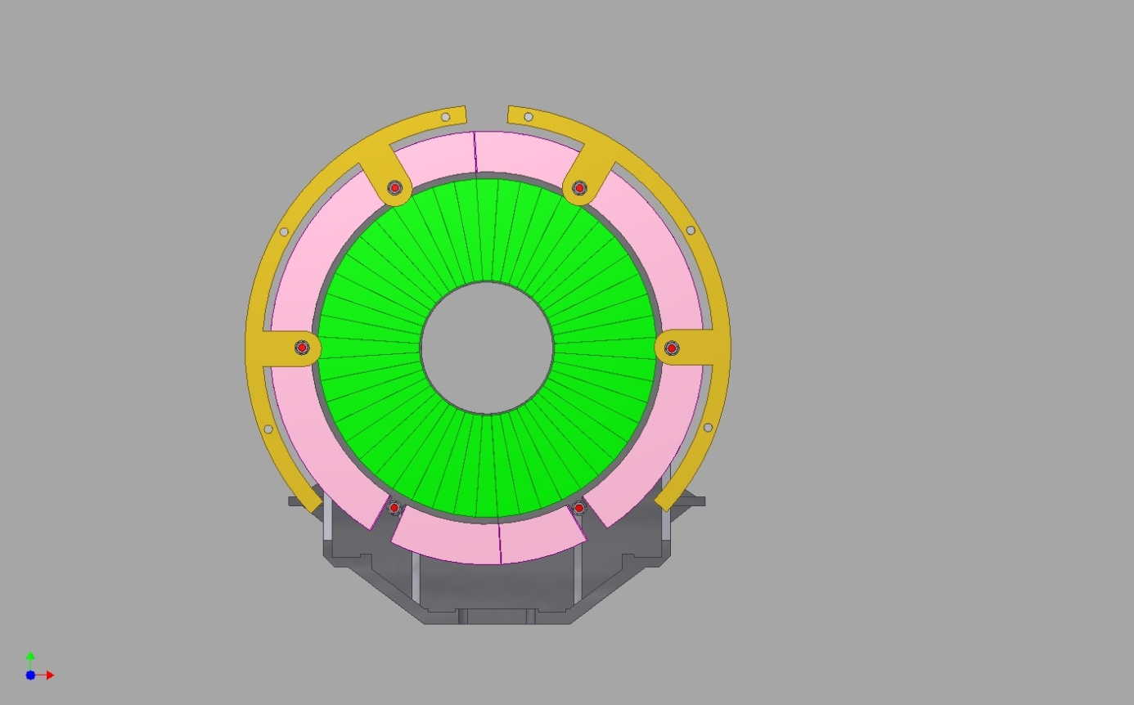

Figure 2: One plane of LumiCal with glued silicon sensor (green).

In Fig. 3 the assembled LumiCal is shown.

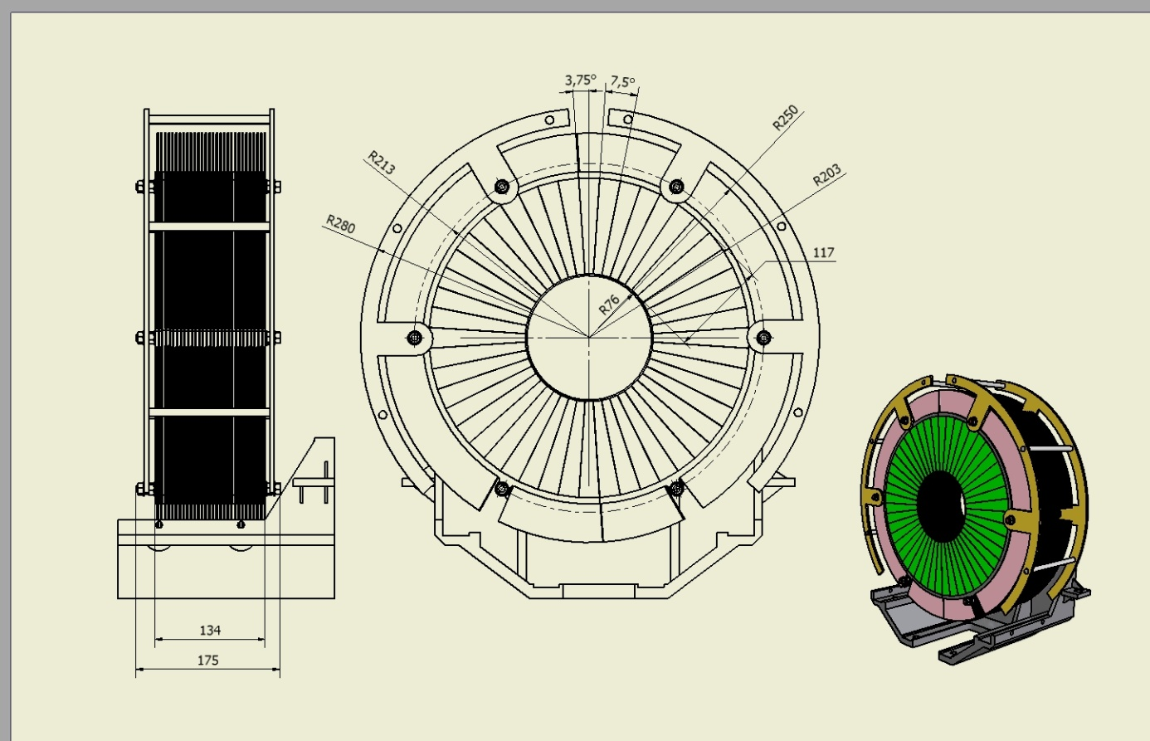

Figure 3: LumiCal with some details of assembly.

The main advantage of the design is its simplicity. The structure is composed of a very limited number of elements.
- Space for electronics
One LumiCal will have 92160 electronic readout channels. On one half plane there should be place for 1536 electronic channels. We foresee a space as shown in Fig. 4 & 5.
The goal was to have all electronics for silicon tiles identical. This induces us to redesign LumiCal mechanical structure to be symmetrical. Due to the rotation of odd and even sensor planes by 3.75° to overlap the gaps in Tungsten absorber, some space for electronics (with full symmetry) is lost (shown in Fig. 4.), but our design minimizes it.
We foresee 3 fixing bolts to mount one half plane, but it is possible to have 5 fixing bolts per half plane (in Fig. 4 & 5 marked with dotted lines). More fixing bolts will increase the stiffness of LumiCal mechanical construction.

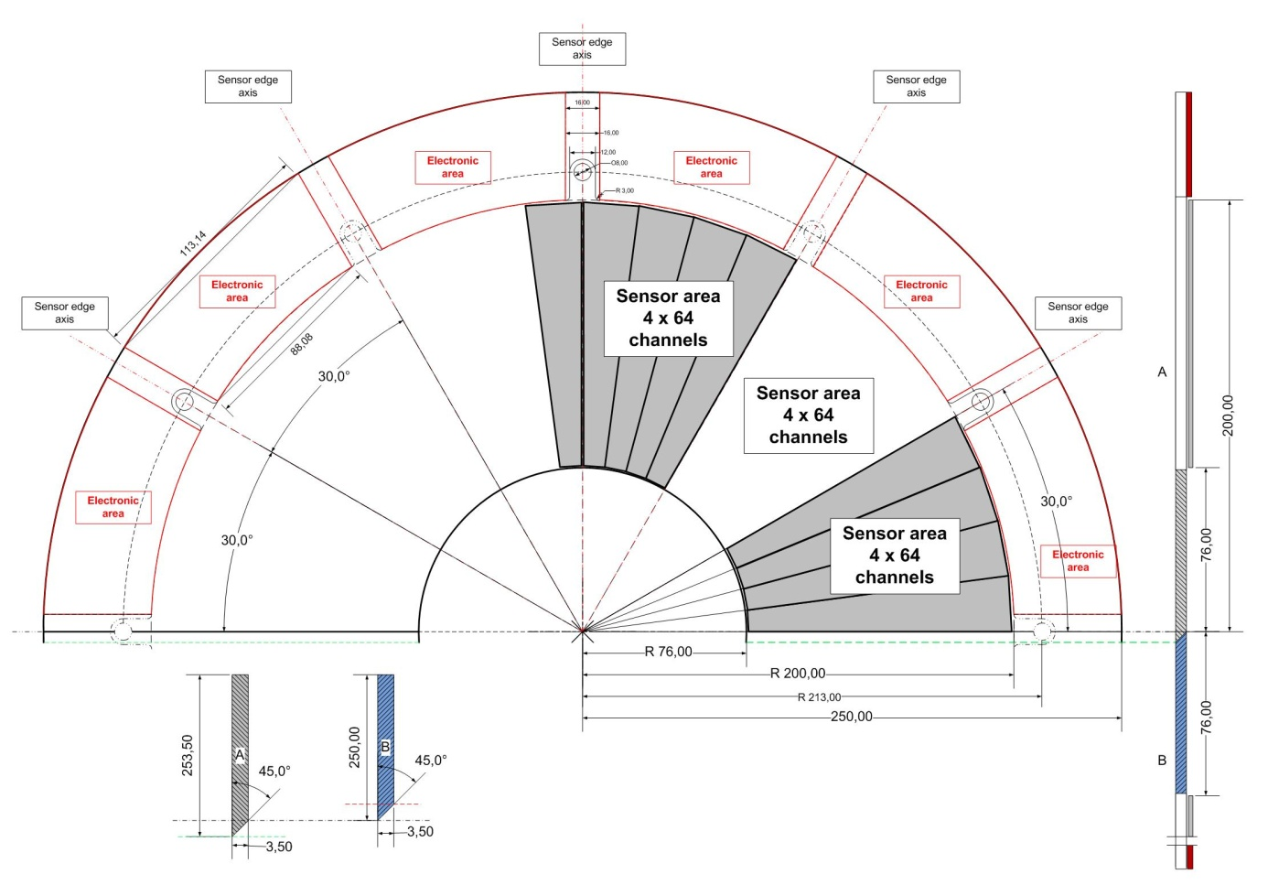

Figure 4: Space for front end electronics on one half plane.
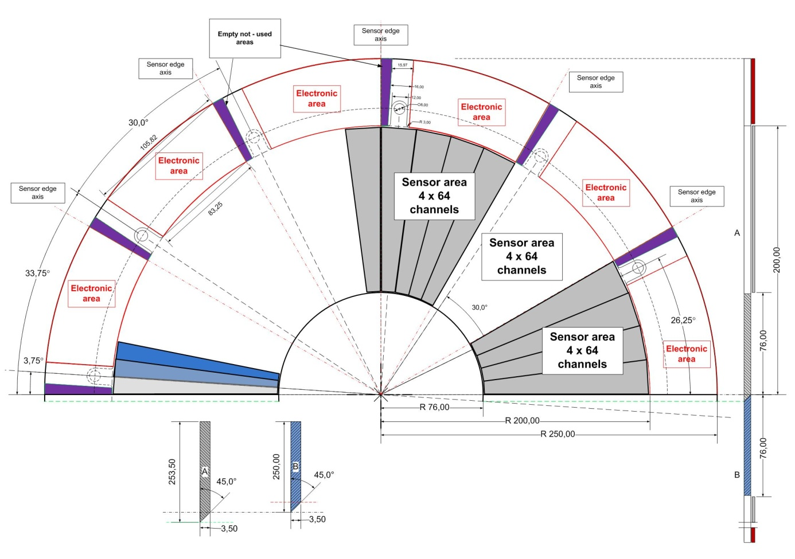

Figure 5: Two half sensors planes rotated by 3.75°

The electronics will be placed on thin 2 mm aluminium plates working also as a heat exchanger. The cross section of a space for electronics is presented in Fig. 6.

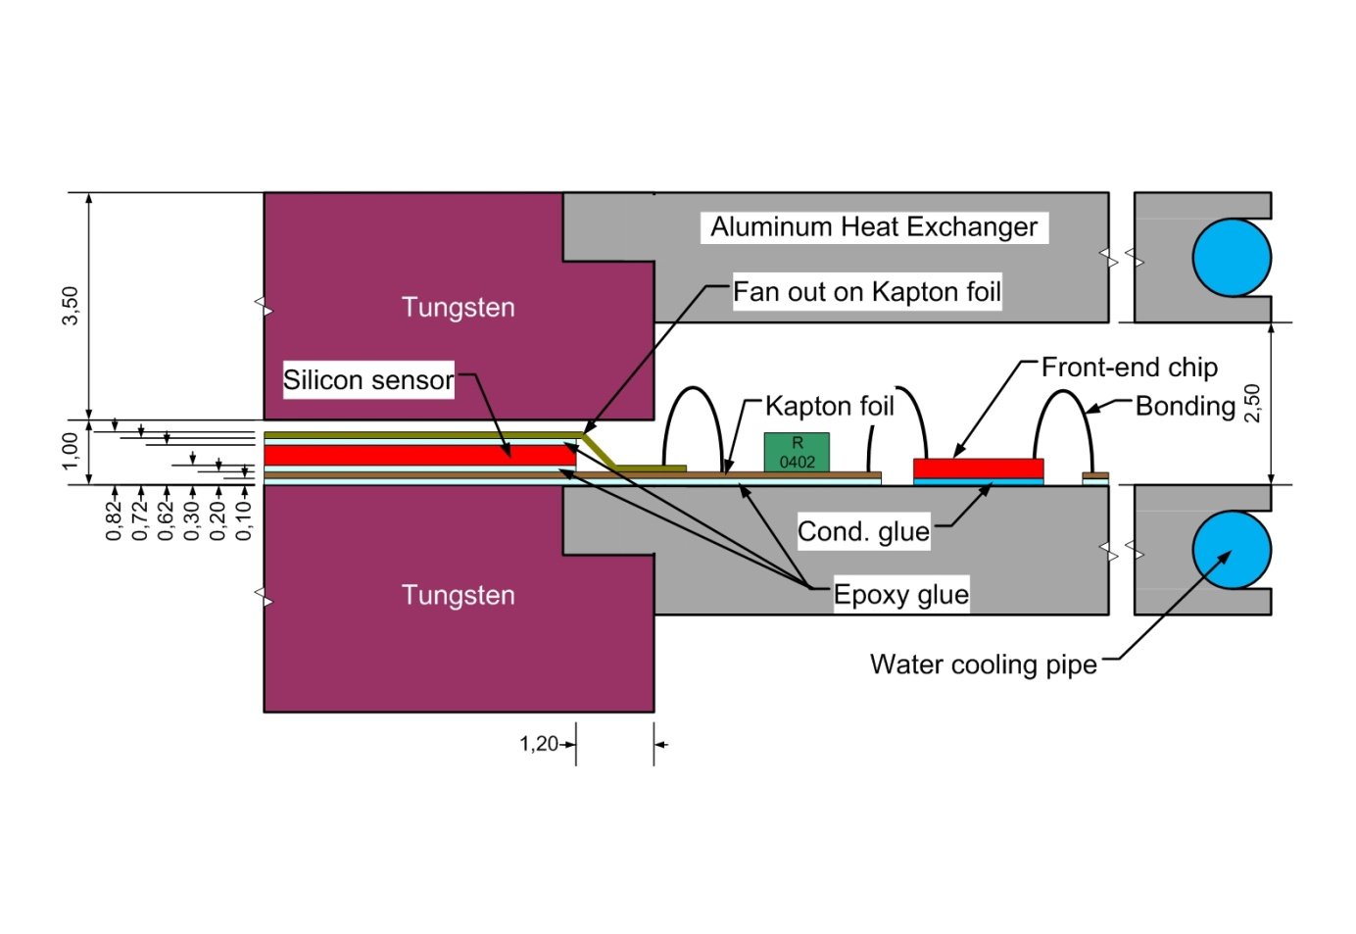

Figure 6: Cross section showing fan out connections to the front end electronics chips.

- Space for cables and cooling
The electronic channels of LumiCal will be read in digital form to the DAQ placed ~10 m far from the detector outside the ILD. The cooper LVDS TP cables will go from each half plane of LumiCal around the barrel to the back side of each LumiCal where Data Concentrator will be placed. From Data Concentrator we foresee optical links to the DAQ. The fibre optics cables will go over LHCal and inside the square support tube (near QD₀ magnet) and outside the ILD detector. The space for cabling and cooling is shown in Fig. 7.

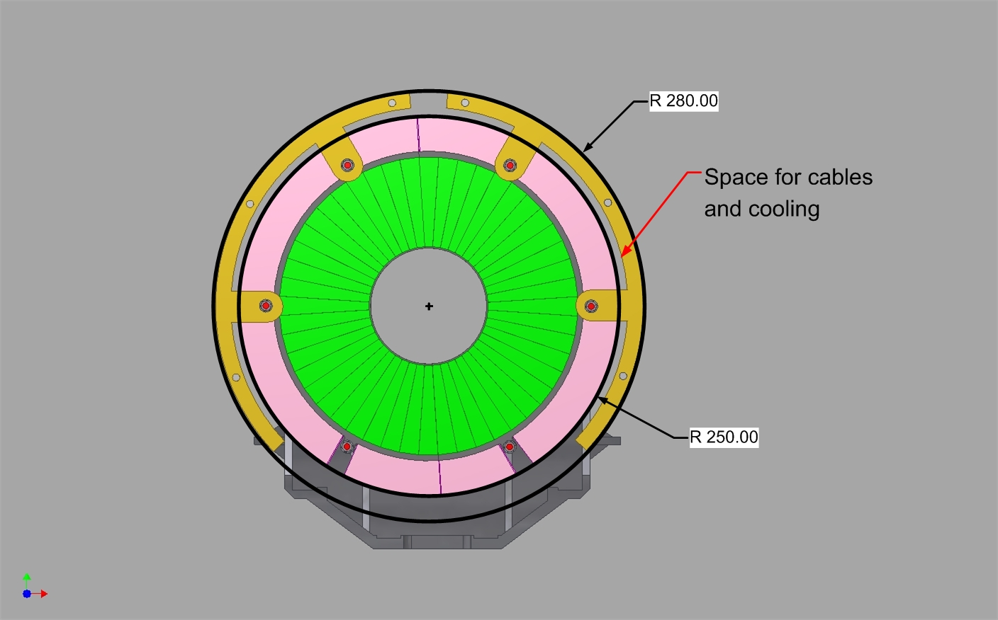

Figure 7: Space for cables and cooling.

Front end electronics will be the major source of heat in the LumiCal. Thanks to the power cycling during brakes (199 ms) between trains (5 Hz, 1 ms), the dissipated power in one LumiCal will be around 30 W. Even if this value was two times higher the dissipated power per sensor plane would be ~ 2 W. The water flow of 0.43 l/min. per plane will take heat off with 0.1 ºC temperature increase. The total cooling water flow in one LumiCal will be less than 15 l/min (probably more than 3 times overestimated). The small water pipes should go outside the detector together with optical links.

6 Conclusions
The design is quite simple, the structure is composed of a very limited number of precisely manufactured elements– only four types of Tungsten plates and identical (one type) electronics for silicon sensors. Reduction of ‘dead’ material in space not equipped with particle sensors will increase accuracy of measurements performed with ILD detector.

Acknowledgement
This work was partly supported by:
The Commission of the European Communities under the 6th Framework Programme “Structuring the European Research Area”, EUDET program: Detector R&D towards the International Linear Collider, contract number RII3-026126
and
The Polish Ministry of Science and Higher Education
under Agreement No. 141/6.PR UE/2007/7.

References
- International Large Detector: http://www.ilcild.org .
- International Linear Collider: http://www.linearcollider.org .
- TESLA Technical Design Report, DESY 2001-011, ECFA 2001-209, March 2001; H. Abramowicz et al., IEEE Transactions of Nuclear Science, 51 (2004) 2983; R&D for ILC – Detector, Instrumentation of the Very Forward Region;
The Forward Calorimetry Collaboration (FCAL):
http://www-zeuthen.desy.de/ILC/fcal ;
DESY PRC R&D Report 02/01, Updated Version, November 2009;
ILD outline document: http://www.ilcldc.org/documents;
The International Large Detector, Letter of Intent , DESY 2009-87, Updated Version
by ILD Concept Group, February 2010.
- EUDET-Memo-2008-13.
- EUDET-Memo-2009-10.

Institute of Nuclear Physics PAN, Cracow, Poland
AGH University Science and Technology and Institute of Nuclear Physics PAN, Cracow, Poland
list of members can be found: http://www-zeuthen.desy.de/ILC/fcal/

